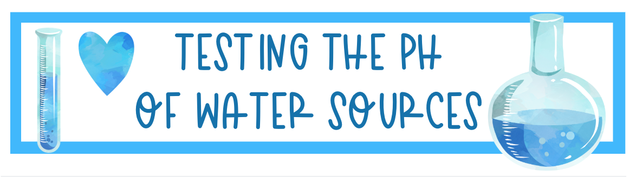

Investigation questions: Do all water sources have the same pH? If we add liquids or powders to water does it affect the pH?
Hypothesis:

Investigation table: pH of water sources
Water Sources | Prediction |  | Actual
Water Sources | pH | Acid or Base | pH | Acid or Base
Blue Lake
Ocean
Valley lake
Little Blue
School
Dog Bowl
Bottled
Pool
Lemon Water
Washing Powder water
Tomato Sauce water
Detergent water

