Procedural Writing Checklist

Aim: To write a structured recipe on how to make your pizza.
Remember: To be super specific in your language choice.

Structure of procedural text:
- Title of recipe
- Ingredients and materials list
- Sequenced steps of how to make the pizza
- Include some visuals showing how to carry out steps (photos)

In my procedure I need to include
- Present tense verbs: describe the action (cut, mix, scoop, slice)
- Adverbs: modifies the action (quickly, briskly, slowly)
- Punctuation (Capital letters, full stops and commas)

Verb Examples | Adverb Examples
- Cook  - peel  - Pour  - Slice  - Add  - melt  - Chop  - Cut  - Measure  - Mix  - Stir  - Slice  - Spread  - Blend  - Heat  - Grease  - Grill  - Knead  - Sprinkle  - Mash  - Crack  - whisk | - slowly  - rapidly  - carefully  - quickly  - almost  - sometimes  - often  - frequently  - occasionally  - rarely  - quick  - towards  - inside  - above  - in  - thoroughly  - upward  - downward  - hastily  - so that  - until  - briefly

Example 1: Ingredients

Ingredient Examples: Be specific!
Basic ingredients | Well written specific ingredients
- Cheese  - Pepperoni  - Sauce | - 2 cups of grated cheese  - 8 slices of pepperoni  - 3 Tablespoons of BBQ sauce

Example 2: Using verbs and adverbs in your sequenced steps

Sequenced Steps
Basic Steps | Well written specific steps
Step 1: Get out your pizza base  Step 2: Put the sauce on the pizza base | Step 1: Get your pizza base out of the fridge and place it on the table  Step 2: Evenly spread the sauce on top of the base, making sure you cover the whole base.

Example 3: Inserting images to demonstrate key skills

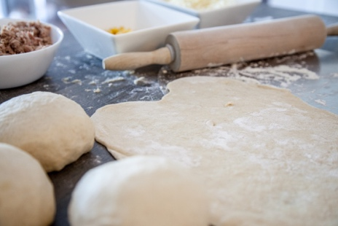
Using a rolling pin, thoroughly roll out the dough until you have a large circle of dough.

Capital letters | Full Stops | Commas

