Part 3A: Adding & Subtracting Fractions

Task: To add, subtract and order fractions

Steps:
- Read the task in the following table
- Copy and paste the required pizza toppings from the pizza topping table
- Answer the add or subtract column

Pizza Toppings
Cheese | Bacon | Pepperoni | Onion
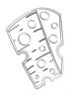 | 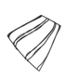 |  | 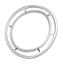
Capsicum | Tomato | Mushroom | Chilli
 |  | 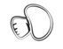 | 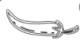

Task | Image | Add or subtract
Place capsicum on 2 pieces of pizza and salami on 3 pieces of pizza how many pieces have toppings on them? | 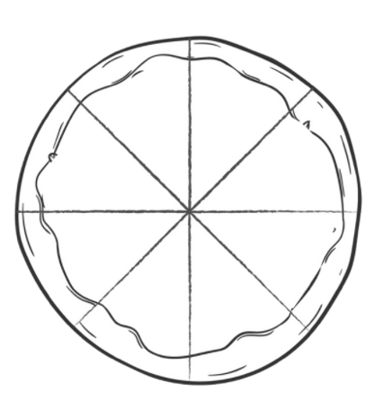 | 2/8 + 3/8 =
Place cheese on half of the pizza and onion on 2/8. How many pieces have toppings on them?

I ordered a cheese and tomato pizza. I ate ¼ for lunch and half for tea. How much pizza was left?

A pizza had 3/12 pepperoni, ¼ capsicum, 1/12 bacon, 2/12 chilli 2/12 mushroom and 1/12 onion. I then ate 4/12 pieces. How much pizza was left? | 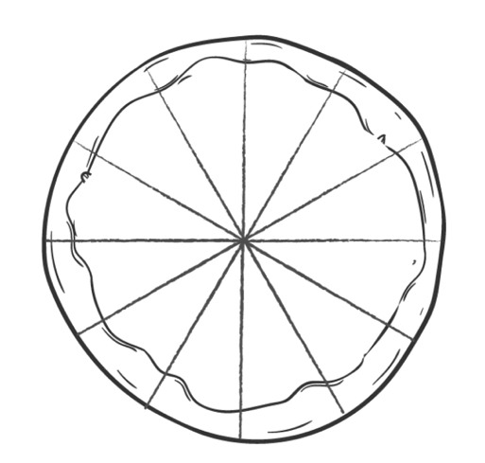
I had a pizza party and ordered 4 whole pizzas. We ate 28/12 slices. How much pizza did we eat altogether? | 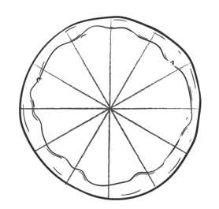 | HINT: You need to convert the improper fraction to a mixed fraction  28/12 =

