Part 2: Faces, Corners and Edges

Task: To identify the faces, corners and edges on 3D shapes

Steps:
- Look at the shape in the shape box
- See if you can find a real-life example of that shape in your house or on the internet
- Count and record how many faces, corners and edges the shape has
Shape | Photo Example | Faces, Corners & Edges
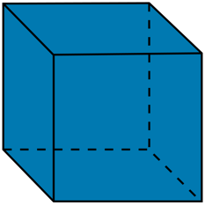 |  | Faces:  Corners:  Edges:
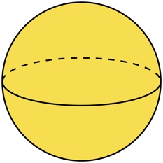 |  | Faces:  Corners:  Edges:
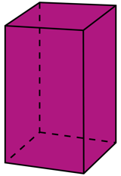 |  | Faces:  Corners:  Edges:
 |  | Faces:  Corners:  Edges:
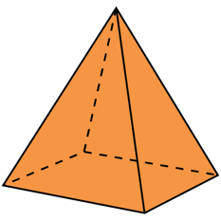 |  | Faces:  Corners:  Edges:
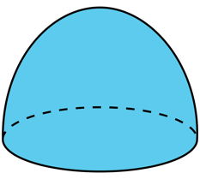 |  | Faces:  Corners:  Edges:
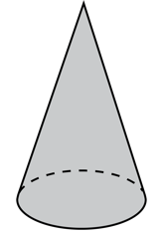 |  | Faces:  Corners:  Edges:
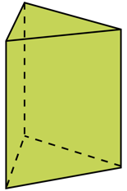 |  | Faces:  Corners:  Edges:

