Part 2: Equivalent Pizza Fractions

Task: To demonstrate your understanding of equivalent fractions using your pizza

Steps:
- Take photos of your pizza demonstrating different equivalent fractions. Alternatively, you could take photos and draw over the top of the pizza.
- For each fraction in the table, type in the equivalent fraction and insert your pizza image demonstrating the fractions.
Example- Option 1: Cutting fractions
Fraction | Equivalent Fraction | Photo Example
1/2 | 4/8 | 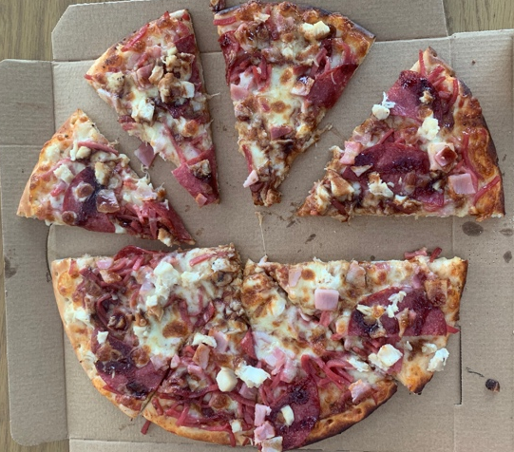

Example- Option 2: Drawing fractions on pizza
Fraction | Equivalent Fraction | Photo Example
1/2 | 4/8 | 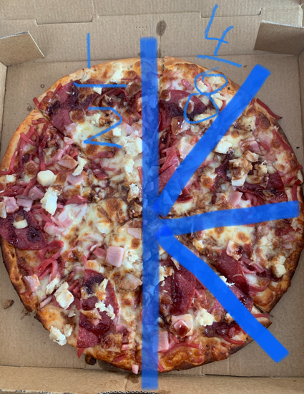

Eighths
Fraction | Equivalent Fraction | Photo Example
1/4

1/2
3/4 | /8
4/4 | /8

Sixths
Fraction | Equivalent Fraction | Photo Example
1/2

2/3
3/3 | /6

