Part 1: Finding different 3D shapes

Task: To find and take photos of 3D objects you can find around your house and outside.

Steps:
- Take photos of objects that are different shapes
- Insert the photo into the word document
- Insert the correct 3d shape and type the name of the shape

Shape Images
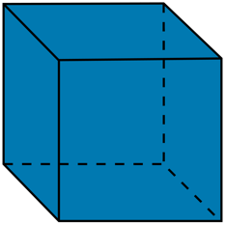 | 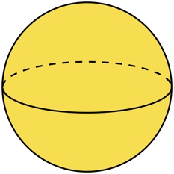 | 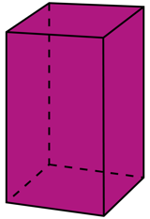 | 
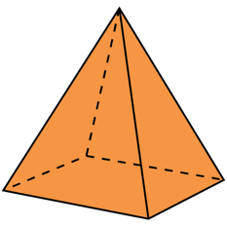 | 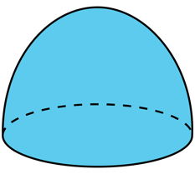 | 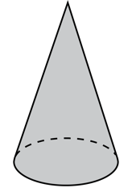 | 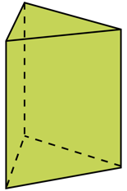

Photo of object | Shape Image | Name the shape
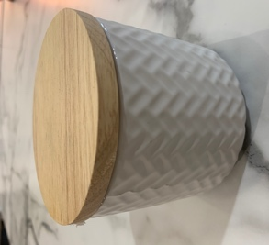 |  | Cylinder

