Length - Your One Stop Shop for Teacher Knowledge, Assessment and Resources
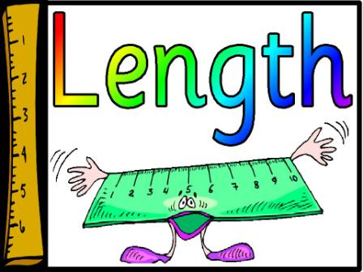
Image by clipart
Summary
You scroll through your planner and your next topic is length. You assess students’ prior knowledge and realise that some students in your grade are working at Foundation level while some are working towards achieving Level Six.
It is always challenging for teachers to know where to start. This unit of work includes:
- the Australian Curriculum outcomes directly linked to length
- the progression of learning in length to upskill teacher’s knowledge
- assessment ideas from standardised tests, whole class tests and individual assessment
- links to resources created by Education Departments
- links to resources created by Australian Curriculum Lesson contributors
- learning intention and success criteria with ‘I can’ statements from Foundation to Level Six
- links to online games which can reinforce skills in length
- links to videos appropriate for length as a tuning in for whole class or small group / individual student extension/enabler
If you find a reputable site which includes length resources (ensure this is in the metric system) please add the link in the comments section below.

 Australian Curriculum
Foundation
Use direct and indirect comparisons to decide which is longer, heavier or holds more, and explain reasoning in everyday language (ACMMG006 - Scootle )
Level One
Measure and compare the lengths and capacities of pairs of objects using uniform informal units (ACMMG019 - Scootle )
Level Two
Compare and order several shapes and objects based on length, area, volume and capacity using appropriate uniform informal units (ACMMG037 - Scootle )
Level Three
Measure, order and compare objects using familiar metric units of length, mass and capacity (ACMMG061 - Scootle )
Level Four
Use scaled instruments to measure and compare lengths, masses, capacities and temperatures (ACMMG084 - Scootle
Level Five
Choose appropriate units of measurement for length, area, volume, capacity and mass (ACMMG108 - Scootle )
Level Six
Convert between common metric units of length, mass and capacity (ACMMG136 - Scootle )
Solve problems involving the comparison of lengths and areas using appropriate units (ACMMG137 - Scootle )

LEARNING PROGRESSION
To upskill teacher knowledge from the Australian Curriculum resources section - relevant length concepts only
Describing length
- identifies the attribute of length (using gestures)
- identifies the longest object using direct comparison
- compares the length of two objects by aligning the ends
- uses everyday language to describe attributes that can be measured
Comparing and ordering objects
- compares objects and explains how they have been ordered using comparative language (shorter, longer)
- orders three or more objects by comparing the size of each of the objects
- makes a copy of the length of one object (with fingers) to then make a comparison with another object
Using informal units of measurement
- estimates the total number of units needed to measure
- uses multiple informal units to measure length (uses paper clips to measure the length of a line)
- chooses and uses a selection of the same size and type of units to measure length (without gaps or overlaps)
- counts the individual units used by ones to find a total to then make comparisons
Using equal units for indirect comparison
- describes the qualitative relationship between the size and number of units (with bigger units you need fewer of them)
Repeating a single informal unit to measure
- measures the length and area of a shape using a single informal unit repeatedly (iteration) (uses one paper clip when measuring the length of a line, making the first unit, marking its place, then moving the unit along the line and repeating this process)
- estimates length or area by visualising how many of the units will fit into the space to be measured
- explains that the distance measured is the space between the marks or ‘ends’ of each unit, not the marks themselves
Identifying the structure of units
- estimates lengths that lie between full units by visualising subdivisions of the unit
Using formal units
- measures, compares and estimates length using standard formal units
- calculates perimetre using properties of two-dimensional shapes to determine unknown lengths
Converting units
- converts between formal units of measurement
- recognises the relationship between metric units of measurement and the base-ten place value system
- explains why having 100 cm in a metre results in 10 000 cm2 in a square metre (using a diagram)
Calculating measurements
- identifies appropriate levels of precision with measurement (significant figures)
Circle measurements
- understands that the relationship between the circumference and the diametre of a circle is constant (pi)
- uses the constant pi to determine the circumference and the area of a circle

LEARNING INTENTIONS AND SUCCESS CRITERIA
Learning Intentions
Content Learning Intention: I am learning about length and the different ways to measure the length of objects and distances.

Language Learning Intention: I am learning how to use these words when talking about length; measure, longer, shorter, same, millimetres, centimetres, formal, informal and metres

Social Learning Intention: I am learning to work in a mixture of groups independently and targeted teaching group and discuss my thinking about length in each situation.

Success Criteria: Progression
Foundation
I can compare the length of two objects
I can explain which is longer or shorter
Level One
I can measure two objects by using uniform informal units
I can compare two objects by using uniform informal units
I can explain my thinking when using informal units
Level Two
I can order objects based on length
I can explain my ordering
I can choose the appropriate uniform informal unit to measure the length
Level Three
I can measure objects using a familiar metric unit of length such as a ruler
I can order objects using a familiar metric unit of length
I can compare objects using a familiar metric unit of length
Level Four
I can use a scaled instrument to measure the length of a shape or object
Level Five
I can choose an appropriate unit of measurement for length
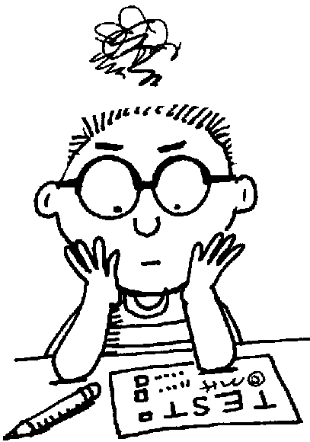
Image by clipart
ASSESSMENT
Pre-Assessment

PAT (Progressive Achievement Tests)
Foundation
Test 2 Q21-Recognise cuboid with smallest capacity (94.3)
Level 2
Test 1 Q24-choose shape that covers fewest grid squares (104.0) VCMMG116
Test 4 Q20-Recognise fewer of heaviest object needed to reach total mass
Level 3
Test 3 Q21-Choose correct unit to measure contents of jug(98.8)
Q22-Find length of object using ruler marked in cm (97.0)
Test 4 Q19-Add two lengths given in 2 diff metric units (128.8)
Level 4
Test 4 Q16-read scale halfway between labelled values (116.2)
Test 5 Q21-Diff of masses measured on a scale (134.8)
Test 4 Q17-Work out area of folded strip in square units (115.7)
Test 5 Q18-read scale with 4 marks between labelled markings (125.3)
Level 5
Test 5 Q19-Choose familiar container for capacity 200ml (124.7)
Test 6 Q23-Find side length of rectangle given area and other side length (125.6)

MAI (Mathematical Assessment Interview)
Foundation
Growth Point (GP) 1-Comparing length MAI: Q45 comparing length of string and stick (tick a &b)
GP2- Comparing length MAI: Q45 comparing length of string and stick (all ticks)
Level 1
GP3- Using informal units MAI: Q46 Measuring straw with paper clips
Level 2
GP3- Using informal units MAI: Q46 Measuring straw with paper clips
Level 3
GP 4- Using standard units to measure length with accuracy MAI: Q47 Measure straw with rule
Level 4 GP 5- Applies knowledge to solve problems involving length MAI: Q48 tearing a streamer around 1 metre long

ACARA (Australian Curriculum Assessment and Reporting Authority)
Level Two Assessment task with satisfactory sample https://docs.acara.edu.au/curriculum/worksamples/Year_2_Mathematics_Portfolio_Satisfactory.pdf
Level Five Assessment task with satisfactory sample
https://docs.acara.edu.au/curriculum/worksamples/Year_5_Mathematics_Portfolio_Satisfactory.pdf

Ongoing Assessment
Anecdotal Notes
Students Self Assessment
Success Criteria - checklist
Open-Ended questions
Worksheets / Work book samples

Post- Assessment
Depending on your pre-assessment will depend on the information you would like to gain from the post assessment

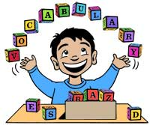
Image by Clipart
VOCABULARY
Display on your numeracy word wall or a section of the room vocabulary students will need during length lesson for students.
This list is not complete and depending on student’s prior knowledge may need to be extended for some students.
Length vocabulary; length, measurement, formal, informal, to measure, distance, accurate, height, width, long, short, longer, shorter, same, equal, estimate, unit, size, centimetres, ruler, millimetres, kilometres and convert.

CONCRETE MATERIALS
The following materials may be useful during this unit; paper clips, icy pole sticks, straws, rulers, unifix blocks, tiles, kindergarten squares, strips of paper, string, pegs, smarties, measuring tape and trundle wheels. Remember that units you are using to measure must be equal.
Posters and blackline master ruler templates https://www.sparklebox.co.uk/maths/shape-space-measures/measuring-and-comparing/measuring.html#.XhK4bVUzaos

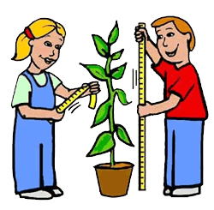
Image by Clipart
RESOURCES
Australian Curriculum Lessons
Exploring Length Lesson Measuring, Estimating, Comparing and Ordering Year 3 /4
Introduction to Length Lesson - Years 3 / 4
Another Introduction to Length Lesson - Years 3 / 4
Smallest to Biggest - A measurement and geometry lesson plan for Foundation

South Australian Education Department 52 page booklet with teacher knowledge and lesson ideas
https://www.acleadersresource.sa.edu.au/features/conceptual-narrative-printables/maths/DECD_Mathematics_Conceptual_Narrative_Using_units_of_measurement_F-Year_2_2017.pdf
Western Australian Education Department FirstSteps Mathematics Books http://det.wa.edu.au/stepsresources/detcms/navigation/first-steps-mathematics/
Victorian Education Department FUSE - length lessons http://fuse.education.vic.gov.au/Resource/ByPin?Pin=B2Q9Y2&SearchScope=All
New Zealand Units of work on Length from Level 1 to Level 6 https://nzmaths.co.nz/length-units-work
Scootle http://education.abc.net.au/home#!/search/Length//
New South Wales Education Department Measurement - Length activity suggestions https://www.australiancurriculum.edu.au/resources/national-literacy-and-numeracy-learning-progressions/national-numeracy-learning-progression/measurement-and-geometry/?subElementId=50803
Nrich Mathematics https://nrich.maths.org/8327/note
IXL Maths - https://au.ixl.com/math/
Smash Maths https://www.smashmaths.com.au/measurement-and-geometry/measurement/length-area-perimetre
ABC Education a collection of games videos, articles from Foundation to Level Six http://education.abc.net.au/home#!/search/Length//
You Tube - length videos (please ensure cyber safety when using You Tube) https://www.youtube.com/results?search_query=measurement+length+for+students
Clipart Images used in this lesson http://clipart-library.com/length-cliparts.html

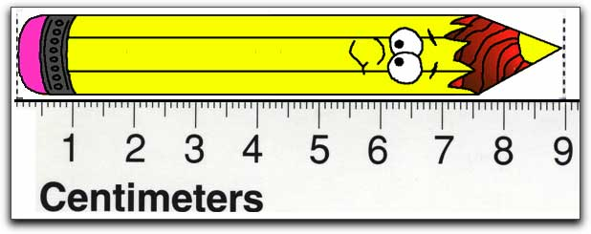
Image by Clipart

