Tuning In (pre-test)
Part One
On the first black interval choose a two digit number. Proceed to count by ones along the black intervals. Then fill in the blue intervals then the red intervals.

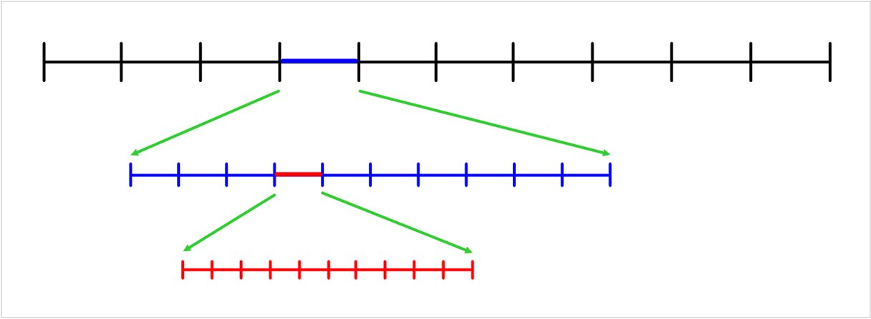

Part Two
Finish this sentence
A decimal is

Part Three
Question 0.42 x 10 =
Explain the reasons behind your answer

