Part 2: Measuring and Classifying Angles

Task: To find and make different angles using objects around your house and outside.

Steps:
- Take photos of different angles you can find in and around the house. Use your body and different objects to create different angles.
- Download an application to measure the degrees in images (Angles in Photo)
- Classify the angles as acute angle, right angle, obtuse angle, straight angle and reflex angle
Photo with angle | Angle degrees | Classify it
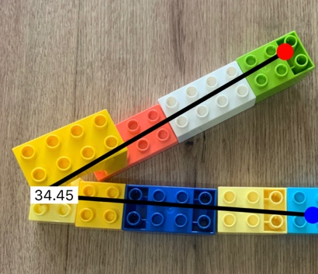 | 34.45 ° | Acute angle  = less than 90 °

