Part 1: Comparing Angles to Right Angles

Task: To find and take photos of different angles you can find around your house and outside.

Steps:
- Take photos of different angles you can find (greater than, smaller than and equal to right angles)
- Use an application to draw over the angle (notes, explain everything, book creator or print and draw on them)
- Classify the angles as greater than, equal to or smaller than a right angle
Take a photo | Draw the angle | Classify it
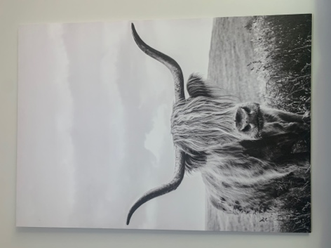 | 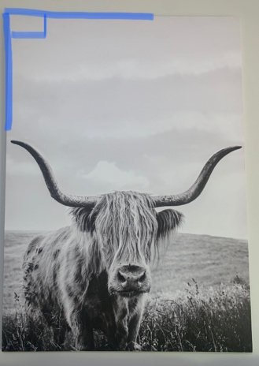 | Right angle

