Parent Support Document:

Writing on photos using notes:

- Take a photo using the camera on your phone or tablet
- Open up the ‘Notes’ application
- Click the camera button and choose photo library. Select the image you want to use. Alternatively, you can choose take phot and take a new one
- Click the pencil icon to draw on your image. Choose the pencil type and colour
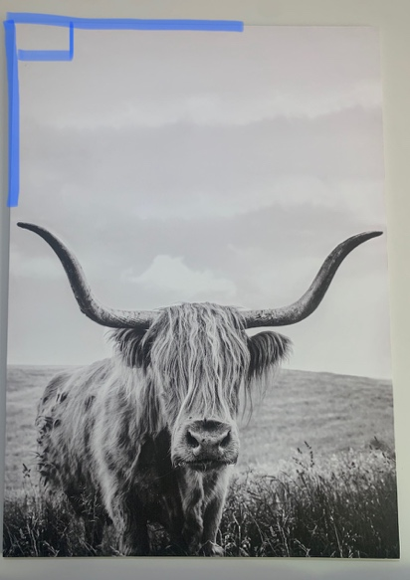
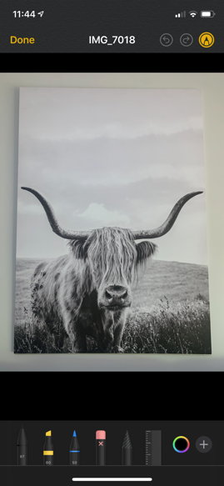
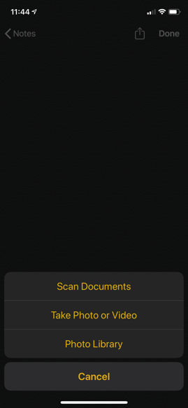
- Draw the angle on top of the image. Take a screenshot of the image to put into your work document

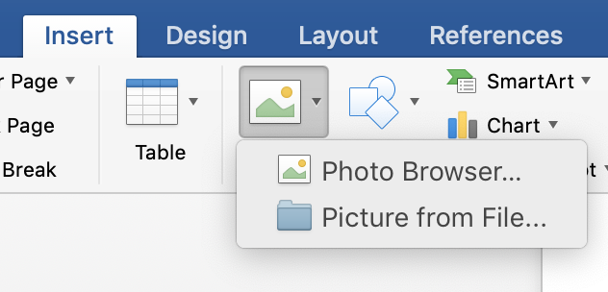
Inserting images into word document:
- You will need to send your angle images to your laptop (airdrop, email etc.)
- On the word document click inside the table section you want to insert the image
- Clock on the insert tab > picture > picture from file
- Select the image you wish to use
- Repeat the process
NOTE: you may want to wrap text and choose ‘tight’ so you can move the image where you wish

Alternatively: You could create the table and all of the work on your tablet if this is an option using the word document to format how the work needs to be set out.

Using Angles App to measure degrees
- You will need to go to the App store on your device
- Search ‘Angles in Photo’
- Download the app
- Once complete, open up the app
- Click the three circle image in the left hand corner and choose either from camera or from library (to take a photo or choose from one you have taken)
- Select ‘choose’ photo
- Place the three dots of your angle on your picture
- Take a screenshot of the angle with measured degrees
- Insert image into your Part 2 work document

