Science
Year 6

Science Understanding
Earth and space sciences
ACSSU096
Sudden geological changes and extreme weather events can affect Earth’s surface

Elaborations:
• investigating major geological events such as earthquakes, volcanic eruptions and tsunamis in Australia, the Asia region and throughout the world
• recognising that earthquakes can cause tsunamis
• describing how people measure significant geological events

Assessment
Anecdotal
Work samples – calibre of research presented

The following worksheets will assist students to understand how sudden ecological weather events can impact our planet.
PLANET EARTH

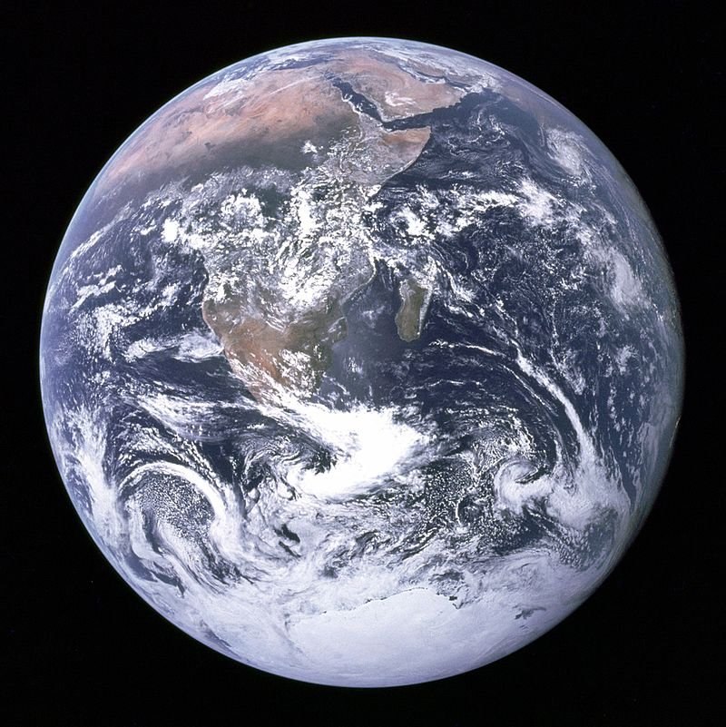
PHOTO: NASA/Apollo 17 crew.
"The Blue Marble" is a famous photograph of the Earth taken on December 7, 1972, by the crew of the Apollo 17 spacecraft en route to the Moon at a distance of about 29,000 kilometres.

Write a short descriptive paragraph as a response to this photo.

………………………………………………………………………………………………………………………………………………………………………….

………………………………………………………………………………………………………………………………………………………………………….

………………………………………………………………………………………………………………………………………………………………………….

………………………………………………………………………………………………………………………………………………………………………….

PLANET EARTH
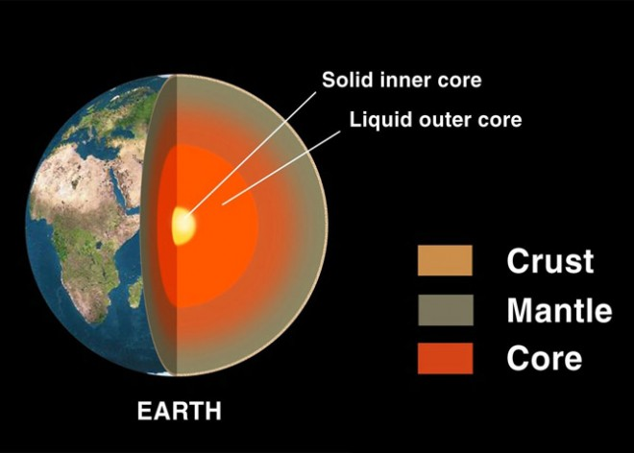

The interior structure of the Earth is layered in spherical shells, like an onion. Write a sentence on each of these layers.

The core:

………………………………………………………………………………………………………………………………………………………………………….

………………………………………………………………………………………………………………………………………………………………………….
The mantle:
………………………………………………………………………………………………………………………………………………………………………….

………………………………………………………………………………………………………………………………………………………………………….
The crust:
………………………………………………………………………………………………………………………………………………………………………….

………………………………………………………………………………………………………………………………………………………………………….

PLANET EARTH
Over 250 million years ago, the continents were all one land mass called Pangea. Watch the animation at https://vimeo.com/14258924 and see the movement of the continents.

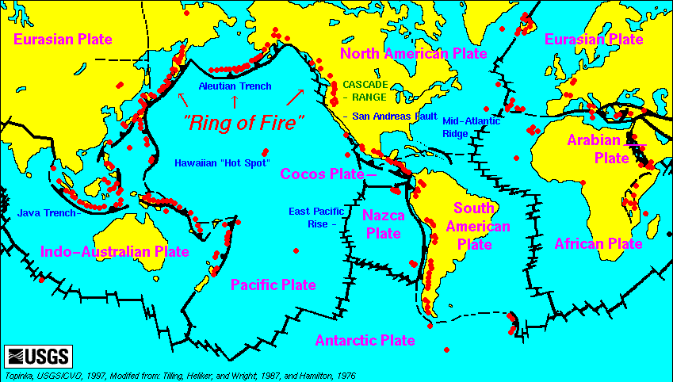
Image: USGS.
Research to learn the answers to the following questions.
What is meant by the term plate tectonics?

………………………………………………………………………………………………………………………………………………………………………….

………………………………………………………………………………………………………………………………………………………………………….

………………………………………………………………………………………………………………………………………………………………………….

………………………………………………………………………………………………………………………………………………………………………….

………………………………………………………………………………………………………………………………………………………………………….

Describe each of the following plate boundaries:

Transform boundaries:

………………………………………………………………………………………………………………………………………………………………………….

………………………………………………………………………………………………………………………………………………………………………….

Divergent boundaries:
………………………………………………………………………………………………………………………………………………………………………….

………………………………………………………………………………………………………………………………………………………………………….

Convergent boundaries:
………………………………………………………………………………………………………………………………………………………………………….

………………………………………………………………………………………………………………………………………………………………………….

What type of convergent plate boundary is found along the west coast of South America where there is an ocean trench offshore and the Andes mountains onshore?
…………………………………………………………………………………………………………………………………………………………………………

What type of plate boundary occurs along the western part of California running from San Francisco to Baja California?
………………………………………………………………………………………………………………………………………………………………………….

What type of convergent plate boundary is found along the southern part of the Himalayas where the plate with India at its northern end has smashed itself against Asia?

………………………………………………………………………………………………………………………………………………………………………….
What type of plate boundary is located nearly halfway between South America and Africa?

………………………………………………………………………………………………………………………………………………………………………….
What type of convergent plate boundary is found in the western Pacific Ocean east of Australia where the Mariana’s Trench thousands of metres below sea level?

………………………………………………………………………………………………………………………………………………………………………….

WORD SEARCH
Create a word search using the following words:

earthquake | tectonic | plate | volcano | divergent
Pangea | magnitude | lava | dormant | eruption
magma | epicentre | energy | fault | aftershock
intensity | seismograph | location | crust | mantle
core | boundary | wave | destructive | disaster

GLOSSARY
Can you match each of these with their correct definition?

P Wave | This is the zone of earthquakes surrounding the Pacific Ocean- about 90% of the world's earthquakes occur there.
velocity | This is the number that characterises the relative size of an earthquake.
plate tectonics | This is a sea wave of local or distant origin that results from large-scale seafloor displacements associated with large earthquakes, major submarine slides, or exploding volcanic islands
crust | This is a mathematical device used to compare the size of earthquakes.
“Ring of Fire” | The epicentre is the point on the earth's surface vertically above the focus, point in the crust where a seismic rupture begins.
tsunami | This is a seismic wave that moves through the interior of the earth, as opposed to surface waves that travel near the earth's surface. P and S waves are body waves.
Richter scale | This is a fracture along which the blocks of crust on either side have moved relative to one another parallel to the fracture.
magnitude | This is the outermost major layer of the earth, ranging from about 10 to 65 km in thickness worldwide
epicentre | This is how fast a point on the ground is shaking as a result of an earthquake.
body wave | This is the part of the earth's interior between the outer core and the crust.
fault | This is the theory supported by a wide range of evidence that considers the earth's crust and upper mantle to be composed of several large, thin, relatively rigid plates that move relative to one another.
mantle | This is a seismic body wave that shakes the ground back and forth in the same direction and the opposite direction as the direction the wave is moving.
Check your answers: http://earthquake.usgs.gov/learn/glossary/

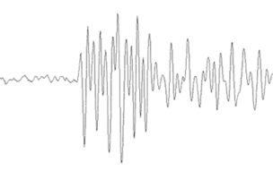 The science of earthquakes
Use the following link to research the answers to the following questions.

http://earthquake.usgs.gov/learn/kids/eqscience.php

What is an earthquake?
………………………………………………………………………………………………………………………………………………………………………….

………………………………………………………………………………………………………………………………………………………………………….

………………………………………………………………………………………………………………………………………………………………………….

What causes earthquakes and where do they happen?
………………………………………………………………………………………………………………………………………………………………………….

………………………………………………………………………………………………………………………………………………………………………….

………………………………………………………………………………………………………………………………………………………………………….

Why does the earth shake when there is an earthquake?
………………………………………………………………………………………………………………………………………………………………………….

………………………………………………………………………………………………………………………………………………………………………….

………………………………………………………………………………………………………………………………………………………………………….

How are earthquakes recorded?

………………………………………………………………………………………………………………………………………………………………………….

………………………………………………………………………………………………………………………………………………………………………….

………………………………………………………………………………………………………………………………………………………………………….

How do scientists measure the size of earthquakes?

………………………………………………………………………………………………………………………………………………………………………….

………………………………………………………………………………………………………………………………………………………………………….

………………………………………………………………………………………………………………………………………………………………………….

………………………………………………………………………………………………………………………………………………………………………….

How can scientists tell where the earthquake happened?

………………………………………………………………………………………………………………………………………………………………………….

………………………………………………………………………………………………………………………………………………………………………….

………………………………………………………………………………………………………………………………………………………………………….

What is meant by the "magnitude" of an earthquake?

………………………………………………………………………………………………………………………………………………………………………….

………………………………………………………………………………………………………………………………………………………………………….

………………………………………………………………………………………………………………………………………………………………………….

What is the difference between magnitude and intensity of an earthquake?

………………………………………………………………………………………………………………………………………………………………………….

………………………………………………………………………………………………………………………………………………………………………….

………………………………………………………………………………………………………………………………………………………………………….

What was the greatest earthquake in world history? Describe its impact.

………………………………………………………………………………………………………………………………………………………………………….

………………………………………………………………………………………………………………………………………………………………………….

………………………………………………………………………………………………………………………………………………………………………….

What is liquefaction and where does it occur?

………………………………………………………………………………………………………………………………………………………………………….

………………………………………………………………………………………………………………………………………………………………………….

………………………………………………………………………………………………………………………………………………………………………….

How does an earthquake generate a tsunami?

………………………………………………………………………………………………………………………………………………………………………….

………………………………………………………………………………………………………………………………………………………………………….

………………………………………………………………………………………………………………………………………………………………………….

WAVES OF DESTRUCTION

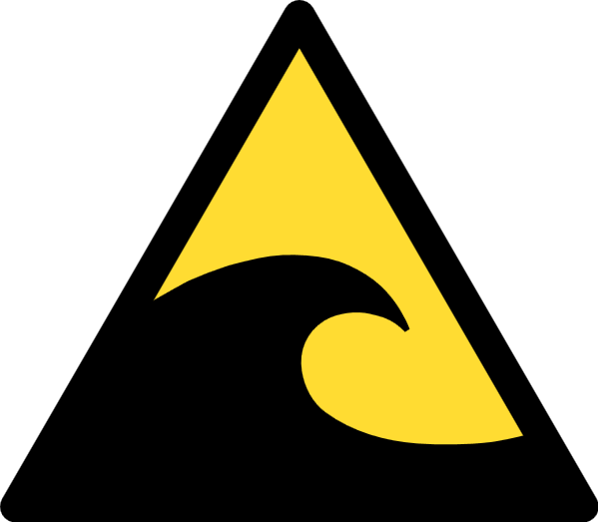
Use the following links to research the answers to the following questions.

Research links:
Tsunami Basics http://www.ga.gov.au/scientific-topics/hazards/tsunami
The Ultimate Guide https://www.emknowledge.org.au/connect/tsunami-the-ultimate-guide
Tsunami animation http://www.ga.gov.au/scientific-topics/hazards/tsunami/basics/causes/earthquakes
How they form http://www.australiangeographic.com.au/topics/science-environment/2011/03/tsunamis-how-they-form

What is a tsunami?
………………………………………………………………………………………………………………………………………………………………………….

………………………………………………………………………………………………………………………………………………………………………….

………………………………………………………………………………………………………………………………………………………………………….

How are tsunamis generated?
………………………………………………………………………………………………………………………………………………………………………….

………………………………………………………………………………………………………………………………………………………………………….

………………………………………………………………………………………………………………………………………………………………………….

What type of earthquake generates a tsunami?
………………………………………………………………………………………………………………………………………………………………………….

………………………………………………………………………………………………………………………………………………………………………….

………………………………………………………………………………………………………………………………………………………………………….

What are the characteristics of a tsunami?
………………………………………………………………………………………………………………………………………………………………………….

………………………………………………………………………………………………………………………………………………………………………….

………………………………………………………………………………………………………………………………………………………………………….

Where and how frequently are tsunamis generated?
………………………………………………………………………………………………………………………………………………………………………….

………………………………………………………………………………………………………………………………………………………………………….

………………………………………………………………………………………………………………………………………………………………………….

How are tsunamis detected?
………………………………………………………………………………………………………………………………………………………………………….

………………………………………………………………………………………………………………………………………………………………………….

………………………………………………………………………………………………………………………………………………………………………….

What happens to a tsunami as it approaches land? Use a diagram to illustrate your answer. Label your diagram.

Describe the impact of the Indian Ocean tsunami of 26th December, 2004?
………………………………………………………………………………………………………………………………………………………………………….

………………………………………………………………………………………………………………………………………………………………………….

………………………………………………………………………………………………………………………………………………………………………….

………………………………………………………………………………………………………………………………………………………………………….

………………………………………………………………………………………………………………………………………………………………………….

………………………………………………………………………………………………………………………………………………………………………….

………………………………………………………………………………………………………………………………………………………………………….

………………………………………………………………………………………………………………………………………………………………………….

………………………………………………………………………………………………………………………………………………………………………….

………………………………………………………………………………………………………………………………………………………………………….

What is the Joint Australian Tsunami Warning Centre? What is its purpose?
………………………………………………………………………………………………………………………………………………………………………….

………………………………………………………………………………………………………………………………………………………………………….

………………………………………………………………………………………………………………………………………………………………………….

………………………………………………………………………………………………………………………………………………………………………….

………………………………………………………………………………………………………………………………………………………………………….

How does the Joint Australian Tsunami Warning Centre operate?
………………………………………………………………………………………………………………………………………………………………………….

………………………………………………………………………………………………………………………………………………………………………….

………………………………………………………………………………………………………………………………………………………………………….

………………………………………………………………………………………………………………………………………………………………………….

………………………………………………………………………………………………………………………………………………………………………….

………………………………………………………………………………………………………………………………………………………………………….

WAVES OF DESTRUCTION

Tsunamis are one of Mother Nature’s worst nightmares. Create your own list of some of the most destructive tsunamis in the last 100 years. Use the following reference links to begin your research.

Research links:
World’s deadliest tsunamis http://geography.about.com/od/hazardsanddisasters/a/deadliest-tsunamis.htm
The 10 most destructive tsunamis in history
http://www.australiangeographic.com.au/journal/the-10-biggest-tsunamis-in-history.htm

Location | Date | Magnitude | Devastation caused

Fukushima Daiichi nuclear disaster

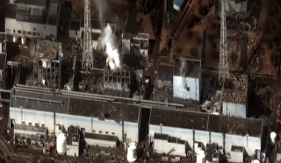
Photo:Wikipedia.org.
One of the consequences of the terrible earthquake and tsunami in Japan on March 11, 2011, was the leak of radiation at the Fukushima nuclear power plant. Japan continues to be vulnerable to earthquake activity.

Should Japan continue to operate nuclear power stations? Respond using facts, maps and statistics to support your arguments.

……………………………………………………………………………………………………………………………………………………………………………………………..

……………………………………………………………………………………………………………………………………………………………………………………………..

……………………………………………………………………………………………………………………………………………………………………………………………..

……………………………………………………………………………………………………………………………………………………………………………………………..

……………………………………………………………………………………………………………………………………………………………………………………………..

……………………………………………………………………………………………………………………………………………………………………………………………..

……………………………………………………………………………………………………………………………………………………………………………………………..

……………………………………………………………………………………………………………………………………………………………………………………………..

……………………………………………………………………………………………………………………………………………………………………………………………..

……………………………………………………………………………………………………………………………………………………………………………………………..

……………………………………………………………………………………………………………………………………………………………………………………………..

……………………………………………………………………………………………………………………………………………………………………………………………..

TEACHER”S NOTES:

