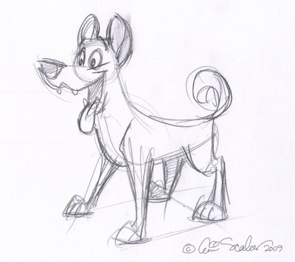
Sketches
- What is a sketch?
A sketch is a rough, quick and detailed drawing done by hand to explore the object

- Shape- the shape of an object is the space occupied by the object. Is it a cylinder, a rectangular prism, an oval or a cone? What are the different shapes that make up the machine?

- Line- used to shape the object. Links the entire object.

- Details- the features and characteristics of the object. Does the machine consist of screws, pulleys, blades etc? What are the relationships between the different parts? The more detailed the sketch the more closely it follows the object being sketched.
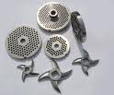
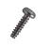
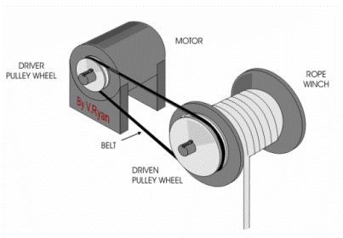

- Size- how big is the object? Estimate roughly the height, width and length of the object.

Videos
http://www.youtube.com/watch?v=SYd6kbSr1C0&feature=related
http://www.youtube.com/watch?v=G54mV91HgR0

