Nutrient rich & healthy meals

Asian pork salad

Preparation time: 20
Cooking time: 10 minutes
Serves: (2)

Ingredients | Nutrients found
Ingredients | P | C | V | M | W | L
- 1T rice vinegar
- ½ small red chilli, seeds removed, finely chopped
- 50g vermicelli rice noodles
- 2T (40ml) light soy sauce
- ½ t sesame oil
- 1 tablespoon fresh lime juice
- 50g Asian salad greens
- 50g snow peas, trimmed
- 1t pickled ginger
- ¼ red onion
- ½ yellow or red capsicum, thinly sliced
- 1 cup fresh herbs
- 200g pork, pan friend and finely sliced
- 5 rice crackers, roughly broken, to serve

Step 1
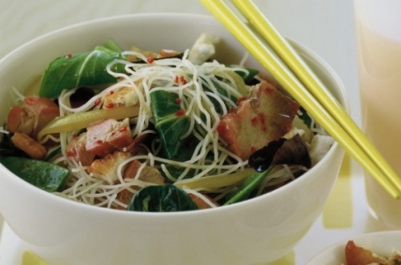
Place noodles in a bowl and cover with boiling water. Stand for 5 minutes, drain, refresh in cold water and drain again.
Step 2
Whisk vinegar, chilli, soy, oil and lime juice in a bowl.
Step 3
Combine greens and snow peas in a bowl. Combine ginger, capsicum, red onion and pork. Toss with noodles and dressing with herbs and serve with crackers.

