Healthy Foods for a Healthy Body!

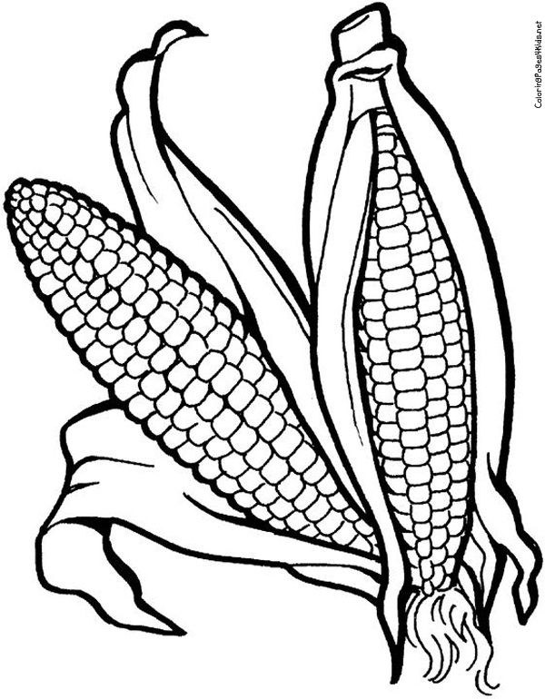
Healthy Foods for a Healthy Body!

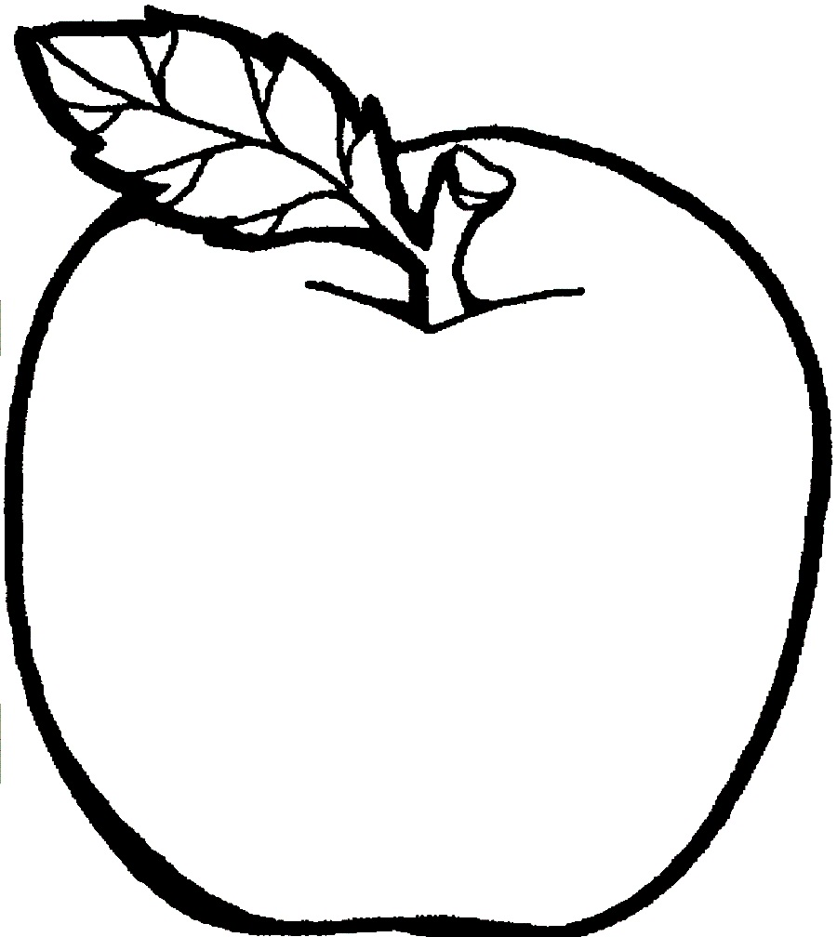

Healthy Foods for a Healthy Body!

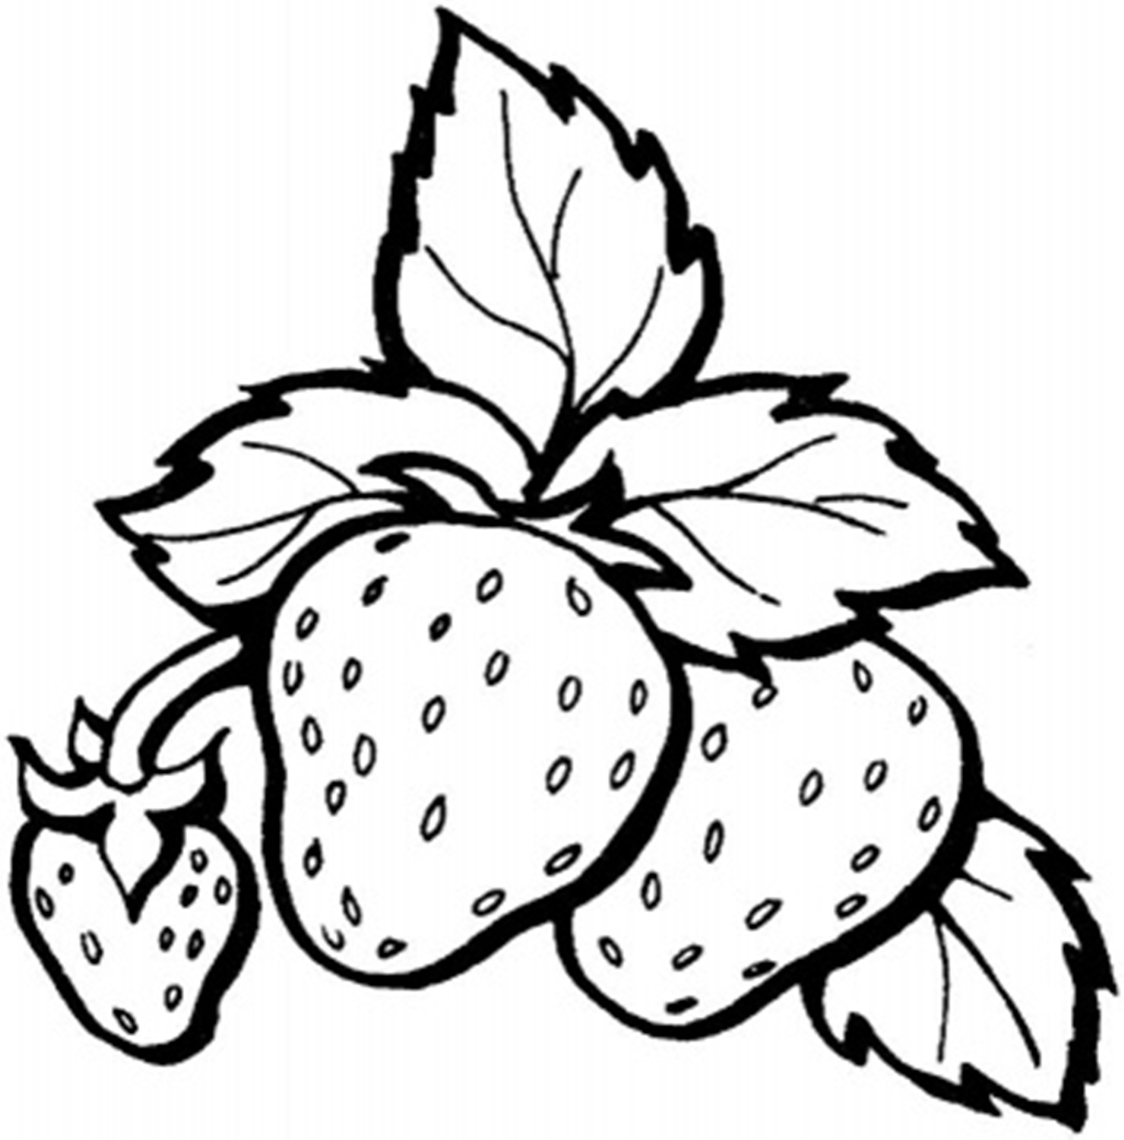


Healthy Foods for a Healthy Body!
Healthy Foods for a Healthy Body!
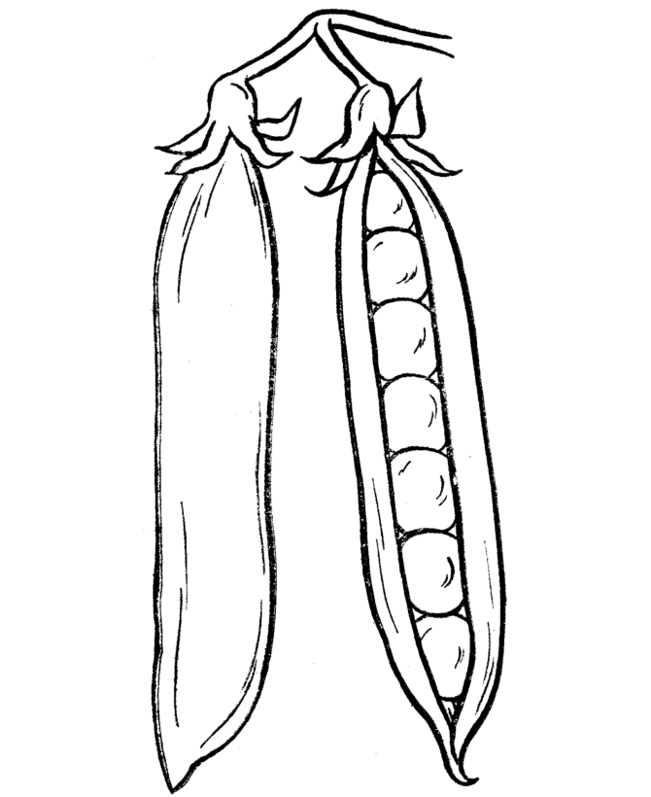

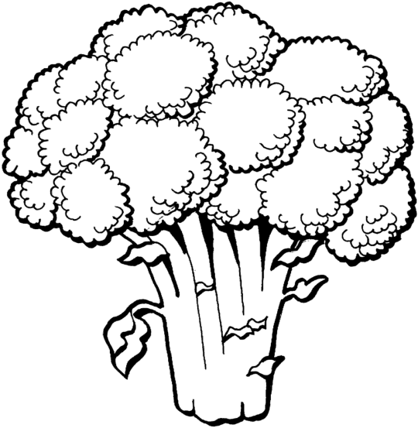
Healthy Foods for a Healthy Body!

Healthy Foods for a Healthy Body!
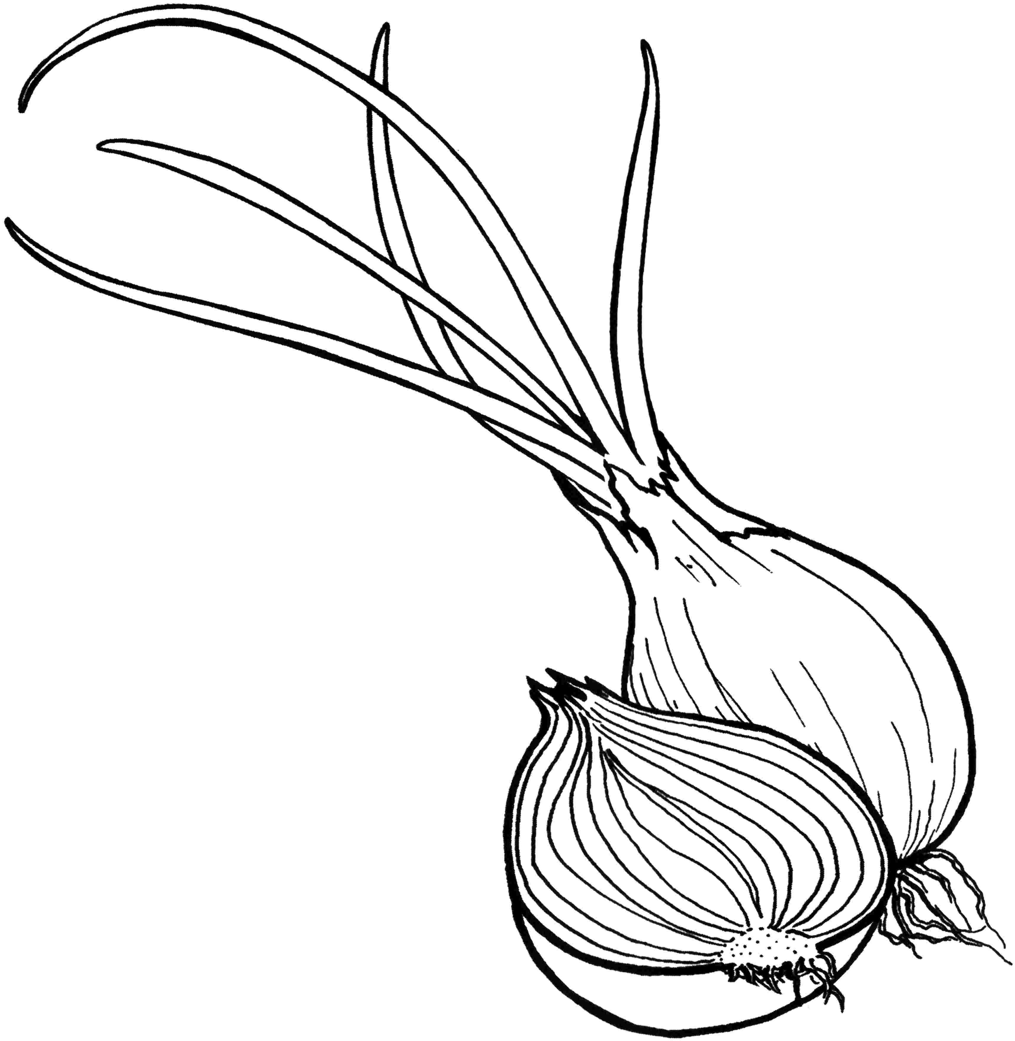

Healthy Foods for a Healthy Body!

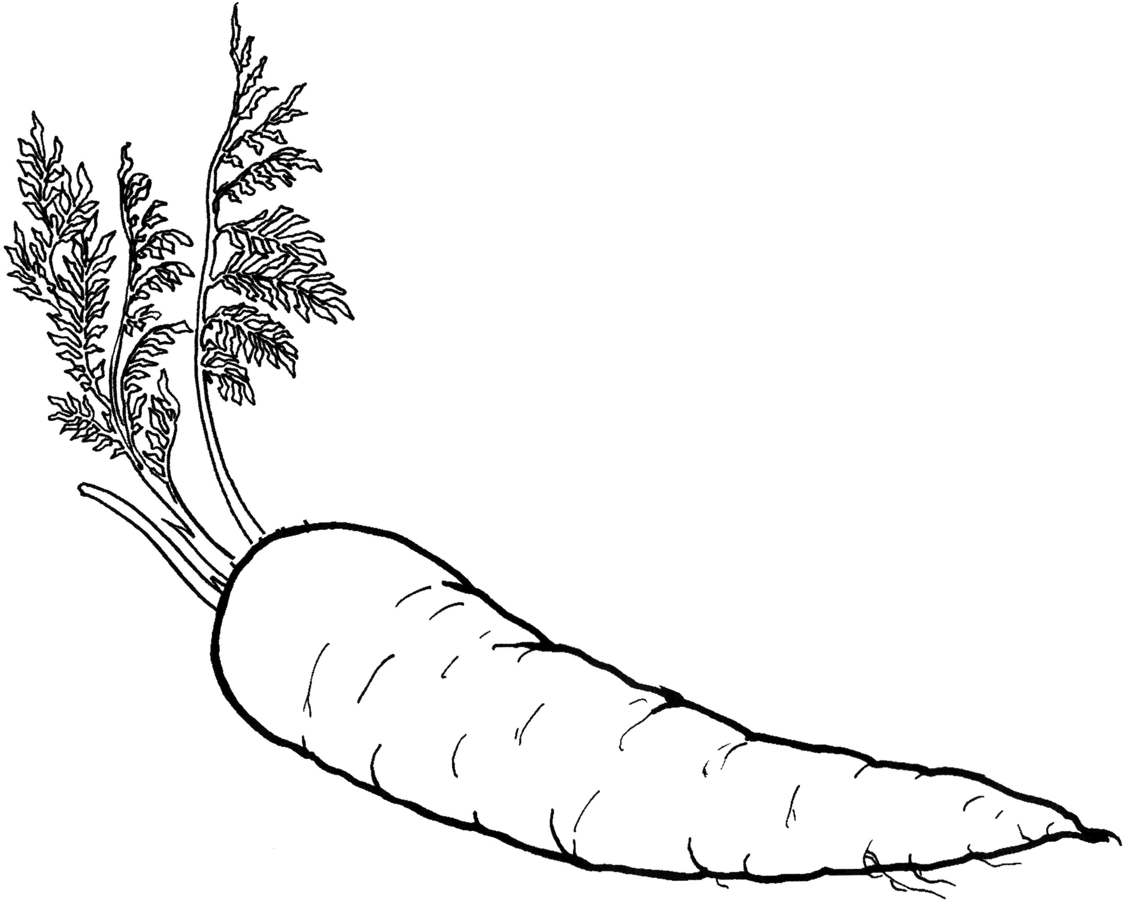
Healthy Foods for a Healthy Body!

