Vegetable Fritters
Hide heaps of veggies in these yummy fritters and watch the kids wolf them down! Make extra, and put them in the lunch box for school or work the next day.

4-8 SERVINGS
Ingredients
2 large carrots grated
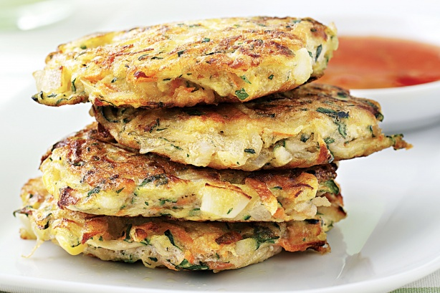
2 zucchinis grated
125g can corn kernels, drained
1 onion, chopped
1/2 cup self-raising flour
1/2 teaspoon salt
1/4 cup chopped parsley (from garden)
3 eggs
2 tablespoons olive oil

Method
Step 1
Peel carrot. Grate into a bowl. Add zucchini, corn, onion, flour, salt, parsley and eggs into a bowl. Stir to combine.

Step 2
Heat a large pan over medium heat. Add a little oil. Add 1/3 cup of the mixture and cook for 5 minutes. Cook 4 at a time. Turn and cook for a further 5-8 minutes. Repeat.

Chicken, Avocado, Tomato and

Cheese Melts
A nutritious and easy recipe for young children and adults alike!

4 SERVINGS

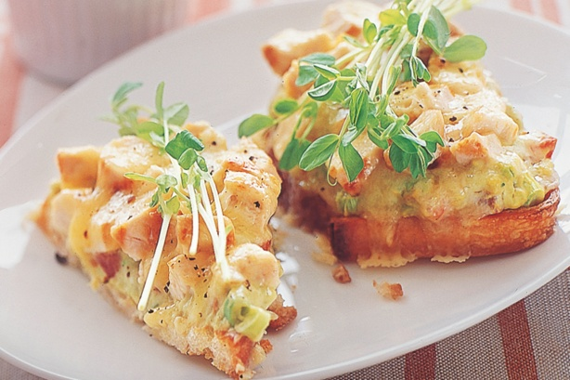
Ingredients
8 cherry tomatoes halved
1 cup shredding BBQ chicken breast
I cup tasty cheese
½ avocado diced
¼ cup chopped parsley
4 thick slices tiger bread

Method
Step 1
Combine avocado, parsley, cheese, tomatoes and chicken in a small bowl. Mix well.

Step 2
Spoon mixture evenly onto each slice of the bread

Step 3
Bake in an oven on 180◦c until cheese is melted

Banana and Strawberry smoothie
Yummy afternoon drink!

SERVES 4

Ingredients
1 large banana
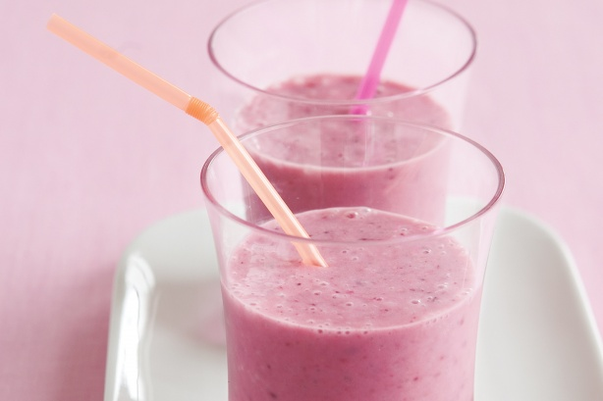
1/2 cup strawberries
2 teaspoons wheat germ
1/2 cup low-fat milk
1/2 cup low-fat strawberry yoghurt
2 teaspoons honey

Method
Step 1
Place banana, berries, wheat germ, milk, yoghurt and honey in a blender.

Step 2
Blend until smooth. Divide between 2 glasses. Serve.

