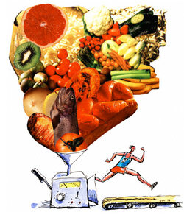
Essential Nutrients
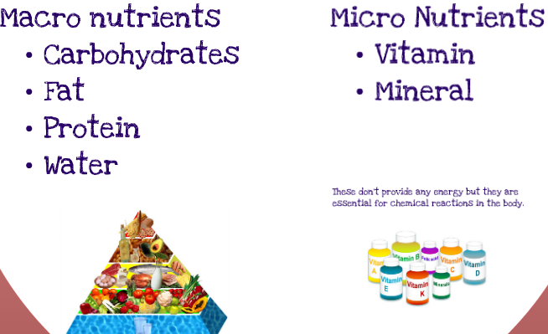

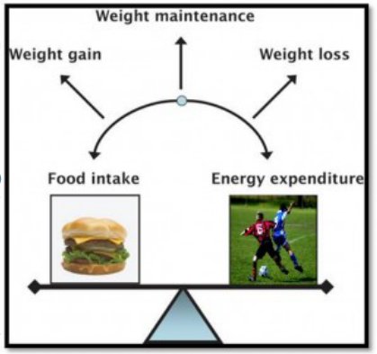




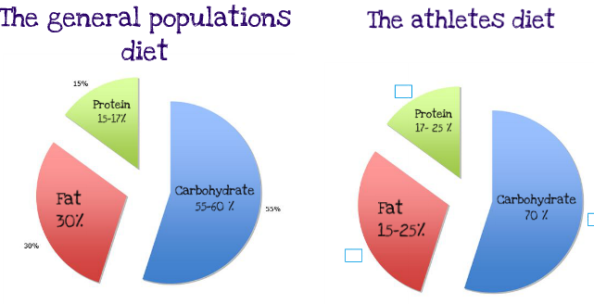

 | Energy (kJ) | Bread, cereals, rice, pasta, noodles | Vegs, Legumes | Fruits | Milk, yogurt, cheese | Meat, fish, poultry, eggs, nuts legumes | Extra foods
Adolescents  12-18 yrs | 8100 | 5-11 | 4 | 3 | 3 | 1 | 1-3
Number of daily sample serves needed to achieve a healthy diet for adolescents

Food Pyramid

