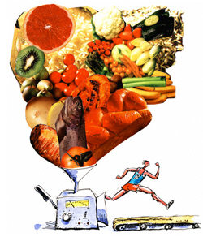
Work Sheet 1

- One gram of these nutrients provides how many kJ?

Carbohydrates ____________
Protein ________________
Fat _______________

- What is the general populations RDI for the following;

Carbohydrates_________
Protein_________
Fat_________

- What is the Athletes RDI for the following;

Carbohydrates_________
Protein_________
Fat_________

- Adam’s cereal breakfast contains 110g of CHO. How much energy does he get from CHO?

- Bruce eats a 200g packed of smiths chips that contain 67g of fat. How much energy does he get from the fat?

- During lunchtime Emma eats 150 g of boiled eggs, which contains 20 g of protein. How much energy does she get from the protein?

Food Calculation

Item | Carbohydrates | Protein | Fat
Small Curly Fries | 40g | 2g | 16g
Large Curly Fries | 81g | 2g | 31g
Hamburger | 37g | 14g | 9g
Cheeseburger | 36g | 18g | 15g
Bacon Cheeseburger | 28g | 27g | 24g

- Sydney ate two hamburgers and an order of large curly fries. How many kJ from fat did he consume? | 2. Kayla ate one bacon cheeseburger and two small orders of curly fries. How many kJ from protein did she consume?
- Amber and her family bought two cheeseburgers, one bacon cheeseburger and three large orders of curly fries. How many kJ from carbohydrates and fat were consumed? | 4. Robert consumed 2 cheeseburgers and a small curly fry. What were the total kJ for this meal?

