Team Measure
Objective | Warm up with gentle stretches – reach high and wide. Then, work together to create a human line. Measure and score points per meter for your team.
Skills | Developing body movement and body management skills:  - Muscle flexibility  - Static and dynamic balances on different body parts  - Team work
Curriculum | Performing FMS to demonstrate weight transference and expressive movements Y3/4: ACPMP043 Y5: ACPMP061  Cross Curriculum and General Capabilities: Mathematics: measurement | personal/social capability
Location | Oval
Resources | - Wool  - Measuring tape  - Score Card  - Start and finish cone markers or beanbags.

Team Measure Instructions
Objective: Work together to create a human line and measure the length
Choose a student to read activity card. Group completes the following:
- Stretch up tall, reach high
- Stand on tip-toes
- Team members line up
- One at a time, lie down, stretching to maximum length
- First person to lie down places a start marker at feet
- Stretch hands over head to FULL body length
- Next person places toes at first person’s head
- Repeat until all members have created a long line
- Last person places end marker at fingertips
- Stand up
- Measure line and record length

Part 2 (If time permits)
- Students hold hands to create a circle
- Slowly, together, step back until each student reaches maximum arms length.
- One team member leaves the circle and uses wool to outline the circumference of the circle
- Team measures circle length

Resources | Wool | measuring tape | score card | 2 cones
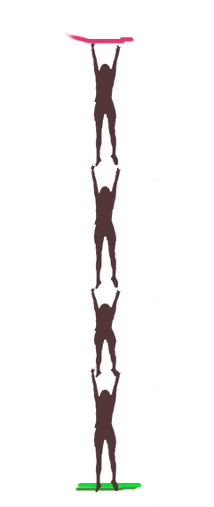
SCORE CARD
TEAM Name:
Team Line Up  Total Length ________m  Total Score ________  (1 point per meter, round to nearest meter) | Team Circle  Total Length ________m  Total Score ________  (1 point per meter, round to nearest meter) | TOTAL SCORE  _____________ Points

