Penny Picker
Objective | Off with socks and shoes! Students use their toes and careful balance to raise some “Money” for their team. Create a group circle. Place bowl into center. Scatter coins around and see how many “dollars” you can collect. (1 coin=1 point)
FMS | Previous Learning: Develop locomotor skill: static balance. Static balance can be taught by highlighting elements of balance (DET, 2000):  - Hold arms out to side or on hips  - Looking ahead (focus on something ahead)  - Relaxing  - Using objects to counterbalance  Practise and refine fundamental movement skills in different situations Y3-4 ACPMP043 Y5-6 ACPMP061.  During activity: Gross motor skills to maintain balance, fine motor skills for dexterity (coin pick-up)(Utley, 2008). Locomotor skills include:
Curriculum | Apply movement skills and strategies Y3-4 ACPMP045 | Y5-6: ACPMP063  GC: numeracy | social/personal | creative/critical thinking
Location | Oval
Resources | - Broad-rim bowl  - Collection of pennies (imitation coins are found in JP classrooms)  - Score card
Penny Picker Instructions
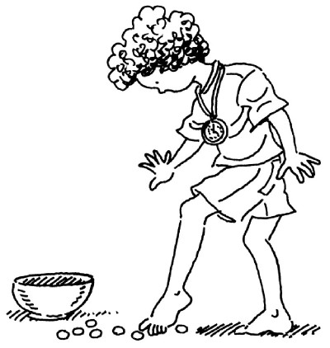 |  | Group leader chooses someone to read instructions:  Remove shoes and socks  - Create a group circle be holding hands and stepping back slowly  - Place stainless steel bowl in center  - Scatter coins around bowl  - Students collect coins using toes  - Students may hold onto a partner for stability  - Place coins into bowl  - 1 coin = 1 group point
Image from Penny Picker

