Preamble

Literary competence is integral to nurturing the broad skills and aptitudes that characterise 21st Century learners. Being literate encompasses using multimodal ways of interacting, communicating, participating and contributing effectively to society. These skills and aptitudes are outlined in the Educational Goals for Young Australians and reflected in the context and throughout the learning scope of the Australian Curriculum. Hence, the role of the 21st Century literacy educator has evolved from instructor to facilitator of new learning experiences. The New Learning pedagogy by Kalantzis and Cope proposes a transformation in the role of both teachers and students. The new learner is active and engaged in knowledge producing learning experiences and the new teacher is a purposeful designer of learning. Hence, the learning journey is marked with authentic, relevant, and engaging experiences that lead students to be independent and effective learners. Therefore, literacy education is delivered in a highly engaging environment, employing multiliteracy approaches, through various aspects of literacy pedagogies.

OVERVIEW: COMMUNICATION TECHNOLOGIES A Closer Look at the things that attract us
Year Level: Year 6 |  |  | Duration of units: 3 weeks per unit |  |  | Focus Learning Area: English
Unit Context | Background
Communication technologies [CT] have become part of everyday life. CT is used to communicate, entertain, inform, and even to function effectively within society. Although CT can be of great benefit, human dependence on CT has had many negative side effects. Many of these side affects are disguised in the addictions and attractions that young people have to CT. Recognising the dangers of CT is crucial to raising informed citizens, an aptitude of 21st Century learners. On the contrary, knowledge and discernment of effective use can support learners in becoming creative and active citizens and assist students in being effective contributors in a technological rich society. The following learning plan uses a range of literacy modes to inform students of the many aspects of communication technologies.
Unit Objectives |  |  | Broad /Transferrable Learning Objectives: |  |  | Structure of Units:
Unit 1: With a focus on receptive modes, students will understand that text structures, context, and content vary according to purpose and audience. Students will understand that texts have different purposes and how these are used to influence and inform the reader.  Unit 2: With a focus on productive modes, by the end of the unit students will create a multimedia presentation, applying their understanding of text structures, context, context, and audience. |  |  | Unit 1: Students will use multiliteracies to inform themselves of the benefits and dangers of communication technologies  Unit 2: Students will use multiliteracies to create persuasive texts in regards to one aspect (either positive or negative) of communication technologies. |  |  | Unit 1 is integrated in the daily literacy block between 9:10 am and recess (Appendix, 1). Mondays and Fridays, students participate in their routine spelling contracts followed with a formally structured literacy block. The contract has been modified to enrich the unit (Appendix, 4). The literacy block integrates subject-specific readings and literacy activities.  Unit 2 is sequential to unit 1, allowing students to apply acquired knowledge to new contexts as they create multimedia presentations to persuade others of their view. Unit 2 is highly student-driven, with teacher playing the role of learning facilitator as students interact with their learning and apply this to their own persuasive presentations.
Educational Goals for Young Australians |  |  | Knowledge Processes |  |  | Prior Knowledge | Previous Learning
Unit 1 Think deeply, logically, obtain and evaluate information. Students are able to make sense of their world (MCEETYA, 2008)  Unit 2: Successful learners: Creative and innovative, drawing on a range of learning areas and disciplines. Develop capacity to play an active role in own learning. Act with moral and ethical integrity (MCEETYA, 2008) |  |  | With a focus on students being active agents and participators of their learning, both units incorporate the skills and knowledge processes outlined in the Learning by Design model (Kalantzis & Cope, 2012). These are outlined throughout the unit program. |  |  | - Exposure to poetry forms (ACELT1617)  - Basic use and exposure to the use of communication technologies in everyday contexts  - Spelling (ongoing) - Understand how to use banks of known words, morphemes, spelling patterns etc (ACELA1525)  - Competency in use and access of digital technologies (Internet, iPads, laptop) to research information  - Work skills: ability and strategies required to work individually and within groups
General Capabilities | Cross Curriculum |  | Literacy Skills Foci |  |  | Links to Key Learning Areas |  | Future Learning | Recommendations
- Literacy  - Personal and social capabilities  - ICT capability  - Creative and critical thinking  - Intercultural understanding  - Sustainability: Actions for a more sustainability requires evaluation of scientific and technological developments based on future social impacts (OI.8, ACARAc, 2014). |  | Language: Text structure and organisation  Literature: Examining literature for structure and content  Literacy: interpreting, analysing, and evaluating  Specific content descriptions outlined within unit outline  Australian Curriculum English (ACARAb, 2014) |  |  | - English  - Mathematics: Evaluating and interpreting data representations (ACMSP147); interpreting data presented in digital media (ACMSP148)  - History: The contribution of individuals in the field of science and technology (ACHHK116)  - Science: Investigate the science of CT and how this has evolved. |  | Future learning within term 2 could include stronger focus on presentation aspects such as speaking persuasively (ACELY1710). Other learning recommendations include, Aboriginal and Torres Strait Islander perspectives: Investigate forms of communications used amongst the first Australians.
UNIT 1 - Week 1: Orientation to the unit | Analysing texts for purpose, structure, and meaning
Learning in unit 1 is delivered within the daily literacy block. See the literacy block timetable (Appendix 1) details. |  |  |  |  |  |  |  | Knowledge Processes
I Introduction | SR/V Shared Reading/Viewing | ET Explicit Teaching | GA Group Activity | PA Paired activity | IA Independent Activity | C Closing
Week 1 Objective  By the end of the week students will recognise that texts are structured and have meaning according to purpose, contexts, and audience  Australian Curriculum  (ACARAb, 2014)  Use/develop banks of words, adopting spelling strategies to recall and attempt spelling (ACELA1526)  Identify, describe, discuss similarities and differences between texts; exploring structures, voice, context, vocabulary etc. (ACELT1616)  Compare/identify and explore texts including media texts that represent ideas in different ways (ACELY1708)  Participate and contribute to discussions, clarifying, identifying, evaluating information experiences and opinions (ACELY1709) | Weekly Spelling / Contract: Monday each week – provide list words and contract (adapted for unit). Contract is designed to develop spelling through creative activities (possibly homework). Due Thursday each week. Friday each week – spelling test.  Monday: Literacy Focus (Spelling and Vocabulary Development) - I: Collaboratively brainstorm aspects of CT to determine what students know and how they perceive CT to be beneficial, dangerous, etc. SR/V: Read poem Look Up (Turk, 2014). Teacher reads first 5 paragraphs. ET: With students’ input, identify unknown/interesting words. GW: Students group into 3/4 to investigate /discuss and look up meaning IA: Students start a glossary for CT journal. Choose at least 6 words. Define. First journal entry: write a paragraph about CT using at least two new words. C: Students share most interesting words with the class.  Tuesday (Literacy Focus – Reading/Viewing for meaning) - I: Overview: meaning through images. SR/V: View/discuss images (class website). Provoke thoughtful responses. Record on EWB. Students share responses. Discuss. ET: Images viewed taught us some aspects of CT. How? What? Review paragraph writing (Teel or Hamburger). GA: Break into groups. Visit Class Website, choose two pictures. Within group, evaluate images. Record your answer. Share with class. IA: Before activity, review yesterday’s word journal and paragraph structures. Journal task 2: choose one of the pictures on the class website and write a paragraph to show what you perceive the picture to be saying. C: Question/discussion time: establish depth of engagement in viewing activity.  Wednesday (Literacy Focus – Analysing written texts) - I: How do I get informed? Looking closely at texts. SR/V: Complete a shared reading activity using article Social Networking Discuss. Use key questions to analyse nature of text. ET: Elements of text have specific genre, purpose, context, and audience. Introduce GAPS model (BBC, 2014). Record elements on EWB. Relate and identify GAPS with reading. IA: Journal task 3: read and identify the GAPS of an article from the class website’s reading page or a book you are currently reading. Record and describe as part of your journal. Extension: Visit the BBC site and complete the quiz for the GAPS model.  Thursday (Literacy Focus – Analysing multimodal texts) - I: Motivation: 4000 years of CT (Class website). Students read slides aloud to class. Discuss. Compare with GAPS. ET: Give background then read Rethinking Addiction (Watkins, 2009, ch. 6). Break down to verifying the context, content, purpose, and audience. Remind students of safe browsing. PA: Students research cyber/media safety sites. Choose one site that provides information. In pairs, take notes, examine, and extract information. Each person completes an analysis chart (appendix). Add to journal. Share findings with class. Discuss differences and validity of texts. Remind students to hand in contracts.  Friday (Literacy Focus - Speaking / sharing) - I: Students begin a mind map for unit. Students may use pen and paper or software (class website). SR/V: In small groups (randomly picked) view one of the videos selected on the class website. Compare with GAPS model. Choose a speaker to share group’s findings with class. ET: A closer look at CT; the dangers and benefits as covered in this week’s reading/activities. Discuss. Beginning with CT expound on the aspects covered in readings this week. Mind map will be added to throughout unit and submitted with journal. IA: Start mind map. C: Ask random individuals to share start of their mind maps with the class. |  |  |  |  |  |  |  | Experiencing the known and new: using everyday scenarios to introduce learners to new perspectives. 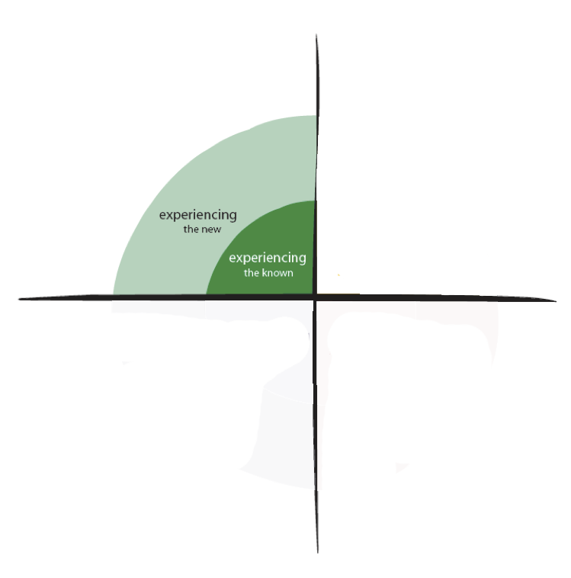
 |  |  |  |  |  |  |  |  | Identifying new rules, aspects of texts by naming concepts
Analysing functionally and critically by using the GAPS model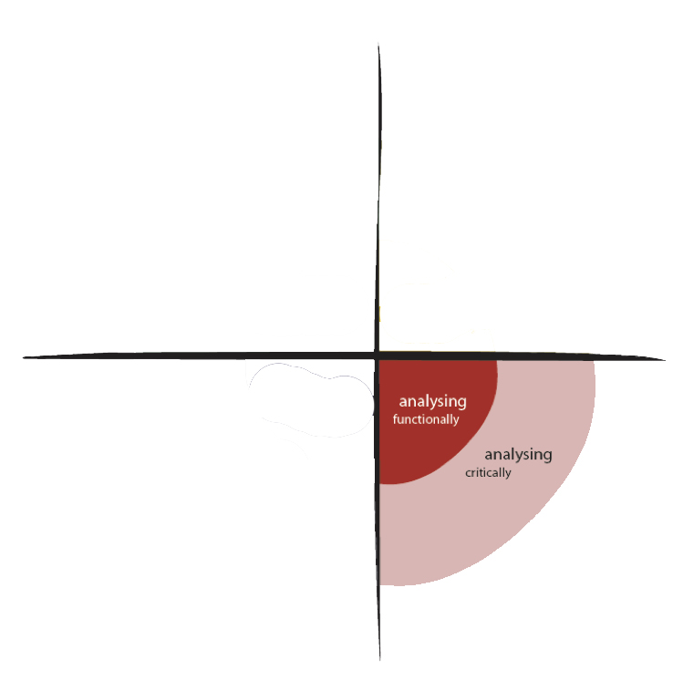

(Kalantzis & Cope, 2012)
Week 2 – Analysing language and structure of informative texts
Week 2 Objective  By the end of the week students will be apply the GAPS model to a variety of informative texts to evaluate the text structure and purpose.  Australian Curriculum  Use/develop banks of words, adopting spelling strategies to recall and attempt spelling (ACELA1526)  Identify, describe, discuss similarities and differences between texts; exploring structures, voice, context, vocabulary etc. (ACELT1616)  Identify and explain how analytical images (figures, tables etc) contribute to factual understanding (ACELA1524)  Participate and contribute to discussions, clarifying, identifying, evaluating information experiences and opinions (ACELY1709) | Monday: Literacy Focus (Spelling and Vocabulary Development) - I: Introduce topic: informative texts. Refresh GAPS strategy. SR/V: Collaboratively read Children Online. Discuss the GAPS of this reading. ET: Informative text background: Structure, language features, genre (scientific report, exposition etc). GW: Students work in groups to analyse the text structures of the article read earlier. Highlight unknown words. Look up meaning. Discuss. Share with class. Provide each student with a printed copy of Research Report (Class Website). Before individual activity, provide overview of the report in easy language and the structure of scientific reports. IA: Individually, students read article abstract only. Journal task 6: Jot down some notes on what the abstract tells you Identify unknown words. Add to your glossary. C: Students share their notes.  Tuesday (Literacy Focus – Reading/Viewing for meaning) I: A closer look at research article. Opening: View 6min of short documentary Impact of CT (Class website). Discuss documentary finding. ET: Look at figures, tables, and graphs in the article. Liken to data presented in documentary. Discuss/evaluate what these figures do for the reader. GW: In mixed ability groups, review the data in the research article. Jot notes about how these inform the reader. Each group shares with class. IA: Journal task 7: Choose one graph from the social media examiner. Write a paragraph to inform the reader of what the graph is showing. C: Share interesting findings.  Wednesday (Literacy Focus – Analysing written texts) - I: Refresh yesterday’s learning. S/V: View remaining 6min of short documentary: Impact of CT (Class website). Discuss how/what this clip informs us. ET: Closer look at research report (Continued from yesterday). Teach: I read, I think, therefore… strategy. Underline specific structural elements of scientific reports. Record on board. Students take notes. GR: Guided Reading: Extracts of the research report. (Teacher needs to determine which paragraphs to read/skip). GA: In small groups, discuss the readings. How does this text inform us? IA: As students analyse article, add new findings to your mind map. C: Explain that although scientific journals are formal and complex, they have are important. Ask students to comment, question, and suggest reasons.  Thursday (Literacy Focus – Writing with purpose) - I: Texts that inform: non-fiction. SR/V: In small groups, read: Digital Responsibility (Class website). Discuss GAPS. Each group answers the four questions on the class website. ET: With class, anslyse GAPS of the article. Identify the author’s specific language choices. IA: Journal entry 6: write one paragraph answering: If I were doing research on CT, what aspect would I research and why? Use your mind map to guide you. Refer to your glossary. Ask a peer to assess/comment. C: Complete this task tomorrow morning. Extension: Prepare a short speech highlighting how/why research in the field of CT is important.  Friday (Literacy Focus - Speaking and sharing) - I: Informing people through speaking. SR/V: Small groups: read “Face to face communication” paragraph in the research article. Discuss how CT have changed oral communication ET: Collaboratively brainstorm (EWB) the ways oral communication is used (speeches, asking, receiving, voice memos). IA: Create a concept map (Appendix) for five of the above aspects and describe skills required to be successful in this type of communication. Give students example on EWB (Appendix). C: Give students opportunity to share work. |  |  |  |  |  |  |  | Brainstorming to experience the known  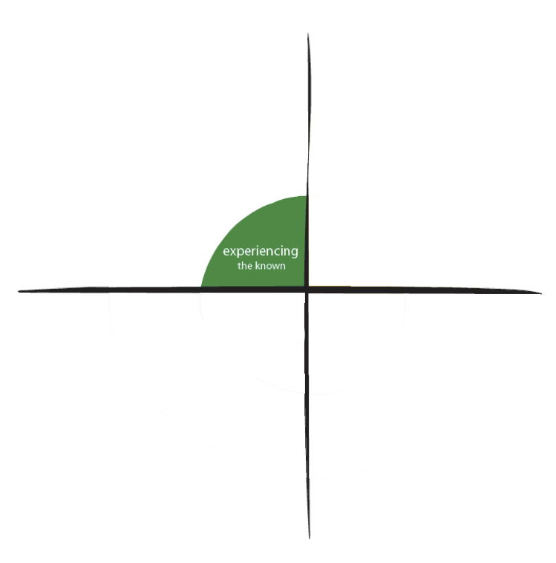
 |  |  |  |  |  |  |  |  | Analysing functionally and critically by using the GAPS model
Conceptualising by naming and theorizing by contributing to the mind map throughout the unit:
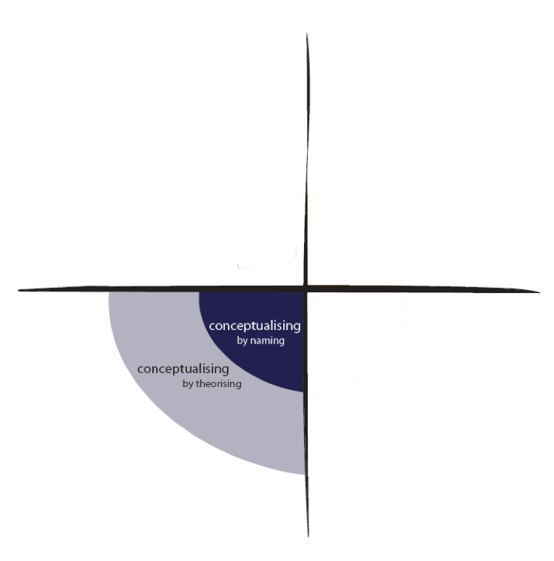

(Kalantzis & Cope, 2012)
Week 3 – Learning through others
Week 3 Objective  By the end of the week students will compare the structures and content of bio/auto biographies and opinion blogging, in contrast to research based reports covered last week.  Australian Curriculum  Use/develop banks of words, adopting spelling strategies to recall and attempt spelling (ACELA1526)  Understand the uses of objective and subjective language and bias (ACELA1517)  Participate and contribute to discussions, clarifying and interrogating ideas, sharing, evaluating information and opinions (ACELY1709)  Compare different types of texts including media texts that represent ideas in different ways (ACELY1708) | Monday: Literacy Focus (Spelling and Vocabulary Development) I: Biography/Autobiography SR: How Obama used social media. During reading, add interesting/unknown words to EWB. IW: Look up definitions and add to glossary. Add new understanding of CT to mind map. SV: Visit http://www.biography.com/ and view biography of Steve jobs and Bill Gates. ET: Discuss difference between bio/autobiography. Explain how these videos and biography/autobiographies inform us. Compare to scientific article covered last week. IA: Journal task 8: create a Venn diagram showing difference between bio/autobiography. C: Share diagrams.  Tuesday (Literacy Focus – Reading/Viewing for meaning) I: Biography structure and analysis. SR: Read and view the biography of Mark Zuckerberg (Class website). ET: Looking at the structure of biography writing (use resource read, think, write). GW: With a partner, visit the two biographies on class website. Read. Jot down notes of the most important aspects. Visit the Bio Cube interactive. Follow instructions and complete. Print and add to journal (students require one for each journal). C What did your find interesting in the biography you read?  Wednesday (Literacy Focus – Analysing written texts) I: Writing to inform – Opinion blog. SR/V: View remaining 6min of short documentary: Impact of CT (Class website). ET: Personal writing can be informative, informing the reader of your view/experiences. Eg, blogging. View Why Blog. Today students will write a short blog for the class website. Blog topic: one aspect of CT that I love. GW: Students are at desk with scrap paper. Ask students to 1). Determine the GAPS of their blog 2). I read, I think, therefore (look at mind map for guidance 3). Jot 5/6 words from your glossary that you will use within the blog. IA: Write a draft 100/150 word blog post. C: Overview of today’s learning. Complete for homework.  Thursday (Literacy Focus – Writing with purpose) – I: Closer look at blogging: View Introduction to blogging. SR/V: In small groups read article: Blogging Helps Socially Awkward Teens. ET: Analyse GAPS of the article. Discuss the author’s opinions/view and how this is demonstrated in the use of language and choice of words. GW: In partners, peer-review the draft blog post created yesterday. Are there clear connections to GAPS. Evaluate language choices. Annotate the work for suggested improvements. IA: Review the comments made on your blog and write a final copy. Submit to the class blog. C: Submit blog posts for marking and feedback.  Friday (Literacy Focus - Speaking and sharing) I: Back to start: Refresh the different types of informative texts covered in wk. 1-3. SR/V: Teacher reads (very expressively) entire poem covered in lesson 1 (Look Up by Turk, 2014). Now view poem clip. ET: Discuss how pictures/motion influence, contribute, enhance, the words. Discuss GAPS. Discuss author’s purpose and meaning of message. GW: In small groups, watch the video again. Discuss above and choose one aspect to share with the class. Think about how the pictures enhance the meaning. Share. C: Take a few minutes to add new findings to your mind map. |  |  |  |  |  |  |  | Experiencing the known and new: using everyday scenarios to introduce learners to new perspectives.
Analysing functionally and critically by:
- Comparing text types, purpose, and audience
- Mind mapping
Applying appropriately by using the conventions of blogging to create a blog post

(Kalantzis & Cope, 2012)
Resources and Teaching Strategies |  |  | Key Questions | Differentiation/Diversity/Extension |  |  | Assessment
- Daily Literacy Block timetable  - List words (Appendix)  - Spelling contract designed for unit (Appendix)  - EWB / iPads / laptops  - Access to Class Website  - Journal marking rubric (Appendix)  - GAPS Model (BBC, 2014)  - Book: Rethinking Addiction (Watkins, 2009)  - Poem: Look Up (Turk, 2014)  - GAPS concept map for analysing texts (Appendix)  - VENN Diagram Template  - Video Bill Gates Biography  - Video Steve Jobs Biography  - Mind mapping Software  Teaching Strategies  - I read, I think, Therefore (Think Literacy, p. 70)  - Biography: Writer’s Workshop (Read, Write, Think)  - Explicit Teacher Instruction  - Modeling using a range of literacy modes  - Explicit teaching of meta-language as new concepts/language is encountered (Killen, 2012) |  |  | Inferential | Open-ended | Evaluative  - How and why do I use CT in everyday life?  - Why was this text written?  - How does the purpose of the text influence you as a reader?  - Describe what this text teaches you  - Does this text change your view?  - Why do people write texts like these?  - How does the purpose of the text influence you as a reader?  - If the author was someone you know well and respected, would it change your perspective/view?  - Have you gained new knowledge or understanding from this reading/viewing? Add this to your mind map. | Weekly words/contract: Modify word list and contract according to students’ needs.  During lessons: Ensure directions are clear. Record on board if necessary. Speak up. Ask questions to clarify understanding. Students may prefer to work individually. Provide keywords to assist browsing. Allow use of ICT in journal assessment and class activities.  ESL: Students struggling with language may require specific, individual, scaffolding to complete journal task 6. Mix fluent English speakers and ESL students into groups. Teacher works individually with ESL as required.  Extension Activities: Students may choose to do further research to add to their journals. Students may interview peers regarding their use of CT, collate data, analyse, and place into graph. View and interact with CyberSmart. Use the GAPS model to analyse a book you a currently reading Draw a picture (or find one in a magazine) of someone using CT, add to journal. Find some blogs on Google. Evaluate these against the GAPS model. What do you like /not like about the blog page. |  |  | Diagnostic assessment  - To determine spelling abilities and groups for list words and contract expectations  Formative assessment  - Key and open ended questioning for deep learning  - Ensure all students participate during group activities and class discussions  - Ongoing feedback to journal entries  - Weekly spelling test and contract  Summative Assessment  Communication Technologies Journal  - Final journal will be marked using a rubric designed for the unit (Appendix). Students are given a copy to glue into their journals at the start of the unit.  - Blog post: teacher feedback

Unit 2 – Creating Texts that Persuade
Unit 2 is a continuation of the knowledge and skills acquired in unit 1. The focus here is on the development of productive skills. Unit Objective: Students will use information, knowledge, and skills acquired throughout unit 1 to create a multimedia presentation persuading others about one aspect of CT (benefits or dangers).
Curriculum Links | Learning Progression |  |  |  |  |  | Knowledge Processes
Australian Curriculum (ACARAb, 2014)  Use/develop banks of words, adopting spelling strategies to recall and attempt spelling (ACELA1526)  Create literary texts that adapt/combine aspects of texts students have experienced in innovative ways (ACELT1618)  Experiment with text structures and language feactues and their effects in creating literary texts (ACELT1800)  Plan, rehearse, deliver presentations selecting appropriate content and multimodal elements according to purpose, audience etc (ACELY1710)  Using a range of software and learning new functions to create texts and presentations (ACELY1717)  Cross Curriculum / General Capabilities  ICT Capability  Creative and critical thinking  Personal and social capabilities  Informed citizens (MCEEDYA, 2008) | Weekly Spelling / Contract: Monday each week – provide list words and contract (adapted for unit). Contract is designed to develop spelling through creative activities (possibly homework). Due Thursday each week. Spelling tested on Fridays.  Week 1: Background and Drafting: Using GAPS model and mind maps from unit 1  - Unit Introduction: provide outline/direction of learning, present multimedia rubric. Teacher shows some good quality multimedia presentations. Analyse with the class. Students work in small groups to brainstorm what makes a good presentation (images, text, sound, video clips, message/content etc). Give students marking rubric for this assessment.  - Planning the Context: (2-3 lessons). Using mind map created in unit 1, determine your position on CT. Students may choose to present a position of personal preference, opinion, or strong interest. Students may work individually or with a partner (partner is preferable). Teacher refreshes the GAPS model and how this was used to assess readings in unit 1. Students use the GAPS concept chart 2 (appendix) to plan the context of presentation. Clear links to GAPS is required before students move on. Submit for teacher feedback prior drafting.  - Planning Content: (1 lesson) In conjunction with the GAPS concept map and mind maps, brainstorm a list of arguments that support your position. Refer to readings covered in unit 1 (class website). Students create a comparison table to show both sides of their argument, highlighting which aspects they will present. Students decide on presentation mode (PowerPoint, Prezi, Empressr). Give lesson time for students to browse and experiment with different presentation software.  Week 2: Drafting and Creating  - Drafting (2-3 lessons): Teacher: refresh the writing cycle: Drafting, revising, editing, evaluating, publishing. Teacher models aspects of drafting, reminding students this is a cyclic process. Students begin draft. Using storyboard template, students begin drafting. At some stage, allow students to join with another group to exchange ideas. Remind students to use mind maps, brainstorming activity, unit glossary, and concept maps to guide the drafting process. Give students lesson expectations each day, to ensure student learning is focused. Teacher needs to be available, providing individual support as required.  - Researching (2-3 lessons). Students use resources from unit 1 (class website) to begin and extend this information through other resources from: school library, newspaper, and websites. Teacher guides students, teaching them how to evaluate resources against the GAPS model. Remind students of using multiple resources as covered in unit 1 (research, personal testimony, images, audio etc). Also, remind students to use a range of vocabulary; refer to unit glossary or list words  - Drafting (1 lesson) A closer look at word choices and language features. Review glossary from unit 1. Encourage students to incorporate topic specific vocabulary as well as sensory language. Teacher directs/explains/reminds how texts in unit 1 used explicit wording and vocabulary to convey meaning.  - Self-Editing (1 lesson): Evaluate your draft. Teacher provides evaluation criteria, explaining what students should look for. Students work individually (or with their partner) using the checklist (appendix). Based on this activity, students will create their own checklist, to evaluate a peer’s draft. Teacher needs to prepare students for this activity by guiding students to the original marking rubric, highlighting key requirements on EWB.  - Peer-Editing (1 lesson) Students collaborate with another group, exchanging their drafts for peer evaluation. Students discuss and make amendments. Teacher reminds students of protocol: sensitivity to classmates in tasks like this. Back to drafting, evaluate peer feedback and apply to draft.  Week 3/4: Creating the presentation (1 week + homework).  - Creating Students use the draft to guide each aspect of creating the presentation. Allow class discussion (beginning and end of lessons) to establish progress of each group. Remind students to use their draft and stay focused within lessons.  - Editing (1 lesson). Guide students through elements of critical assessment of their presentations. Remind students to consider specifics such as spelling, grammar, and punctuation. List these on board so students can easily self-edit. Students should also practice presenting the presentation, reading aloud to find any missing words, practice fluency, and ensure full functionality of the presentation.  - Presenting Students present to the class. Possibly do presentation at a time where parents can attend.  - Reflecting Students write a paragraph (submitted with the presentation) evaluating their presentation. Consider the marking rubric, the mind map, and concept map 2. Include a reflection of how the GAPS model, the mind map, and concept maps assisted the drafting process of the presentation. Include a reflection of what you have learned about CT. |  |  |  |  |  | Applying appropriately and creatively by transferring knowledge acquired in weeks 1-3 into a multimodal presentation  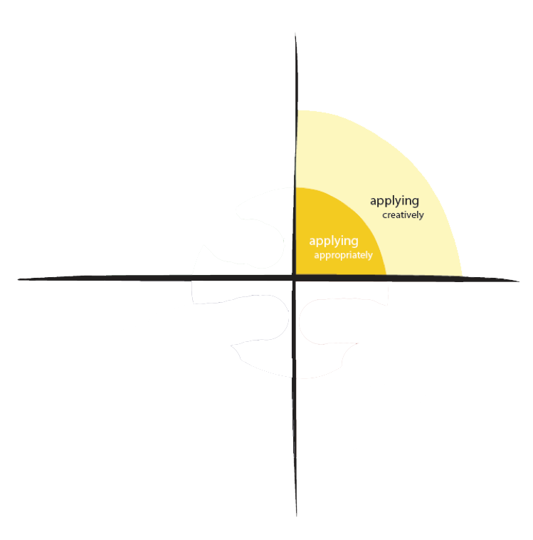
Analysing functionally using the storyboard template to create logical flow and fluency within presentations
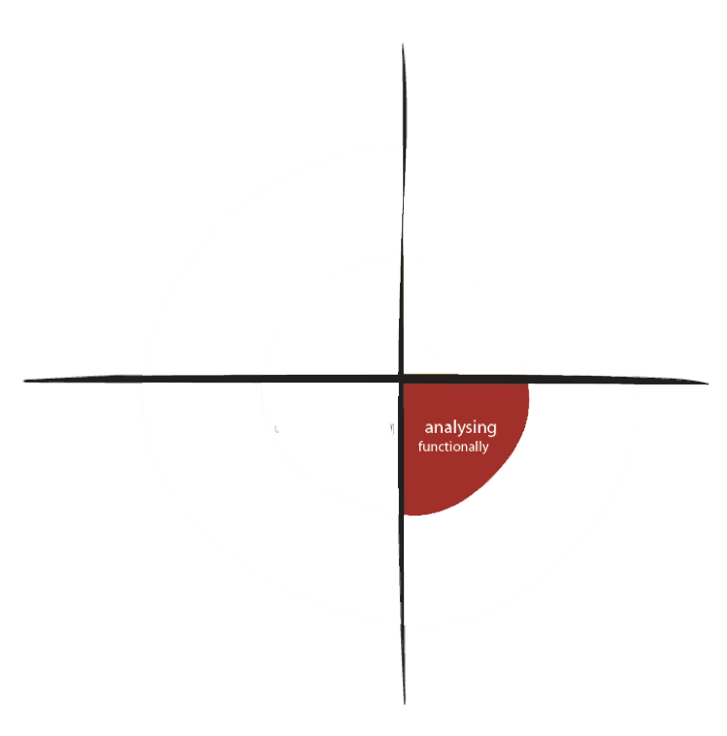
Conceptualising by naming and by theory by drawing on terms, diagrams, research, mind map and formulating an argument for presentation.

(Kalantzis & Cope, 2012)

Resources and Teaching Strategies |  |  | Key Questions | Differentiation/Diversity/Extension |  | Assessment
- List words (Appendix)  - Spelling contract for unit (Appendix)  - EWB / iPads / Laptops  - Mr Law’s PowerPoint Tutorial (TES Australia, 2014)  - Storyboard Template  - GAPS concept chart (2) for planning texts (Appendix)  - Multimedia marking rubric  - Self-assessment checklist  - Multimedia Presentation Examples  Teaching/Learning Strategies  - The Writing Process Model (Martin & Thacker, 2009)  - Questioning and self-reflection  - Modelling and explicit instruction  - Student-directed in planning, creating, assessment, and reflection of presenation. |  | - Have I identified the GAPS of my presentation?  - According to mind map, what side of CT would you like to represent? Why?  - Which presentation software are you using and why?  - How can I be more persuasive?  - What does persuasive language look like? List some strong persuasive words.  - Have I used new/interesting vocabulary covered throughout this unit?  More questions in self-assessment rubric |  |  | Differentiation: Make specific adjustments for students with learning needs according to need (eg. Adapt slide quantity expectations or mode of presentation preference).  ESL: Students struggling with language may require specific, individual, scaffolding to complete presentation. Mix fluent English speaking and ESL students as partners. Teacher works individually with ESL as required.  Extension: Encourage gifted/talented students to study their view at deeper levels. For example, present the contrasting opinion and refute their arguments using valid sources. | Diagnostic  - Determine students’ level of understanding of text structures using journal assessment from unit one. Provide extra support during this unit if needed.  Formative  - Key and open ended questioning continually throughout unit for deep learning  - Ensure all students participate during group activities and class discussions  - Ongoing feedback and guidance as students prepare presentations  - Peer and self assessment as outlined in unit  Summative  - Use the presentation marking rubric for assessment of final presentation.

Appendix

- Detailed Literacy Block
- Year 6 Australian Curriculum English overview
- Spelling list suggestions
- Weekly spelling contract

- Unit 1
  - Journal Marking Rubric
  - GAPS concept map for text analysis

- Unit 2
  - GAPS concept Map for writing analysis
  - Checklist for self-editing multimedia presentation
  - Multimedia presentation marking rubric

1. Detailed Literacy Block

LITERACY BLOCK TIMETABLE
 | Monday | Tuesday | Wednesday | Thursday | Friday
 | Spelling and vocabulary development | Reading / viewing for meaning (text comprehension) | Analysing written texts / structure and content | Writing with purpose | Speaking / Sharing  Oral literacies
9:00 | 8:50-9:10 School Flag Raising Ceremony | Introduction: Outline of daily program / learning. Refresh previous learning. | Introduction: Outline of daily program / learning. Refresh previous learning. | Introduction: Outline of daily program / learning. Refresh previous learning.  Weekly spelling contract due today. Mark and return. | 9:00-9:30  School Assembly
9:10 | Introduction: Outline of daily program / learning. Refresh previous learning. Issue spelling words and weekly contract | Shared Reading/Viewing | Teacher Guided Reading as a precursor to the explicit teaching | Shared Reading/Viewing | 9:00-9:30  School Assembly
9:30 | Shared Reading/Viewing | Explicit Teaching followed by group or paired activity. Use modeling, questioning, manipulatives, interactive as appropriate. | Explicit Teaching followed by group or paired activity. Use modeling, questioning, manipulatives, interactive as appropriate. | Explicit Teaching followed by group or paired activity. Use modeling, questioning, manipulatives, interactive as appropriate. | Weekly spelling test
9:45 | Explicit Teaching followed by group or paired activity. Use modeling, questioning, manipulatives, interactive as appropriate. | Group/paired activity  As per unit outline | Group/paired activity  As per unit outline | Group/paired activity  As per unit outline | Introduction followed by explicit teaching followed by small group discussion
10:10 | Independent Activity incorporating spelling and vocabulary development and/or weekly spelling list | Independent Activity Reading/analysis activity specific to literacy unit | Independent Activity Reading/analysis activity specific to literacy unit | Independent Activity Writing activity aligned to literacy unit | Independent/paired Activity Writing/reading or speaking activity aligned to literacy unit
10:15 Brain Food Break (5 minute maximum)
10:40 | Closing and reflection  Teacher directed. Allow students to share findings, questions, and personal reflection. | Closing and reflection  Teacher directed. Allow students to share findings, questions, and personal reflection. | Closing and reflection  Teacher directed. Allow students to share findings, questions, and personal reflection. | Closing and reflection  Teacher directed. Allow students to share findings, questions, and personal reflection. | Closing and reflection  Teacher directed. Allow students to share findings, questions, and personal reflection.
10:50 Recess
Notes: Silent reading occurs after recess/lunch several times a week. During silent reading, teacher assesses individuals for reading development, continuously recording students’ progress throughout the year. The teacher’s role during independent activity time is to provide individual scaffold and mentoring to students as needed. Times are flexible. Teacher is judicious in timing, determining transitions according to daily/activity situations.

3. Spelling List Suggestions

Words selected and adapted from:
- NSW Literacy Strategy - Spelling K-6, level 3 http://www.curriculumsupport.education.nsw.gov
- Catholic Education Spelling Bee: http://moodle.skhplism.catholic.edu.au/
- Unit readings: Class Website

Week 1 | Week 2 | Week 3
Addiction  Advancement  Announcement  Assault  Brilliant  Broadcast  Capture  Cautious  Characteristic  Circumstance  Communication  Contemporary  Disconnection  Immersed  Influence  Motivation  Satisfaction  Separates  Technologies  Technicalities | Accommodate  Awkward  Bullying  Collaboration  Consideration  Demonstrate  Elaboration  Emission  Emphasis  Evaluation  Generation  Harassment  Internet  Network  Perpetrated  Proportion  Recommend  Release  Scientific  Scientist | Autobiography  Biography  Competitor  Confident  Consideration  Constitution  Contribute  Cooperation  Creator  Criticism  Definitely  Engineer  Enterprise  Frequently  Pioneer  Potential  Research  Replicate  Reproduce  Society
Week 4 | Week 5 | Week 6
Contribution  Corruption  Encyclopedia  Environment  Exception  Excerpt  Experiment  Exploit  Foundation  Fundamental  Generate  Genuine  Headquarters  Necessarily  Percentage  Perspective  Successful | Abilities  Aspire  Compel  Conspire  Convert  Enterprise  Examined  Expel  Extensive  Identify  Multitasking  Multimedia  Organize  Recognise  Revert  Transcribe  Transmit | Anonymity  Behaviours  Consequences  Consuming  Concurrently  Focused  Forceful  Functioning  Fundamental  Judgment  Persuasive  Preparation  Presentation  Presenter  Technology  Tremendous  Unscrupulous

4. Weekly Spelling Contract

Level A - 1 POINT | Level B – 2 POINTS | Level C – 3 POINTS | Level 4 – 4 POINTS | Level 5 – 5 POINTS | Level 6 – 8 Points
A1: Write out your list words in different fonts. | B1: Use 3 or more of your words in one sentence. | C1: Create an acrostic poem for one of your list words. | D1: Create a word search using your words | E1: Use a dictionary to find the meanings of 6 of your most challenging words. | F1: You are a teacher, giving your students a spelling test. Write 5 dictation sentences for 5 of your list words.
A2: Write out your list words from least amount of letters to most amount of letters. | B2: Use scrabble tiles to work out the sum of each of your words. | C2: Create an alphabet code. Write 5 of your letters in your newly developed code. | D2: Place your words into a table, grouping the words according to how many letters they have. | E2: Place your list words into groups. Explain how you grouped them. | F2: Put your words onto a scale from easiest to spell – hardest to spell. Why did you order them that way?
A3: Write your words in alphabetical order | B3: Choose 5 words and draw a picture for each one. | C3: Create a crossword using your list words. | D3: Choose three spelling words. Using those letters to see how many other words can you make? | E3: Create a cartoon that has at least 4 boxes. Write a caption under each image that includes a list word. | F3: Create an artwork using only your list words.
A4: Write a word tree for 5 of your words. | B4: Complete a spelling activity on www.spellingcity.com | C4: Create three jokes using your list words. | D4: Find a synonym or antonym for each of your list words. | E4: Write a conversation between two people that uses ten of your list words. | F4: Choose any activity from the grid and complete it. Explain why it has helped you learn your words to score the full 6 points.
A5: Clap and record the syllables in each of your list words. | B5: Choose 5 words from your list. Give your partner a comprehensive explanation of their definition. | C5: Create a tongue twister using the sound of the week. | D5: Find and record words that rhyme with your list words. | E5: Write a song using your list words. | F5: Create a hand-clapping chant with a partner and say your list words. Show the teacher.
A6: Rewrite your list words, adding an ending to each word to make it plural or to change its tense. | B6: Ask your parents to test you on your words for homework. | C6: Type out and print your words. Cut them into parts that help you use them. Glue them into your spelling book. | D6: Jumble up your words. Have a partner un-jumble them. | E6: Create a new spelling activity to help others learn their words. | F6: Use ten of your spelling words to write a paragraph. Write these words incorrectly and have a partner correct the misspelt words.
A7: Group your words into two lists: words that you find hard and easy. | B7: Complete a look, say, cover, write, check for homework. | C7: Choose 5 words that you have trouble with. Write them out 5 times each. | D7: Create a word ladder using all of your list words. | E7: Organise your words in reverse alphabetical order.  Z – A. | F7: Use your list words to write a story. Underline the list words in red. BONUS 5 points if you manage to use all your words.
Downloaded and adapted from www.australiancurriculumlessons.com.au You’re Welcome!
5a. UNIT 1: Journal Marking Rubric
(Distribute to students at commencement of unit 1)

Journal Task 1 – Paragraph of Communication Technologies
- In response to daily reading: Look Up (Turk, 2014) write a paragraph summarising your opinion of communication technologies. Do you agree with the author of Look Up? Why or why not?
Poor (0-4) | Good (5-6) | Exceptional (6-10) | Teacher Comments
The task was not submitted. Work was rushed and incomplete. | All aspects were submitted and correct. Your paragraph showed engagement in the reading. You used at least two of the new words explored in the lesson. | An exceptional paragraph. Your paragraph was comprehensive. It was evident you understood the reading, and reflected deeply on the content.
Journal Task 2 – Viewing and Interpreting
- View at least one of the pictures on the class website. Analyse the image and discuss what message it conveys to you, the viewer.
Poor (0-4) | Good (5-6) | Exceptional (6-10) | Teacher Comments
The task was not submitted. Work is rushed and/or incomplete. | All aspects were submitted and correct. Your paragraph showed engagement in the viewing. You used at new words explored in the unit correctly and creatively. | An exceptional paragraph. Your paragraph was comprehensive. It was evident you understood the viewing and drew some through-provoking responses from the images..
Journal Task 3 – Using the GAPS model to analyse informative texts
- Analyse the given text. Identify basic structure using the GAPS: Genre, Audience, Purpose, and Structure.
Poor (0-4) | Good (5-6) | Exceptional (6-10) | Teacher Comments
The task was not submitted. Work is rushed and/or incomplete. | You have completed the activity, showing your understanding of the genre, audience, purpose and structure of the given text. | A very detailed description of each of the GAPS elements. You have also included additional information. Well done.
Journal Task 4– Using the GAPS to complete a concept map
- Using the GAPS concept map, analyse the text provided during the lesson. Identify the genre, audience, purpose, and structures. Add the map to your journal.
Poor (0-4) | Good (5-6) | Exceptional (6-10) | Teacher Comments
The task was not submitted. Work is rushed and/or incomplete. | You have completed the activity, showing your understanding of the genre, audience, purpose and structure of the given text. | An exceptional concept map, showing detail of the genre, audience, purpose, and structure of the given text.
Journal Task 5 – Mind Mapping
- Using readings, viewings, activities, and experiences in this unit, create a mind map that explores the many aspects of communication technologies
Poor (0-4) | Good (5-6) | Exceptional (6-10) | Teacher Comments
The task was not submitted. Work is rushed and/or incomplete. | Your mind map is detailed. It is evident that you have recorded new findings / understanding / knowledge through engaging in the unit readings. Well done. | An exceptional mind map. Very detailed. It is evident that you have recorded new findings / understanding / knowledge through engaging in the unit readings and elaborated on these. Well done.
Journal Task 6 – Research Article Notes
- Using the research article provided through modelled, shared, and independent reading times, note key points and findings that are evident in the article.
Poor (0-4) | Good (5-6) | Exceptional (6-10) | Teacher Comments
The task was not submitted. Work is rushed and/or incomplete. | Your notes show that you have identified some important elements in this complicated research paper. Well done. | Your notes show that you have identified and comprehended several important elements presented in this research article. Fantastic.
Journal Task 7– Analysing Data from Research Article
- Using the research article provided, elaborate on the purpose, function, and importance of graphic data representation as it appears in this article.
Poor (0-4) | Good (5-6) | Exceptional (6-10) | Teacher Comments
The task was not submitted. Work is rushed and/or incomplete. | Your outline shows that you understand the importance of graphic representations in texts. | Your outline shows that you understand the value of graphic representation in texts. You have identified how and why this is important.
Journal Task 8– Venn Diagram
- Use the VENN Diagram template provided to show the differences and similarities between biographies and autobiographies
Poor (0-4) | Good (5-6) | Exceptional (6-10) | Teacher Comments
The task was not submitted. Work is rushed and/or incomplete. | An accurate description of the differences and similarities between biographies and autobiographies | An accurate and detailed description of the differences and similarities between biographies and autobiographies
Journal Task 9 –The BioCube
- Use the interactive bio-cube (accessed through class website) to progress through the structure and stages of biography writing. When completed, print, colour and add to the journal.
Poor (0-4) | Good (5-6) | Exceptional (6-10) | Teacher Comments
The task was not submitted. Work is rushed and/or incomplete. | You have followed the structure of biography writing as outlined in the lesson and interactive. A well presented bio cube. Well done. | You have followed the structure of biography writing as outlined in the lesson and interactive. You have added detail beyond the interactive requirements. A well presented bio cube. Fantastic!
Journal Task 10 – Blog Post
- Use the GAPS model to analyse blogging. Create a blog on the class blog page on the given topic: One aspect of Communication Technologies that I love. After self and peer editing, post your blog on the class website for teacher assessment. Use terminology from your journal glossary.
Poor (0-4) | Good (5-6) | Exceptional (6-10) | Teacher Comments
The task was not submitted. Work is rushed and/or incomplete. | Your blog demonstrates understanding of the GAPS model. It is evident that you have self and peer assessed for clarity, spelling and grammar. You have incorporated interesting words discovered in this unit. Well done. | Exceptional blog! Your blog demonstrates understanding of the GAPS model. It is evident that you have self and peer assessed for clarity, spelling and grammar. You have incorporated interesting words and elaborated on the ideas/readings discovered in this unit.

5b. UNIT 1: GAPS Concept Map for Text Analysis
Created by Miriam Jaeger in reference to GAPS Model (BBC, 2014)

Who does this text target?
How is this text written?
What is the text for? Why?
What type of text is this?
GENRE

PURPOSE
STYLE
AUDIENCE
TEXT:
_______________
WWW: _______________

6a. UNIT 2: GAPS Concept Map for Text Analysis
Created by Miriam Jaeger in reference to GAPS Model (BBC, 2014)

GENRE

AUDIENCE
PURPOSE
STYLE
My Presentation
Who will my watch, listen, or view my presentation? What sort of things do they need to hear?
What will my writing style and presentation look like?
What am I trying to achieve by writing this text and creating this presentation for?
How will I write my text and present my information?

6b. UNIT 2: Checklist for Self-Editing Writing
Created by Miriam Jaeger

Students use this checklist for self and peer assessment.
 | It’s Ok | It’s Good | It’s Great! | Comments
GAPS
The genre of my text is clear
I have identified the audience of my text
The purpose of my text is clear.
My writing style is consistent with the genre, audience, and purpose of my text
I have checked my writing for:
Missing words
Punctuation
Spelling errors
My writing makes sense

6c. UNIT 2: Multimedia Presentation Marking Rubric
Retrieved from: Kathy Schrock’s Rubrics Page

