 | SPECIFIC LEARNING OUTCOMES | ACTIVITY  (Shape + method) | Teaching Focus  (cues or questions) | CLASS ORGANIZATION (Shape) | TIME
I  N  T  R  O  D  U  C  T  I  O  N | - List rules for lesson and point out boundaries. | Introduction  - Revise the safety and respect rule  - What did we learn last week?  Split students into 4 groups | - Whistle Use  - Cues of dribbling  - Shooting and moving around are key for today’s lesson | T  T | 5 mins
I  N  T  R  O  D  U  C  T  I  O  N | - Demonstrate good defensive positioning and game sense | Individual rebound  Within the 4 groups  Lay-up And Rebounding Lines  - layers make two lines. The lay-up line is well outside the three point line towards the sideline. The rebound line is on the opposite side of the court at about the three point line. The first person in the lay-up line has a ball.  - Players in lay-up line make hard drives to the basket for a lay-up.  - Rebounder moves to basket anticipating rebound and takes strong rebound.  - Player who took lay-up moves to end of rebound line.  - Rebounder takes two strong dribbles out, make a good pass to next player in lay-up line and then move to the end of the lay-up line.  Variations:  1. Swap sides of court.  2. Increase number of balls (up to as many as number of players  will allow).  3. Vary type of lay-up (e.g. reverse, two-foot stop into power lay-  up etc.)  http://www.youtube.com/watch?v=dMK9irj5lYg | Jump up high  Catch with two hands  Wide land  Pivot and pass  Correct lay-up form.  Make it a hard drive to basket (game speed).  Ball does not hit floor on the rebound.  Strong rebound, protects ball, strong dribble, hard pass.  Receiver to receive the ball running to the basket, not standing | 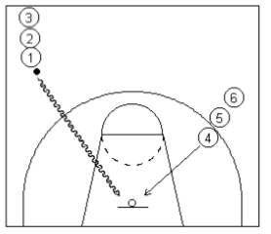
I  N  T  R  O  D  U  C  T  I  O  N |  | Offensive play  Demonstrate with students walking, process speed and add defender  Triangle formation  Player 1 (point) passes to player 2, player one runs to cones, and moves to wing left, player 3 moves to point. Player 3 passes to player 1 to left wing a revers the process. |  | 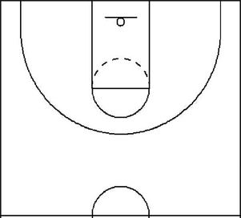
 | Students will demonstrate game sense, applying tactics in attack and defence. | 3 v 3 or 4 v 4 Half court game play  Defenders clear the ball to halfway and then become attackers  -No contact- arms distance when defending.  -Personal fouls, barging/blocking.  -double pts for scoring from a rebound  Double points if they perform the offensive play and score | Defenders: set up zone defence, move around towards the ball, call who you have.  Attackers: try and use back door, give and go, fake and shoot.  Patience , move with and without the ball. | 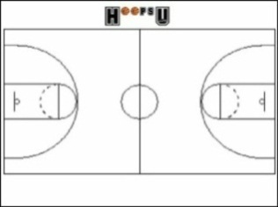 | 15 mina
C  L  O  S  U  R  E | - Students can list things learnt from the session  - Enthusiastic for next weeks activities. | Pack up  - Students put balls away for next group  - Congratulate on session, point out positives  - Back to meeting place | Which activity did you enjoy the most?  Why is communication so important in a game?  What are the 2 types of communication? | X X  T | 5 mins  (10.21-10.26)

Lesson Plan Pro forma (Health & Physical Education)

NAME: |  | TIME: | 9:15-10:26 am  (60 minutes) |  | DATE:
ACTIVITY: | Basketball | CLASS / YEAR |  | year 10
EQUIPMENT: | Flat markers, 6x basketballs, 15x Bibs, whistle.

Learning area: Health & Physical Education Band: Middle Years
Strand: Physical Activity and Participation Strand: Personal & Social Development
Key Idea (.1) (.5)
Students will participate in a variety of problem based tasks & games to improve personal competence in aspects skilful play, build self confidence and teamwork. Students will adopt various roles, take responsibility for safe, fair participation and collaborate with others in an enjoyable active setting.
Essential learnings:  - Futures  - Identity  - Interdependence  Thinking  Communication | Key Competencies  KC1: collecting, analysing, organising  KC2: communicating ideas and info  KC3: planning & organising activities  KC4: working with others in teams  KC5: using mathematical ideas  KC6: solving problems  KC7: using technology |  | Equity Perspectives  - Aboriginal & Torres Strait Islander  - Multicultural   Gender  - Socio economic  - Disabilities  - Rural and Isolated
Student learning Outcomes:  Evidence of learning …. The students will |  | Teacher outcomes:  The teacher will:
Cognitive & Physical (‘skilful’ play)  - Identify primary rules of activities to increase levels of enjoyment  - Apply bare bones of dribbling and shooting in effective play.  - Demonstrate game sense through tactics and effective passing and receiving.  Personal Responsibility  - Incorporate primary rules into working effectively with teammates (game sense)  Social  - Work cooperatively in team games and have fun. |  | - Ensure a safe and inclusive learning environment for all students.  - Become involved in games and get students motivated to participate.  - Give relevant and constructive feedback consistently.

