 | SPECIFIC LEARNING OUTCOMES | ACTIVITY | Teaching Focus | CLASS ORGANIZATION | TIME
I  N  T  R  O  D  U  C  T  I  O  N | - Students will recall group norms | Introduction  Welcome students positively  Recall previous lessons objectives  Inform them of the days objectives  Defence is main focus for todays session | Be at meeting point before children  Stay close to partner  Use both hands | T  X X X X X X | 5 mins.  (2.00-2.05)
I  N  T  R  O  D  U  C  T  I  O  N | - Demonstrate visual scanning and agility to keep running towards the cones | Dibble tag  There will be 2 students with the ball, they must dribble and tag the other students | Keep your up high  Make sure your scanning | 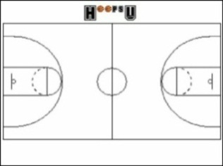
D  E  V  E  L  O  P  M  E  N  T | Students will demonstrate game sense, applying tactics in attack and defence. | 3 v 3 or 4 v 4 Half court game play  Defenders clear the ball to halfway and then become attackers  -No contact- arms distance when defending.  -Personal fouls, barging/blocking. | Defenders: set up zone defence, move around towards the ball, call who you have.  Attackers: try and use back door, give and go, fake and shoot.  Patience , move with and without the ball.
D  E  V  E  L  O  P  M  E  N  T | - Demonstrate good defensive positioning and game sense  - Demonstrate agility while dribbling to move to space | 4v4 tournament  Divide students into 4 groups of 5  5 min games  Rules:  - No contact  - Every one has to touch the ball before scoring  - 3 pts for scoring  - 1 pt for hitting the board  - 1 pt for communication | - Students demonstrate game sense through passing and receiving.  - Defending students read the play by picking opportunities to intercept.  - Applying agility in a game situation. | 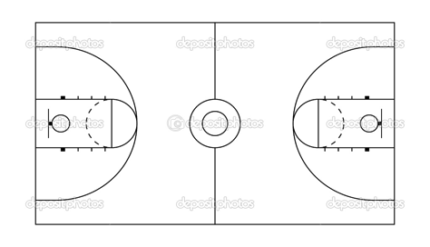 | 16 mins.  (9.03-9.19)
C
L
O
S
U
R
E

C  L  O  S  U  R  E | - Provide specific feedback to enhance students techniques and elements of skilful play for future lessons | Debrief/Pack Up  - Congratulate students on successful beginning to basketball  - Give enthusiastic and positive feedback to any questions or queries | Debrief/Pack Up  - What students thought worked well; what you thought worked well | T  X X X X X X | 5 mins.  (9.40-9.45)

Lesson Plan Pro forma (Health & Physical Education)

NAME: |  | TIME: | 9:15-10.25pm  (40 minutes) |  | DATE:
ACTIVITY: | Basketball | CLASS / YEAR |  | Year 10
EQUIPMENT: | Flat markers, basketballs, Bibs, whistle.

Learning area: Health & Physical Education Band: Middle Years
Strand: Physical Activity and Participation Strand: Personal & Social Development
Key Idea (.1) (.5)
Students will participate in a variety of problem based tasks & games to improve personal competence in aspects skilful play, build self confidence and teamwork. Students will adopt various roles, take responsibility for safe, fair participation and collaborate with others in an enjoyable active setting.
Essential learnings:  - Futures  - Identity  - Interdependence  Thinking  Communication | Key Competencies  KC1: collecting, analysing, organising  KC2: communicating ideas and info  KC3: planning & organising activities  KC4: working with others in teams  KC5: using mathematical ideas  KC6: solving problems  KC7: using technology |  | Equity Perspectives  - Aboriginal & Torres Strait Islander  - Multicultural   Gender  - Socio economic  - Disabilities  - Rural and Isolated
Student learning Outcomes:  Evidence of learning …. The students will |  | Teacher outcomes:  The teacher will:
Cognitive & Physical (‘skilful’ play)  - Identify primary rules of activities to increase levels of enjoyment  - Apply bare bones of dribbling and shooting in effective play.  Personal Responsibility  - Incorporate primary rules into working effectively with teammates (game sense)  Social  - Work cooperatively in team games |  | - Ensure a safe and inclusive learning environment for all students.  - Demonstrate thoughtful positioning so that all students are in view  - Give relevant and constructive feedback where necessary.  - Have a louder voice more constantly throughout the whole lesson.

