 | SPECIFIC LEARNING OUTCOMES | ACTIVITY  (Shape + method) | Teaching Focus  (cues or questions) | CLASS ORGANIZATION (Shape) | TIME
I  N  T  R  O  D  U  C  T  I  O  N | - List rules for lesson and point out boundaries.  - Demonstrate visual scanning and agility to keep running towards the cones | Introduction  - Revise the safety and respect rule  - What did we learn last week?  Touch the line  - Students spread out on the side line  - They must jog to the first cone and run back | - Whistle Use  - Cues of dribbling  - Shooting and moving around are key for today’s lesson | T  T | 5 mins
I  N  T  R  O  D  U  C  T  I  O  N | - Demonstrate good defensive positioning and game sense | One on One Defense Full Court  One player dribbles the ball while the other player defends the ball | Defence  Heads up high looking at your partner | 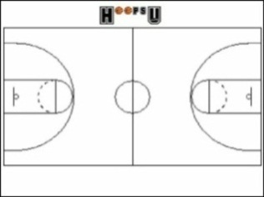
 | Students will demonstrate understanding and ability to set up fast break in attack. | 3 v 2 continuous defensive transition  ‘fastest with mostest’  Want to get players into attack quickly  - Teams of 3, two teams start at each end. Always return to the same end.  - Attack- one shot only, then quickly back to defend.  Two defenders only | When did fast break option arise?  Quickly transition from attackers to defenders to get back and defend.  What can you do to create a fast break? | 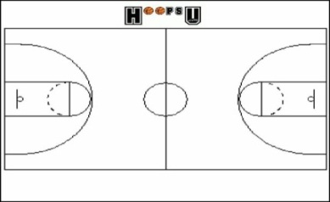  Play across whole court end to end. | 7 mins
 | - Demonstrate good defensive positioning and game sense  - Demonstrate agility while dribbling to move to space | 4v4 tournament  Divide students into 4 groups of 5  5 min games  Rules:  - No contact  - Every one has to touch the ball before scoring  - 3 pts for scoring  - 1 pt for hitting the board  - 1 pt for communication | - Students demonstrate game sense through passing and receiving.  - Defending students read the play by picking opportunities to intercept.  - Applying agility in a game situation. | 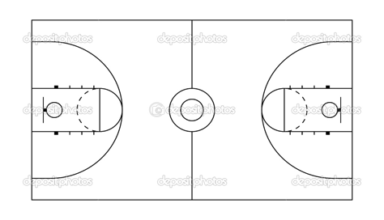 | 7 mins
 | Students will demonstrate game sense, applying tactics in attack and defence. | 3 v 3 or 4 v 4 Half court game play  Defenders clear the ball to halfway and then become attackers  -No contact- arms distance when defending.  -Personal fouls, barging/blocking. | Defenders: set up zone defence, move around towards the ball, call who you have.  Attackers: try and use back door, give and go, fake and shoot.  Patience , move with and without the ball. |  | 15 mina
C  L  O  S  U  R  E | - Students can list things learnt from the session  - Enthusiastic for next weeks activities. | Pack up  - Students put balls away for next group  - Congratulate on session, point out positives  - Back to meeting place | Which activity did you enjoy the most?  Why is communication so important in a game?  What are the 2 types of communication? | X X  T | 5 mins  (10.21-10.26)

Lesson Plan Pro forma (Health & Physical Education)

NAME: |  | TIME: | 9:15-10:26 am  (60 minutes) |  | DATE:
ACTIVITY: | Basketball | CLASS / YEAR |  | year 10
EQUIPMENT: | Flat markers, 6x basketballs, 15x Bibs, whistle.

Learning area: Health & Physical Education Band: Middle Years
Strand: Physical Activity and Participation Strand: Personal & Social Development
Key Idea (.1) (.5)
Students will participate in a variety of problem based tasks & games to improve personal competence in aspects skilful play, build self confidence and teamwork. Students will adopt various roles, take responsibility for safe, fair participation and collaborate with others in an enjoyable active setting.
Essential learnings:  - Futures  - Identity  - Interdependence  Thinking  Communication | Key Competencies  KC1: collecting, analysing, organising  KC2: communicating ideas and info  KC3: planning & organising activities  KC4: working with others in teams  KC5: using mathematical ideas  KC6: solving problems  KC7: using technology |  | Equity Perspectives  - Aboriginal & Torres Strait Islander  - Multicultural   Gender  - Socio economic  - Disabilities  - Rural and Isolated
Student learning Outcomes:  Evidence of learning …. The students will |  | Teacher outcomes:  The teacher will:
Cognitive & Physical (‘skilful’ play)  - Identify primary rules of activities to increase levels of enjoyment  - Apply bare bones of dribbling and shooting in effective play.  - Demonstrate game sense through tactics and effective passing and receiving.  Personal Responsibility  - Incorporate primary rules into working effectively with teammates (game sense)  Social  - Work cooperatively in team games and have fun. |  | - Ensure a safe and inclusive learning environment for all students.  - Become involved in games and get students motivated to participate.  - Give relevant and constructive feedback consistently.

