 | SPECIFIC LEARNING OUTCOMES | ACTIVITY (shape) | focus  TEACHING POINTS  (cues or questions) | CLASS ORGANIZATION (shape) | TIME
I  N  T  R  O  D  U  C  T  I  O  N | - Students will walk in a quick and orderly fashion from the meeting area to the basketball court.  - Students will recall group norms  - Demonstrate visual scanning and agility to keep running towards the cones  - Have fun and work positively with peers  - Demonstrate agility while dribbling to move to space  - Demonstrate good defensive positioning and game sense  - Demonstrate passing and receiving  - Promote a positive and safe environment for all  - Demonstrate passing and receiving and apply an understanding of depth and width  - Have fun and work positively with peers  - Develop shooting technique and following a shot to rebound  - Develop communication skills to work as part of a team  - Work co-operatively to achieve success as a team  - Demonstrate reading the play and game sense by moving to supporting positions  - Apply rules understanding of no double dribble and no travelling rules  - Have fun with the element of competition and use positive supporting encouragement to peers/team  - Demonstrate the ability to shoot while under pressure in a game context  - Demonstrate elements of skilful play including passing and receiving, visual scan, agility, and reading the play  - Students will display their current knowledge of the rules of basketball  - Reflect on key learning’s of the lesson  - Understand how far they have come | Welcome/intro  - Welcome students positively  - Recall previous lessons objectives  - Inform them of the days objectives  - Defence is main focus for todays session  Touch the line  - Students spread out on the side line  - They must jog to the first cone and run back  Defending technique  - Introduce defensive slide  - Students put into 4 groups  - One student to dribble the ball up to a cone and back avoiding a defender then pass to the other student  - Defender has to maintain correct positioning of arms and no contact on attackers  Lane defensive slide shadow  http://www.youtube.com/watch?v=rjjvyUv6K1E  Lane defensive attack and retreat  http://www.youtube.com/watch?v=rNnUUvvT4d8  wave drill  http://www.youtube.com/watch?v=P_vs2DnfzEo  Defence activity  - Student observes the teacher demonstration of the 5 steps.  - Fan defence  - Push attacker wide  - Never foul jump shooter  - Challenge & block out  - Student slipt into group of 3 and perform the defensive block 5 time each and rotate.  Defensive basktball  http://www.youtube.com/watch?v=ERH0rPqVKZQ  Check in, push wide, deny the shoot, block and deny the shot.  One on One Defense Full Court  http://www.youtube.com/watch?v=LOQEWsa58Dc  4v4 game  - Students will play a game of basketball  - Two points will be rewarded for each goal and one point for a defensive interception  - No contact, travel, and double dribble rules will be emphasised  - The ball needs to be carried behind a line to move from defence to attack  Debrief  - De-brief students, acknowledge performance, participation, and effort and make them realise how much they have improved  - thank the students and explain what will happen after the holidays  Students can be talked to informally during the 5 minutes eating time before recess | Be at meeting point before children  Stay close to partner  Use both hands  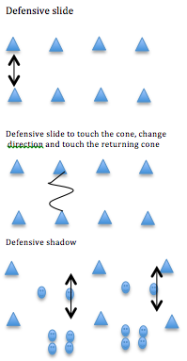  Defensive slide:  Knees bent  Feet shoulder width apart  Arm out  Small steps sideways  Defenders shadow  Hands up  What are the rules considered when defending?  Fan defence:  Side step, arms out wide  Push attacker wide:  Decreases change of scoring  Never foul jumps shooter:  50% chance of scoring in comparison to 80% in the free throw line  Challenge & block out:  Always challenge the jump, as you land turn back and step into the player  Arms out wide wait for the rebound.  Use space and communication  Move to supporting space, depth and width  Look for best passing option  What are the main rules of basketball?  What were the techniques we learnt?  What have we learnt about basketball?  Thank Students and highlight their achievements, especially being able to stick to group norms  Give brief introduction to new sport | T  X x  X x  X x x  x x x x x x x x  T  10M  7M  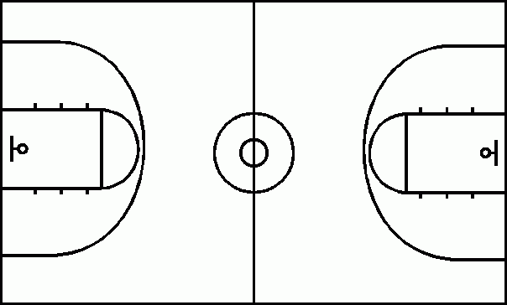  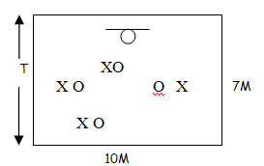  T  X x  X x  X x x | 2mins  3mins  10 mins  15mins  10 mins  2 mins
D
E
V
E
L
O
P
M
E
N
T

C
L
O
S
U
R
E

Defensive slide activities
http://www.youtube.com/watch?NR=1&feature=fvwp&v=IueVgTdZjQg

Lesson Plan Pro forma (Health & Physical Education)

NAME: |  | TIME: | 2:00-2.40pm  (40 minutes) |  | DATE:
ACTIVITY: | Basketball | CLASS / YEAR |  | Year 10
EQUIPMENT: | Flat markers, basketballs, Bibs, whistle.

Learning area: Health & Physical Education Band: Middle Years
Strand: Physical Activity and Participation Strand: Personal & Social Development
Key Idea (.1) (.5)
Students will participate in a variety of problem based tasks & games to improve personal competence in aspects skilful play, build self confidence and teamwork. Students will adopt various roles, take responsibility for safe, fair participation and collaborate with others in an enjoyable active setting.
Essential learnings:  - Futures  - Identity  - Interdependence  Thinking  Communication | Key Competencies  KC1: collecting, analysing, organising  KC2: communicating ideas and info  KC3: planning & organising activities  KC4: working with others in teams  KC5: using mathematical ideas  KC6: solving problems  KC7: using technology |  | Equity Perspectives  - Aboriginal & Torres Strait Islander  - Multicultural   Gender  - Socio economic  - Disabilities  - Rural and Isolated
Student learning Outcomes:  Evidence of learning …. The students will |  | Teacher outcomes:  The teacher will:
Cognitive & Physical (‘skilful’ play)  - Demonstrate good defensive positioning and game sense  - Apply bare bones of dribbling and shooting in effective play.  Personal Responsibility  - Incorporate primary rules into working effectively with teammates (game sense)  Social  - Work co-operatively to achieve success as a team |  | - Ensure a safe and inclusive learning environment for all students.  - Demonstrate thoughtful positioning so that all students are in view  - Give relevant and constructive feedback where necessary.  - Have a louder voice more constantly throughout the whole lesson.

