 | SPECIFIC LEARNING OUTCOMES | ACTIVITY  (Shape + method) | Teaching Focus  (cues or questions) | CLASS ORGANIZATION (Shape) | TIME
I  N  T  R  O  D  U  C  T  I  O  N | - List rules for lesson and point out boundaries. | Introduction  - Revise the safety and respect rule  - What did we learn last week? | - Whistle Use  - Cues of dribbling  - Shooting and moving around are key for today’s lesson | T  T | 5 mins
I  N  T  R  O  D  U  C  T  I  O  N | - Demonstrate dribbling technique without eyes on the ball  Engage in fun, physical challenge. | Dribbling and scanning.  - In groups of 2 or 3, students line up. One student dribbles to partner and read how many fingers partner is holding up.  Ball is thrown to partner and they become new dribbler. | Dribbling and scanning  - Main cues for dribbling?  - Loud calls  Eyes up | 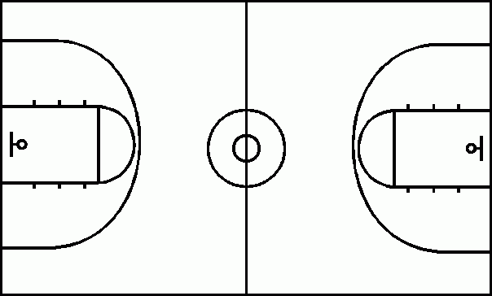
 |  | Around the world:  Shoot from just outside the key and rotate to the next spot when a shot is successful- as a team alternate shots. | Demonstrate to students how to perform the activity  Cue  B-Balance  E-Eyes on target  E-Elbows 90 degrees  F-follow through | 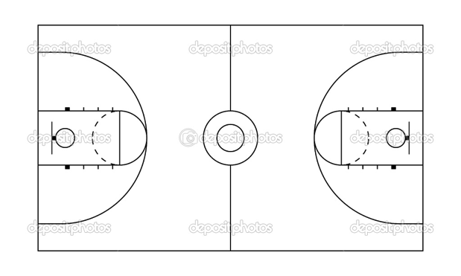 | 7 mins
 | - Students demonstrate the ability to perform the lay up in control and pressured situations | Lay up  - Students receive a ball per group and move into a free space, they will practice the set shot.  - Students get into groups of three and move to the free throw line  - Students will practice their lay up  Rules:  - 3 pts throw the hoop  - 2 point for the the square  - 1 point for hitting the board  Progression:  - Start close to the hoop and progress to going further  - 1 min challenge to get the highest score, repeat to beat old score  45 sec group challenge | Cues  - Approach the basket on a 45 degree angle  - Step with the outside foot followed by the inside foot  - Lift the ball to approximately eye level with both hands  - Place the shooting hand behind and under the ball  Bank the ball off the backboard |  | 7 mins
 |  | Pushing the ball forward (weaving)  - Student will work as a team to take the ball forward and shoot.  - The person in the middle passes the ball to the left and goes around that player and so one for the other students  - Once completed the shot the student must get back to the same formation and do the same to the get ball to the next group.  Progression:  - The person who shoots become the defender  The 2 last players to touch the ball becomes the defenders | Communication  Finish with a lay up shot  Use width and depth to score  3 man weave  http://www.youtube.com/watch?v=2RvphKAknnI |  | 15 mina
 | Students will demonstrate understanding and ability to set up fast break in attack. | 3 v 2 continuous defensive transition  ‘fastest with mostest’  Want to get players into attack quickly  - Teams of 3, two teams start at each end. Always return to the same end.  - Attack- one shot only, then quickly back to defend.  Two defenders only | When did fast break option arise?  Quickly transition from attackers to defenders to get back and defend.  What can you do to create a fast break? | 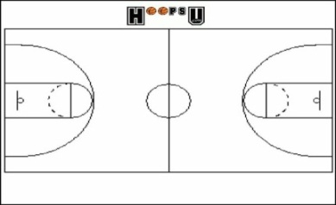  Play across whole court end to end. | 15 mins
 | - Students demonstrate game sense through passing and receiving.  - Defending students read the play by picking opportunities to intercept.  - Applying agility in a game situation. | 5v5 tournament  Divide students into 4 groups of 5  5 min games  Rules:  - No contact  - Every one has to touch the ball before scoring  - 3 pts for scoring  - 1 pt for hitting the board  - 1 pt for communication | Scanning  Find free space  Show a target | 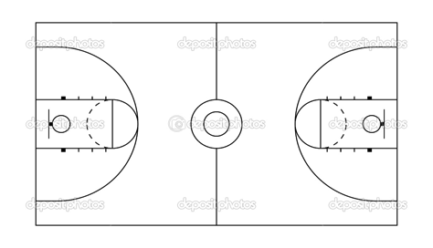 | 20 mins
C  L  O  S  U  R  E | - Students can list things learnt from the session  - Enthusiastic for next weeks activities. | Pack up  - Students put balls away for next group  - Congratulate on session, point out positives  - Back to meeting place | Which activity did you enjoy the most?  Why is communication so important in a game?  What are the 2 types of communication? | X X  T | 5 mins  (10.21-10.26)

Lesson Plan Pro forma (Health & Physical Education)

NAME: |  | TIME: | 9:15-10:26 am  (60 minutes) |  | DATE:
ACTIVITY: | Basketball | CLASS / YEAR |  | year 10
EQUIPMENT: | Flat markers, 6x basketballs, 15x Bibs, whistle.

Learning area: Health & Physical Education Band: Middle Years
Strand: Physical Activity and Participation Strand: Personal & Social Development
Key Idea (.1) (.5)
Students will participate in a variety of problem based tasks & games to improve personal competence in aspects skilful play, build self confidence and teamwork. Students will adopt various roles, take responsibility for safe, fair participation and collaborate with others in an enjoyable active setting.
Essential learnings:  - Futures  - Identity  - Interdependence  Thinking  Communication | Key Competencies  KC1: collecting, analysing, organising  KC2: communicating ideas and info  KC3: planning & organising activities  KC4: working with others in teams  KC5: using mathematical ideas  KC6: solving problems  KC7: using technology |  | Equity Perspectives  - Aboriginal & Torres Strait Islander  - Multicultural   Gender  - Socio economic  - Disabilities  - Rural and Isolated
Student learning Outcomes:  Evidence of learning …. The students will |  | Teacher outcomes:  The teacher will:
Cognitive & Physical (‘skilful’ play)  - Identify primary rules of activities to increase levels of enjoyment  - Apply bare bones of dribbling and shooting in effective play.  - Demonstrate game sense through tactics and effective passing and receiving.  Personal Responsibility  - Incorporate primary rules into working effectively with teammates (game sense)  Social  - Work cooperatively in team games and have fun. |  | - Ensure a safe and inclusive learning environment for all students.  - Become involved in games and get students motivated to participate.  - Give relevant and constructive feedback consistently.

