 | SPECIFIC LEARNING OUTCOMES | ACTIVITY | Teaching Focus | CLASS ORGANIZATION | TIME
I  N  T  R  O  D  U  C  T  I  O  N | - Develop an understanding of rules, revisiting from before the holidays | Introduction  - Welcome students and introduce yourself  - Introduce Safety and Respect rules  - The use of whistle | - Use of whistle (one whistle, eyes front; two whistles, stop and come back to meeting place)  - Boundaries (physical-end of playing field, social-no hitting/contact) | T  X X X X X X | 5 mins.  (2.00-2.05)
I  N  T  R  O  D  U  C  T  I  O  N | - Demonstrate the ability to actively engage in the end zone | End zone 4v4  - Divide students into 4 group of 4  - Get straight into a game and observe their technical ability  Rules:  - Everyone has to touch the ball before scoring  - No contact (cannot take the ball away when in possession)  - Arms distance apart when defending | Keep your head up high  Make sure your scanning  Fair play  Control the ball | 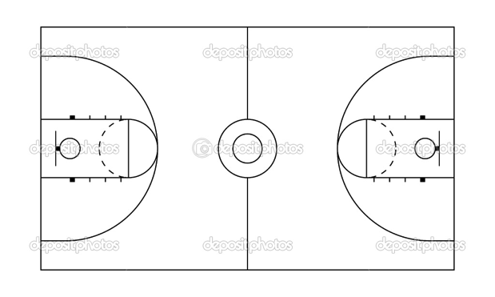 | 5 mins.  (2.05-2.08)
D  E  V  E  L  O  P  M  E  N  T | - Development of a responsible and enjoyable playing environment  - Beginnings of development of technical abilities within a different sporting area | Introduction of Basketball  - Basketball as a sport (TEAM GAME, 5 ON 5, COURT AREA)  - Introduce main rules of basketball  - Travel/ carry  - Double dribble  - No contact | - Very early signs of which students will be more competent than others with regards to technique  - Start engaging them with ball as early as possible, to increase familiarity with ball and its properties  - ENCOURAGE to make sure students enjoy playing around with the balls | T  X X X X X X | 5 mins.  (2.08-2.12)
D  E  V  E  L  O  P  M  E  N  T | Technical ability  - Apply bare bones of passing in a control environment  Apply rules and play fairly.  Technical ability  - Apply bare bones of dribbling in a chaotic environment  - Apply rules and play fairly. | Ball control  - Each student receive a ball  - Practice moving the ball around the head, weights, legs, individual leg and figure 8.  - Change directions  Passing  - Students will partner up and face each other  - Practice passing the ball to each other  Progression:  - Chest pass  - Bounce pass  - Over head pass  - One hand pass  Dribbling  Students dribble the ball around the area.  Progression:  - Individually dribble ball:  - Dribble while moving around (decrease playing area)  - Students dribble ball and try to knock out other players’ balls while keeping control over theirs.  - 2 points for stealing | Gradually increase the speed  Key cues:  Chest pass:  Arms extended, thumbs pointing down, step forward  Bounce Pass:  Step forward, point to the ground  Over head pass:  Elbows bend, eyes up, step forward  Key Cues:  Scan- eyes up  Body between ball and defence  Use finger pads, not palm or tips.  Keep ball waist height and close to body  What did you try to do to protect your ball?  Stop and take the time to encourage and give specific feedback to learners; showing them how to position their hands in order to successfully complete the technique | T  T  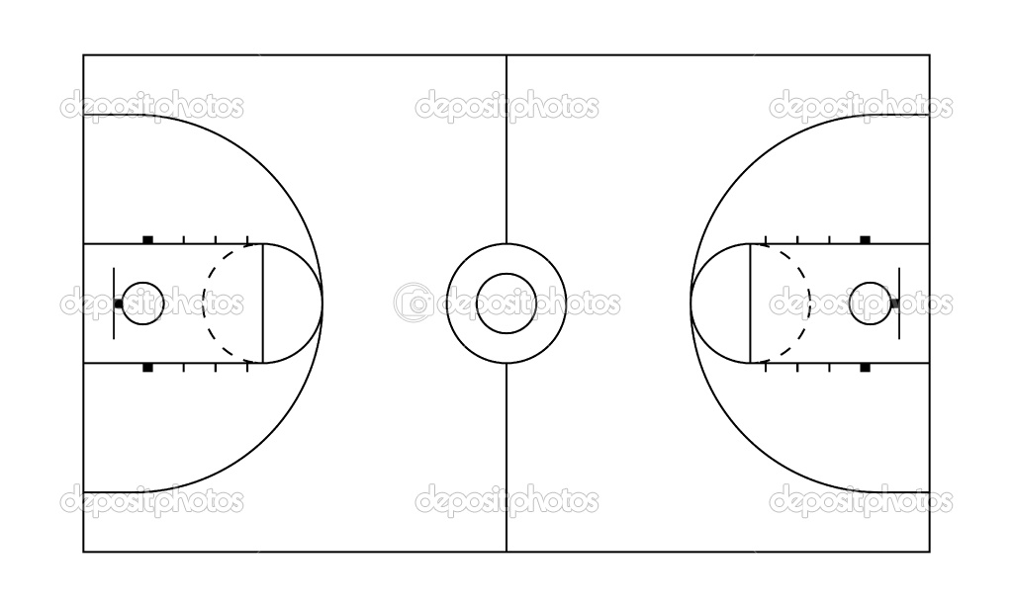  T | 16 mins.  (9.03-9.19)
D  E  V  E  L  O  P  M  E  N  T | Technical ability  - Apply bare bones of set shot/ jump shit in a control and chaotic environment | Shooting activity  - Students receive a ball per group and move into a free space, they will practice the set shot.  - Students get into groups of three and move to the free throw line  - Students will practice their shooting  Rules:  - Must be behind the free throw line  - 3 pts throw the hoop  - 2 point for the the square  - 1 point for hitting the board  Progression:  - 1 min challenge to get the highest score, repeat to beat old score  - 45 sec group challenge | Cues of set shot  - Balance ball on shooting hand  - Elbow stays directly under the ball and over your knee  - Eye on the target  - Follow through snapping wrist above head.
D  E  V  E  L  O  P  M  E  N  T |  | 5v5 game  Divide students into 4 groups of 5  Rules:  - No contact  - Every one has to touch the ball before scoring  - 3 pts for scoring  - 1 pt for hitting the board | 5v5 game  Divide students into 4 groups of 5  Rules:  - No contact  - Every one has to touch the ball before scoring  - 3 pts for scoring  - 1 pt for hitting the board
C
L
O
S
U
R
E

C  L  O  S  U  R  E | - Provide specific feedback to enhance students techniques and elements of skilful play for future lessons | Debrief/Pack Up  - Congratulate students on successful beginning to basketball  - Give enthusiastic and positive feedback to any questions or queries | Debrief/Pack Up  - What students thought worked well; what you thought worked well | T  X X X X X X | 5 mins.  (9.40-9.45)

Lesson Plan Pro forma (Health & Physical Education)

NAME: |  | TIME: | 2:00-2.40pm  (40 minutes) |  | DATE:
ACTIVITY: | Basketball | CLASS / YEAR |  | Year 10
EQUIPMENT: | Flat markers, basketballs, Bibs, whistle.

Learning area: Health & Physical Education Band: Middle Years
Strand: Physical Activity and Participation Strand: Personal & Social Development
Key Idea (.1) (.5)
Students will participate in a variety of problem based tasks & games to improve personal competence in aspects skilful play, build self confidence and teamwork. Students will adopt various roles, take responsibility for safe, fair participation and collaborate with others in an enjoyable active setting.
Essential learnings:  - Futures  - Identity  - Interdependence  Thinking  Communication | Key Competencies  KC1: collecting, analysing, organising  KC2: communicating ideas and info  KC3: planning & organising activities  KC4: working with others in teams  KC5: using mathematical ideas  KC6: solving problems  KC7: using technology |  | Equity Perspectives  - Aboriginal & Torres Strait Islander  - Multicultural   Gender  - Socio economic  - Disabilities  - Rural and Isolated
Student learning Outcomes:  Evidence of learning …. The students will |  | Teacher outcomes:  The teacher will:
Cognitive & Physical (‘skilful’ play)  - Identify primary rules of activities to increase levels of enjoyment  - Apply bare bones of dribbling and shooting in effective play.  Personal Responsibility  - Incorporate primary rules into working effectively with teammates (game sense)  Social  - Work cooperatively in team games |  | - Ensure a safe and inclusive learning environment for all students.  - Demonstrate thoughtful positioning so that all students are in view  - Give relevant and constructive feedback where necessary.  - Have a louder voice more constantly throughout the whole lesson.

