Unit Plan

Basketball

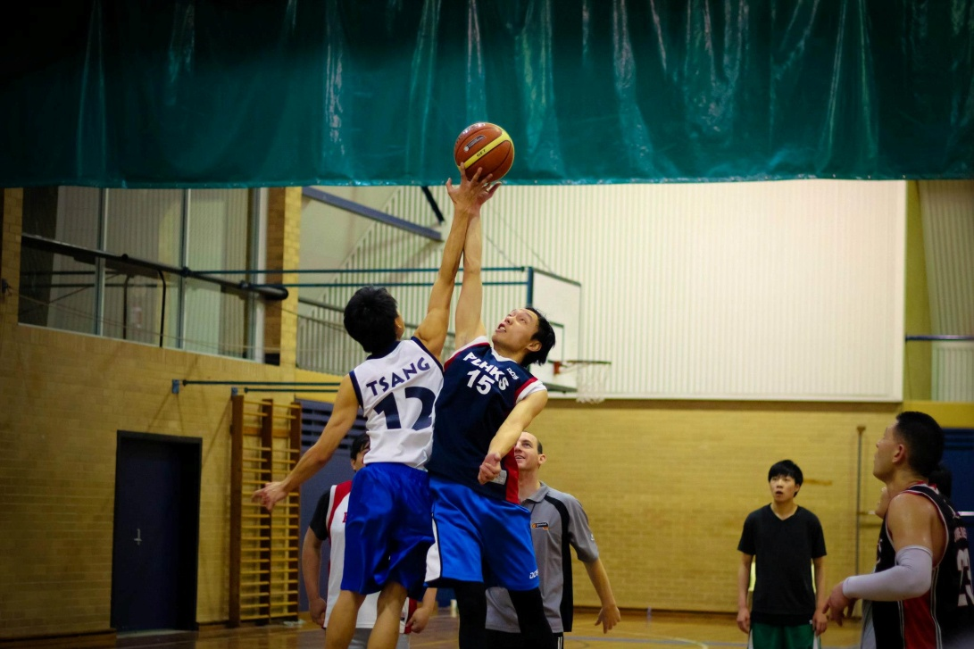

Basketball –Unit Plan

- General situation & constraints:
The unit will run over a period of four weeks consisting of two single lessons and one double lesson for a total of 12 lessons to complete the unit. Each lesson runs for 40 minutes where double lessons will run for a total of 1 hour, 20 minutes. Single lessons are held on Tuesday lesson 7 and Friday lesson6, where double lessons are held on Thursday lesson 1&2. This particular year 10 class is made up of 21 students.

Situation/ Constraints |  | Implications for your pedagogy
Year Level | Year 10  21 students | Compulsory for students in this year level to attend school, however they choose their own subjects so it is likely that students in PE are there because they want to be and enjoy the subject.
Lessons per Week | 1x double (120 minutes)  2 x single (40 minutes) | Lots of time is allocated for PE, especially with the double lesson it is important to have plenty of activities planned as students get tired and/or bored easily in this amount of time.
Unit Length | 4 Weeks | Plan for and allow progression over the four weeks, scaffold learning and have a clear idea of expectations for the end of each week.
Time of Lessons | Tuesday Lesson 7  Thursday Lesson 1&2  Friday Lesson 6 | Double lesson can seem a really long time if it is not well planned, must have a range of activities ready to ensure that students don’t get bored.
Teaching Space | Gymnasium indoor basketball courts  Enough basketballs for one between two or three students. | The gym has one basketball courts and is a suitable space to accommodate the class.
Personal Experience with Activity | Haven’t every played basketball competitively, only socially with friends and at Uni. | Need to ensure that I am clear on the rules, tactics and techniques for basketball so that I can be confident with my teaching and I maintain respect of the students.
Context of School | Many of the staff in the school are heavily involved with PE and it is promoted in all year levels. | Positive climate: PE has been established in the school, therefore I need to ensure I work this to my advantage and provide positive experiences so this is maintained.

- Nature of the learner:

The students are all boys the ages vary from 15 -16 years old.All of the learners are at differing experience levels in basketball ranging from beginners to students that have played the sport for up to 3 or 4 years. However all of the students really enjoy their physical education classes at school and always participate to the best of their abilities.
As always some students may enjoy this particular unit more than others so it is essential to make sure that equal opportunity is given to all of the students throughout this unit block. Most of the students throughout the class all work extremely well together however there are a few students who act like the leaders of the group and talk for the group. There are then also other students how keep more to themselves, nevertheless they are all still able to work together as a group meaning they are always included and accepted.

Students will demonstrate a high level of personal responsibility as they will not only be participating in activities and games but will also be required to umpire and score games and also be responsible for the equipment in helping to set it out at the beginning of lessons and activities and packing it up at the conclusion of the lesson.
As the students teacher I hope to build upon our relationship that I developed with the students in Reflective Practice 1. I will endeavour to be a role model for them by being energetic and excited about the lesson whilst also trying to keep them enthused throughout the entire unit.

- Activity/ Topic analysis
Part 1a)
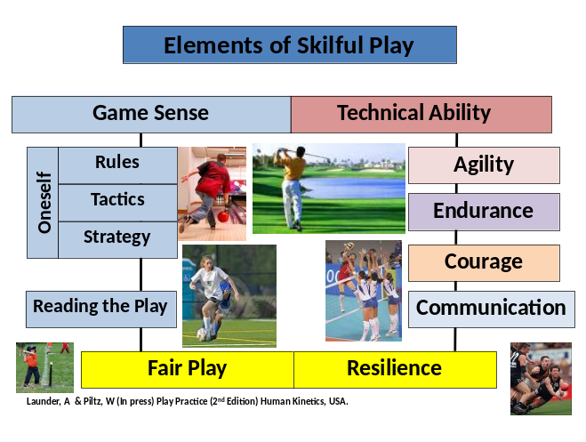Description of the activity:

Basketball is a team interactive, court invasion game whereby the objective is to outscore the opposing team (Launder 2001). A basketball team consists of 5 players on the court at any one time. Play is started with a jump ball between two players in the middle of the court at the beginning of the game and at the start of each quarter. To score a goal the ball must be shot through the 3 metre high basket at the attacking end of the court. Goals inside the 3 point line are worth 2 points, where as a penalty foul shot is only worth 1 point. Any shots scored from behind the 3 point line are awarded 3 points. After a team has scored, the opposing team recommences play by throwing the ball back into play from behind the baseline. Basketball is generally played in four ten minute quarters. The clock stops when play is interrupted or inactive (ball goes out of court) and when a timeout (coach requested interval) is called.

The game is played under many officials, including, umpires/referees and officials who keep track of time, score, fouls, shot clock, substitutions and the possession arrow. The only equipment essential to basketball is the ball, two 3 metre high baskets at either end of the court, and a court with approximate 28x15 metre dimensions.

There are 5 positions in defence, which are centre, point guard, shooting guard, small forward, and power forward, no positions are determined in attack. Substitutions can be made when play has been stopped. There are no restrictions on the number of substitutions a team can make but timeouts are limited, and should last no longer than 1 minute. All players are permitted on all areas of the court; however a 3 second time limit does apply to attacking players in their key.

The main aim of attack is to penetrate down the court as quickly as possible to score. The main aim of defence is to delay play and try to stop their opposition from scoring a goal. There are many technical abilities and elements of effective play required in basketball, including shooting, passing, dribbling and player positioning on the court. The elements of effective play which are most important for success include communication, agility, endurance, game sense and the ability to read the play. As basketball is fast paced, the nature of the game is usually chaotic meaning that communication is a fundamental for effective play. In order to help the students develop and become skilful players, as the teacher we can implement the ‘play practice’ principles by teaching basketball through small sided, game based learning experiences.

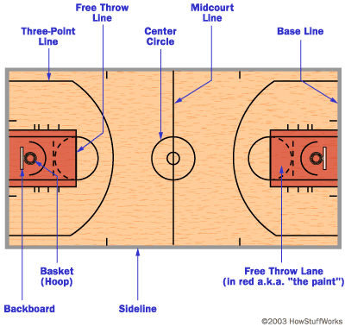
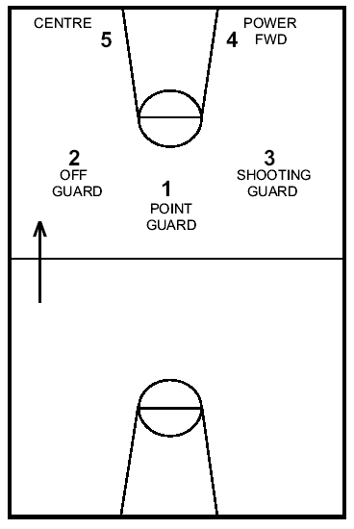

Dimensions & Positions of a typical Basketball court -28m length X 15m width.

Elements of a Skilful Player

Fundamental Movement Patterns

  - Change in direction – agility dodging
  - Defensive footwork
  - Offensive footwork
  - Running
  - Jumping
  - Stopping quickly

Technical Ability

- Throwing
- Catching
- Dribbling
- Defending

- Shooting technique
- Lay-up
- Jump shot
- Rebounding

Communication

- Verbal
- To receive ball
- Encouragement
- Defensive communication
- Non-verbal
- Target
- Signals

Knowledge of the Rules

  - 5 v 5
  - Travel
  - Double dribble
  - Cross-court
  - Non-contact – fouls
  - 3 seconds in the key when attacking
  - Out of court
  - 5 seconds with ball when defended
  - Carry

Tactical Awareness

- Principles of play in Attack
- Penetration with/without ball
- Drawing defender – to you or away from you
- Support with width or depth
- Faking
- Cutting
- “Drive, draw, dump, score”

- Principles of play in Defence
- Delay
- Support with depth

Decision Making “Skill”

  - Passing & receiving
  - Selecting the appropriate option
  - Triple threat – pass, dribble or shoot
  - Anticipation – reading the play in attack or defence
  - Defensive positioning

Fitness

  - Aerobic base
  - Anaerobic – short bursts
  - Power
  - Speed
  - Strength
  - Flexibility
  - Balance

Sportspersonship

  - Ethics of playing within the rules
  - Fair competition
  - Encouragement
  - Umpiring
  - Fun
  - Involving everyone
  - Acknowledging good play

Mental Toughness & Resilience

- Maintain effort
- Focus on goals
- Encouragement
- Optimal arousal leve
Part 1b)
Analysis of the activity
Technical ability

- Technical ability refers to a learner’s ability to control and direct the object (Launder 2001).
  - & 1.2
Technique is a significant aspect of basketball that is needed by novices and experienced players to be successful in this activity. It is clear that dribbling the ball effectively while unopposed or opposed is essential for a successful basketball player. Participants need to successfully dribble the ball up and down the court, evading opponents and piercing the oppositions defence to be in range for an accurate shot on goal. Having the correct shooting technique is also essential as the main aim of the game is to shoot the ball through the basket. Participants shooting technique is vital during a game when free from defenders or under pressure where the better technique will generally score more goals. Passing the ball is another essential technique that is required to be successful in this activity. The ability for participants to pass the ball quickly and efficiently will determine their success. Fast, effective passes will penetrate oppositions defence and make scoring easier. Finally, defending the opposition’s attackers individually and as a team is extremely important for success. Individually, players aim to delay the ball carrier, block a shot on goal or intercept a pass. The team defence is usually in the form of a ‘key’ or a ‘zone’ that they set up around the ring to protect the opposition from scoring a goal.

1.3
Dribbling:
Dribbling can be separated into two main categories- unopposed and opposed. Depending on how close a defender is the player in possession of the ball will define which type is being used. Unopposed dribbling is an easier technique for players as the only real variable they need tot consider is the ground. Opposed dribbling on the other hand is more difficult as it usually involves protecting the ball from defenders in order to maintain possession.

The difficulty associated with unopposed dribbling differs depending on whether or not the player is moving. When standing still, the level of control over the ball is minimal. However if the player is moving with the ball it is important that more attention is paid to maintaining control. The key cues a player should keep in mind for the basic dribbling action is to push with the fingertips, keep the bounce at waist height and keep the ball slightly in front of their body. The player also needs to ensure they keep their head and eyes up to constantly scan for passing or shooting options and also defenders.

Opposed dribbling and therefore protective dribbling is used when a defender is threatening the ball. The player need greater control of the ball and increased ability to change the direction of the ball quickly. In this case the ball should be bounced slightly lower and there should be more bounces per period of time. In order to protect the ball the player should aim to keep their body between the defender and the ball. This is to increase the likelihood of drawing a foul from the defender if they attempt to steal the ball.

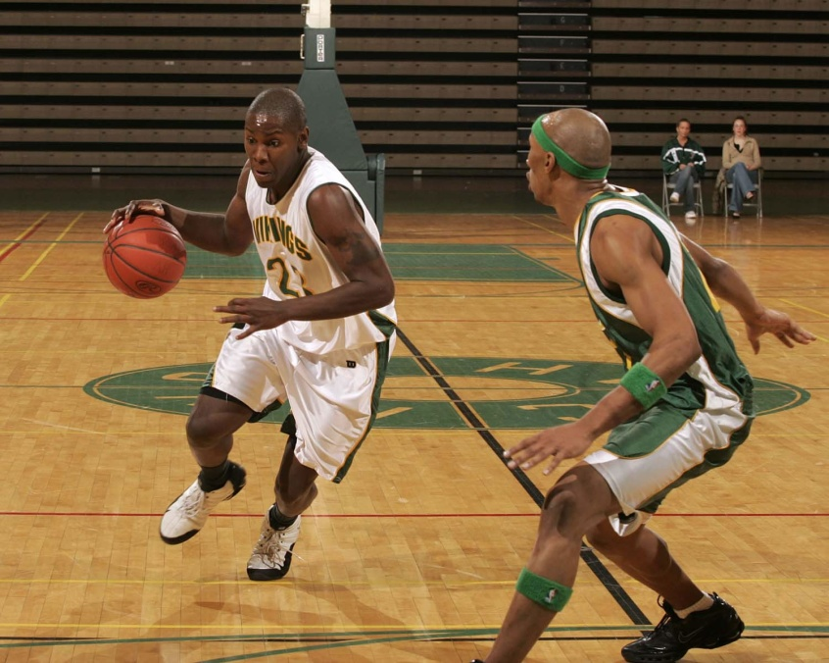
Dribbling
- Scan- eyes up
- Body between ball and defence
- Use finger pads, not palm or tips.
- Keep ball waist height and close to body

Perceptual demands
Rating- High

When dribbling the ball down the court, perceptual demands placed on the novice are high. At a novice level it is difficult to perceive where opponents and team mates are while dribbling as the novice must scan in front, on the side and behind while moving down the court to ensure they do not lose possession from a defender. Basketball is an interactive chaotic game meaning that the novice must keep the ball close to the body whilst dribbling as perceptual demands have not yet been mastered.

Timing demands
Rating- High

Dribbling requires high timing demands for the novice basketball player. In particular, when under pressure from a defender, the dribbling attacker must ensure the ball is bounced at the correct height (waist) and at the correct time and speed to ensure a defender does not move to intercept the ball. It is important for the novice to keep on the move at all times while dribbling. By doing this, defenders find it difficult to judge the timing and the speed of the ball. Also, it reduces the chance of being cornered by 2 or 3 defenders.

Movement pattern
Rating- High

The environment is unpredictable and chaotic therefore movement patterns when dribbling are generally high. It is a coordinated sequence that must be used to avoid defenders and pierce the ‘key’ to position them to score.

Shooting:
There are two main shooting techniques used in basketball- the set-shot/jump-shot and the lay-up. The lay-up shot involves players driving to the basket and pushing the ball up into the ring. It is important that players understand a lay-up is achieved from a high jump, not a long jump. Their bodily momentum should help carry the ball upward from the point of release. Players should ensure that they are jumping off the basket-side foot rather than the board-side when they are driving in e.g. if driving in from the right, the player should jump off their left foot and push the ball up with their right hand and the opposite for driving from the left. The lay-up should be shot with the arms up in front of the player’s head. Players should be encouraged to use the backboard if there is any angle. Most importantly players need to keep their head up so that they can see their target- the basket.

The jump shot should be used when there is no immediate threat from a defender. This is not a good shot to use if a defender is close as it is likely that they will intercept the shot. With the jump shot or set-shot the player should elevate the ball, shooting it from overhead with the arms centered. The ball should be balanced on the shooting hand and the shooting elbow should stay directly under the ball but over their knee. The player should ensure their shoulders are square with the target and that as they follow through their hand should reach out and follow the shot- this should form a ‘goose neck’ with their hand and arm.
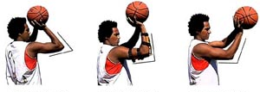

Shooting
(Set shot/jump shot)
1. Balance ball on shooting hand
2. Elbow stays directly under the ball and over your knee
3. Eye on the target
4. Follow through snapping wrist above head.

Perceptual demands

Rating- High

When shooting, during a lay up or a set/jump shot high perceptual demands are placed on the novice. Rarely in a game of basketball, with the exception of a free throw following a foul, do players shoot the ball free from defenders. Generally, players are under pressure and novices need a high sense of awareness to determine what is happening around them while shooting the ball.

Timing demands
Rating- High

Shooting the ball during a set/jump shot or a lay up the timing demands placed on the learner are high. The attacker must determine the appropriate time to shoot the ball or execute a lay up. The defending team generally set up a key or zone defence therefore the timing for an attacking player is crucial ensure a shot on goal that has not been rejected.

Movement pattern
Rating- High

During the lay up the movement pattern placed on the novice is extremely high as they are required to penetrate the key and around the defenders. The lay up is a coordinated sequence that requires agility, where the set/jump shot is a simple sequence that is executed following a coordinated movement pattern to move into a free shooting space.

Passing:
Passing is a key technical ability needed by players to succeed in a game of basketball. Players need to be able to pass quickly and accurately to decrease the chance of a defender intercepting the pass. The two most common passes used in basketball are the two-handed chest pass and the one-handed push pass. Two-handed passes are generally used to keep the ball moving down the court without too much threat of interception. Single-handed passes are used for longer passes. This type of pass is also useful to pass a greater range of angles due to the manoeuvrability of the arm.

The key cues for the two-handed pass are to step forward, push with both arms and follow through to the target. For a one-handed pass, the player should point to their target with the non-throwing hand and have their non-throwing foot forward. Their throwing arm needs to push through and follow through to the target. Diagram- Following page

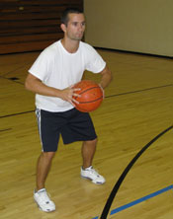
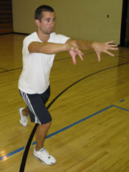

Passing
- Square body to target
- Thumbs against chest--elbows bent and out
- Step toward target
- Extend arms fully releasing ball to target
- Thumbs should now be pointing down

Perceptual demands
Rating- High
Passing requires novices to perceive where defenders are around teammates and the ball carrier. The chaotic environment means that the perceptual demands are high. Novices must ensure the ball is close to the body when executing the pass to make sure defenders cannot slap the ball from their hands.

Timing demands

Rating- High
Timing is extremely important when passing the ball as novices must ensure they pass the ball at the right time so defenders cannot intercept the ball. As the novice basketball player’s body movement and positioning is not at a high level, defenders may find it easier to position them to intercept the ball that has been passed. The quicker the novice can move into a passing position and execute the pass, the less chance the defenders have to create a turnover.

Movement pattern
Rating- Low

Movement pattern is not essential for the novice. Passing can be executed while moving or stationary. Movement patterns are more essential for the ball carriers team mates as they have to move into a suitable position to receive the pass. Passing is a simple action that requires great technical ability rather than particular movement patterns.

Defending:
The key to good defending is positioning. A player should always aim to keep their body between the player they’re marking and the basket. They should also attempt to keep an eye on both the offensive player and the ball. A good defender should attempt to keep their knees bent, weight balanced and eyes on the ball handler’s midsection to track their movements. The player should have their hands slightly out and away from their body, ready to block a pass.

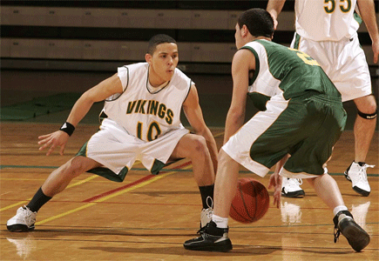

Defence:
- Watch the ball carrier
- Arms out
- Weight evenly distributed
- Bent knees

Perceptual demands
Rating- High

When defending the novice must focus on the ball carrier and the attackers cutting through the key. This places enormous perceptual demands on the defender as the open environment and speed of the attackers make it difficult for the novice to perceive where the attackers are moving.

Timing demands
Rating- Med-High

Timing demands are also relatively important for novices as they must time when to intercept or spoil the ball from the attackers. The timing is important as defenders make perform a ‘fake’ pass or shot. If the defender over commits the attacker can easily move forward and shoot free from pressure.

Movement pattern
Rating- High

Novice defenders are required to perform coordinated sequences to block and remain between the attacker and the ring. The movement patterns required are unpredictable and may change every time. Evenly distributed weight is the key to for novices to defend effectively so they can move quickly and efficiently to block the attacker.

1.4
Secondary techniques (advanced level):
- Fake pass
- No look pass
- Bounce pass
- Key set up
- Cutting the key
- Slam drunk
- Alley Oop

Agility
Agility Is the ability of the player to move effectively into spaces on the playing space (Launder 2001).
2.1
Agility is of ‘high’ importance to be effective in basketball. Whether defending or attacking, agility is essential to be able to perform at a high standard. As basketball is an interactive chaotic team game, agility is essential for players to move the ball up and down the court and evade to oppositions defenders. Players are required to move into good positions at exactly the right time to receive a pass or shoot a goal. Running forward, sideways and backwards as well as turning, accelerating, jumping and land are all types of movement that successful basketball players must master.

2.2
Agility is an important aspect of an effective basketball game. Agility is required by all players during both attack and defence. During attack it is important that players are able to use agility to move quickly into new spaces. To do this, they must be able to dodge to move around the defending players. The player in possession of the ball must also use agility to keep moving their body between the defenders and the ball. Agility is an important component in basketball for players to be able to complete a fake movement effectively. The fake is an excellent tool used by players to fool a defender. In order for the fake to be effective, players must be able to change their direction quickly before the defender has time to recover from their first movement.

Agility is also very important in defence. Defence is often considered the most important aspect of the entire game of basketball. It is vital that players are able to move back quickly into a defending position if the ball is turned over in the attacking half of the court. Defenders need to change direction of play quickly to ensure they block up the space in their opponent’s attacking half. Defenders also need agility to defend their players and stop leads.

Another aspect of basketball in which agility becomes important is when there is a loose ball. Players must be able to move quickly to retrieve the loose ball to ensure it is their team which gains possession.

2.3
During basketball the ball carrier must be agile to quickly move into space to perform a pass to a team mate or a shot on goal. The more agile the ball carrier is the more time they have to perform the technique with less pressure being applied from the defenders. Agile players will generally make fewer mistakes or less turnovers as there technical ability will be at a higher standard.

An understanding of the rules
An understanding of the rules is vital in a unit of basketball. There are some basic rules that must be introduced in the early lessons. Some of the rules that are essential for students to learn in the early stages of the unit include moving with the ball, personal fouls, out of bounds, technical fouls, general violations and free throws. It is important to shape the play for novices in the initial stages of this activity. If some of the personal fouls are modified, fewer players will find themselves being fouled off. Coaches or umpires should not be too hard on these rules as novices are prone to fouling quite a lot.

3.1
Primary Rules
Moving with the ball:
The ball is advanced up the court by dribbling, passing or shooting.
-Passing: is completed using a flat hand.
-Dribbling: continuous bouncing of the ball as the player runs with it. Contact with the ball must be with one hand only and the player may take unlimited bounces. Dribbling finishes once the ball is caught or rested in one hand and a player cannot recommence dribbling until after the ball is passed, shot or stolen. Failure to dribble or taking more than two steps is called ‘travelling’ and a penalty pass is awarded to the other team.
Personal fouls:
If a player with the ball is touched, held, bumped, struck, tripped, pushed, blocked etc a personal foul is awarded.
-If the foul occurs during general play a throw from the side is awarded
-If the foul occurs during the act of shooting one or more free throws are awarded. If the original shot was not successful the player is awarded 2 free throws (or 3 if the shot was taken from the 3 point line). If the shot was successful the 2 (or 3) points are awarded, plus one extra throw is awarded.
-If a player without the ball in a correct and stationary defence position is charged by a player with the ball a personal foul is given against the player with the ball.
Free throws:
The free throw must be taken from behind the free throw line and all other players must be outside the key area.
-If the second free throw doesn’t hit the ring or if it successful the play is restarted from behind the base line with a throw in.
-If the second free throw bounces off the ring it is ‘play on’ and players are free to compete for the ball
Technical fouls:
Technical fouls involve no contact but rather unsporting behaviour. Two free throws are awarded to be taken by any member of the team
Out of bounds:
A player is out of bounds when touching the floor or any object outside the side or base line.
-The ball is out of bounds when it touches:
-a player or any person out of bounds
-the floor or any object out of bounds
-the back of the backboard, any overhead objects or the roof
-If the ball goes out of bounds it is thrown in from the nearest side/base line
General violations:
-traveling (running/stepping twice with the ball)
-kicking or punching the ball
-double dribble or carrying the ball whilst dribbling
-causing the ball to go out of bounds

3.2
Secondary rules rules:
Some of the more advanced rules that may be introduced to students over time include time rules, five fouls, some more general violations and illegal screening.
General violations:
-3 second violation- when a team has possession of the ball each player in the offensive team is not allowed inside the key at their scoring end for longer than three seconds. This does not include when the ball is in the air for a shot at goal, during a rebound or when the ball is dead.
-5 second violation-When a player has the ball and is closely guarded they must pass, shoot or dribble the ball within 5 seconds.
-Back court violation- When a team has possession of the ball in their front court they must not allow the ball to go back into their back court. This only applies if the team has control of the ball and I the last to touch it in their front court before it roll or goes into their back court. If a player on the same team touches the ball in the back court a violation will result.
Time rules:
-30 second rule- upon gaining possession of the ball the team has 30 seconds in which to shoot.
-10 second rule- upon gaining possession of the ball in the back court the team has 10 seconds in which to advance the ball over the centre line.
Five fouls:
-Any player who commits 5 personal fouls may take no further part in the game
-Once a team has committed a total of 5 fouls, the next foul automatically gives the opposing team a free throw.
Illegal screening:
-Is an attempt to illegally delay or prevent an opponent who does not control the ball from reaching a desired position on the playing court.

3.3
When a player applies the rules in basketball they are demonstrating games sense (Launder 2001). To be effective at basketball knowledge of the rules is essential, particularly in relation to personal fouls, double dribble and travel. By reducing personal fouls such as blocking, contact or charging, the player will be better off playing in the later stages of the game as they will not be under threat of being fouled off. Having an understanding of the travel and double dribble rule will help your team to minimise turnovers.

3.4
A full list of rules and regulations can be viewed at International Basketball Federation 2009: <http://www.fiba.com/downloads/Rules/2008/OfficialBasketballRules2008.pdf>

An understanding of tactics
4.1
There are a number of key tactics that players should have an understanding of to effectively play the game. Some are more advanced than others but the simpler tactics can be taught in the earlier stages of the unit. Once novices have improved their technical ability then it is important to develop an understanding of tactics with basketball. Tactics such as those stated below help teams keep possession of the ball, score more easily and regain possession of the ball.

Primary tactics
-Support- when attacking, players should try to always support the ball carrier with width and depth down the court. This increases the options for passing and decreases the chance of a defender intercepting the ball.
-Mobility of players- players should remain mobile at all times to ensure space is created and that when leading they are leading to the ball to decrease the chance of an interception
-Mobility with the ball- players should attempt to move the ball quickly and attempt to get the defenders out of position to create holes and therefore space to move into
-Patience- players should always be prepared to make the ball work in order to tire the defenders
-Defensive patterns- while there are a number of different defensive formations, the two most basic ones are either a zone defence or a man-to-man defence. Teaching teams to decide which defence they wish to use will enable them to have a focus while they are defending

4.2
There are many basic tactics however once novices moved towards a more advanced level then more complex tactics can be initiated. It is important to master basic tactical principle before moving onto the more advanced level.

Advanced tactics
-Split the seams- position attackers between the defenders to ‘split the seams’. This draws the defenders out and can cause confusion about which defender goes. Players should also drive into the seams and draw the defender.
-Reverse the ball- fake to move the ball one way and then reverse the ball. This may get the zone off balance and out of position.
-Skip passes- a skip pass will open up a zone. A skip pass forces the defenders to move over a greater distance with one pass
-Overload- players should try to outnumber the defenders eg. 2v1

4.3
The relationship between tactics and technical ability as stated by Launder (2001) is that students who are tactical probable, are technically able. This simply means that if novices are able to perform the correct primary techniques or skill, e.g. dribbling, shooting, passing or defending, then tactical principles can be implemented within the game plan.

Reading the play
5.1
As basketball is an interactive court invasion game, 5 players from each team play on the court at any one time creating a chaotic, unpredictable environment. Reading the play is essential for any team or individual to be effective in this sport. On a relatively small court, reading the play is vital for players to score goals and attempt to steal the ball from the opposition.

5.2
Reading the play is a rather complex element of effective play as players have to process complex displays of information on the court and decide how to respond to it. Reading the play is incredibly important in both basketball offence and defence. In offence, players must be able to choose the best passing options, lead effectively into space, choose effective times to use the jump shot, read the path of defender’s to choose effective lay-up options and be able to rebound the ball. It is important that attackers are able to read the play effectively to ensure that they maintain possession of the ball. Without possession, goals cannot be scored.

The ability to read the play is equally important in defence as players need to be able to intercept the ball and regain possession as often as possible. In defence, players need to be able to read the body language of the player in possession of the ball to attempt to read where the ball will be thrown. Another element of reading the play in defence is the aspect of reading the attacking formation being used. At the more advanced level, attacking teams use set plays to advance the ball down the court. In this case, it is important for defenders to begin to recognize the plays and read where the attackers will move to. This will make it easier for the defenders to block up the space in the court and hopefully create an opportunity for a turn over and score.

Game sense
The ability to use an understanding of the rules, of strategy, of tactics and most importantly of oneself, to solve the problems posed by the game or by ones opponents (Launder 2001).
6.1
- when in offence and in possession of the ball/ object;
- The ball carrier must decide whether to keep dribbling, or pass the ball.
- Attack the defence or hold back and wait for team mates to cut the key.
- Move the ball quickly, or move the ball slowly.
- Move to the right side of the court, or the left.

- when in offence and not in possession of the ball/ object;
- support the ball carrier with width
- support the ball carrier with depth
- move to a position to receive the ball
- cut the key
- hold a static position

- When in the various defensive roles.
- Whether to follow the attacker, or hold position in the key.
- Whether to jump to rebound the ball or hold position.
- Whether to jump for a rejection, or hold position on the ground.

6.2
Games sense is extremely complex in basketball due to its unpredictable environment. It is about moving into the right position at the right time, and then making the best decision in regards to what to do next when you get there. In basketball decisions have to be made quickly as the playing area becomes congested and good options are quickly covered. The ability to interpret all of the information in the context of the game to make the right decision is a complex element of basketball.

Fitness/ Endurance
7.1
Endurance is a very important element of effective play in basketball due to the small number of players on the court at any one time. There are not enough players to have half playing defence and half playing offence. All players need the fitness to cover all areas of the court when needed. E.g. when attacking, all players need to be involved. A big requirement of basketball is the ability to fall back into defence as quickly as possible when the ball is turned over. This often requires a sprint down to the other end of the court. Basketball requires both aerobic and anaerobic fitness. The players would largely rely on their lactic-acid system to provide energy as they are usually required to produce high levels of energy for a greater period than 10 seconds. The aerobic system is used to assist recovery during less active parts of the game and also for when the players are given to opportunity to recover on the bench for a few minutes.

Communication
8.1- 8.2
Communication plays a big role in an effective game of basketball. While the player in possession of the ball must decide when to release the ball, it is the catcher who knows best when and where he wants to receive the ball. If the catcher is able to communicate this information to the thrower, the outcome of the pass is likely to be a better one. To receive the ball accurately, the leader/catcher must signal for the ball. This can be done in two ways- verbally and non-verbally. This signal should convey both direction and timing of the pass.

Verbal communication is the most common form used by beginner players, with simple calls such as ‘here’. This can be an effective form of communication however players should remember that it also increases the chance of a defender intercepting the pass as they are more aware of where the ball will be going.

Non-verbal communication often involves the catcher pointing to where they want the ball and presenting their hand as a target for the thrower to pass to. This form of communication is good because it is discreet and less likely to provoke interceptions. However, students should be aware that it is also more liable to errors in interpretation and accuracy.

Players should be made aware that the best way to communicate with team-mates is through a combination of non-verbal and verbal techniques. It is important for players to call for the ball so that the thrower is aware of who is open but they should also use their hand to present a target so the thrower knows exactly where to pass the ball.

An understanding of strategy
A strategy is a long term plan for the way that you will play developed by considering the strengths of the individual / group and the philosophy of the coach. This enables player to be empowered during the game (Launder 2001).

An understanding of strategy is very important for team plays in basketball. Because basketball is very much a team game it is important that they analyse their personal strengths and weaknesses to determine their best options in terms of offense and defense. For example if the team has one exceptionally tall player on their team they may wish to try and place that player under the basket for rebounds as often as possible. Strategy is important for the long term prospects of the team. If the team has a goal such as making the finals, they will need to develop a strategy to help them achieve this. It is vital that all team members understand the strategy otherwise it is unlikely that it will be successful.

The ability to follow a game plan
This compliments the strategy and it is devised by taking into account the relative strengths and weaknesses of specific opposition (Launder 2001).

Game plans are formed in conjunction with the strategy however change slightly to suit specific opponents. They are developed in preparation for each weekly contest. It is important that all players have an understanding of the game plan because then they know their part in it and are able to focus on their role and show leadership when necessary. For example, it may be a team’s game plan to target a team who lack height. To target the opposition’s weakness they execute high passes to players inside the key, making it hard for the defenders to intercept. This will provide a huge advantage as once they receive the ball they can execute a jump shot which will make it extremely hard to be blocked. Similarly, the following game may be against a team with lots of tall players, therefore the game plan will change to exploit their weakness, i.e. court speed or endurance.

The capacity to focus and be resilient
This enables the player to concentrate on the task at hand and to recover proactively from set backs (Launder 2001).

11.1
The capacity to remain focussed is important throughout the game of basketball. Players need to stay focused to ensure their ability to read the play stays high. Focus is important to ensure all team members are aware of the form of defence being used and/or the set play for attack.

As with all sports, resilience is also important in basketball. Players may begin to feel dejected if their team is losing however this is where resilience is most important. If they miss a shot, they need to keep their head up and simply focus on the next passage of play. Without focus and resilience within a team, the chance of loss becomes greater.

11.2
Some typical setbacks that may occur in basketball are that if one player loses focus and demonstrates poor body language, it generally filters through the entire team, particularly when losing the game it can affect the team’s mental resilience. If an individual or team has poor aerobic endurance they may find opposition teams become more dominant in the later stages of the game, where physical resilience can be questioned. Finally, individuals and teams will be set-back if they are not morally resilient. If an umpiring decision goes against them they must accept the decision rather than dispute it even if they see the decision as incorrect. Umpires call the play how they see it and will not change their minds once the decision has been made.

The ability to play fairly
12.1
This is a very important aspect of team games and in particular school programs. Fair play should be evident in all sports. In basketball, players should use their understanding of the rules to know what they can and cannot do to their opposition. For example players should know what constitutes a foul and not make too much physical contact with their opponent. Fair play also relates to how the players treat the umpire. It is important that players respect the umpire because without umpires, the game cannot be played.
12.2
Generally, there are no specific requirements regarding fair play in basketball with the exception of playing within the rules of the game. No intentional fouls or contact should be made to opposition players. When opposing players are shooting a free throw, players generally remain quiet; however it does not have a significant impact on the outcome of the game.

What MUST be taught | what SHOULD be taught | what COULD be taught
Technique including;  - Dribbling (right and left hand, looking up and moving through space)  - Passing and receiving to create space  - Set shot/layup  - Defending  Tactics; knowing where to be in attack (supporting the ball carrier with width and depth, moving into free space) and defence (positioning between attacking players and the ring).  Agility; moving to receive the ball, changing direction/pace to create lead or free space  Games sense – solving problems and making good decisions using knowledge of rules, technique and tactics.  Communication; using hand signals, eye contact, voice, position.  Fair play; playing by the rules, cooperative practice, student umpiring, personal and team responsibility for play and equipment. | - Dribbling should be connected to tactical und. i.e. fast break, fake and drive  - Defensive dribbling (using body to block opponent)  - Passing in game context including element of agility. Options include the give and go, sideline throw in (2v1) and end zone  - Set shot: high post and low post  - Fast break  - Tactics in attack: penetrate by advancing to the ring overload by outnumbering defenders i.e. 2v1, mobility of the ball and players (play passing game).  - Tactics in defence: man on man; delay the ball through position between attacker and ring, stick to your player.  - Incorporate reading the play. Are players scanning the court to evaluate what is happening, are they well positioned to see? How can you use information to anticipate play?  - Communicate using Strategy; playing according to the strengths of the team (i.e. using zone defence, passing to good shooters).  - Fair play using the rules well/ to advantage  - Discuss rules that continually get broken, why? | - Tactics; attacking a zone defense: penetrate by splitting the seams, overload, skip pass and mobility  - Tactics of a zone defense: concentrate defence in the key, cover cuts by moving into space if team mate moves to defend, block access to the ring & communicate.  - Communicate using Game plan; factoring strengths of opponents into play  - Fair play; loss of points for excessive fouls or inappropriate behaviour i.e. bad language

- Implications for teaching
An outline of how the unit will be taught and why
Teaching the practical component of this unit will be modelled on the Play Practice approach (Launder 2001). The Play Practice approach has been selected because it centers student learning and outcomes in games based contexts. The advantage of implementing this approach is that students can begin playing a modified version of the game and increasingly play their way to fuller versions. Play practice is a holistic approach to sports education that challenges students to go beyond elements of physical skill to employ critical thought, decision making skills, cooperation communication and personal responsibility.
Students will fulfil learning outcomes through participation. They will be assessed by their teacher and will also be required to assess themselves and their peers. Although the unit is based in participation, students will be required to analyse and critique performance using the key elements of play (technique, understanding of rules and tactics and games sense) as a conceptual framework.

Particular teaching methods
Sequencing
Practical aspects of learning include the development of techniques required by the game, knowledge of rules and tactics and the development of games sense. In terms of sequencing, students will be immersed in modified game play from the outset of the unit. Students are expected to gain the competencies required to play successfully. From a teaching viewpoint, students will have opportunities to learn techniques from the ‘bare bones’ through the implementation of working models of technique. Working models of technique provide students with a clear picture of what the technique should look and feel like through teacher demonstration and provision of verbal cues. To complement this, students will practice techniques in game context. As students progress, learning will be layered by adding elements of play into game contexts such as tactics, agility, modification of rules and so on, so that they play their way to understanding the game and gaining competence. Strategies for enhancing the play will complement the development of physical elements of play with theoretical concepts relating to the game.

Students will be given an outline of the unit in rubric form showing what participation in the course requires and what they will be assessed on. Students will be assessed by their teacher, their peers and themselves.

Strategies for enhancing play and promoting positive learning states
Shaping practice enables teachers to modify the dimension of the court, the number of players per side, the rules and equipment used. In basketball, students could play half court games of 4v4. Rules could be used to promote cooperation, communication and the development of tactical understanding. Examples include a carry limit of 5 seconds, a minimum number of 4 passes before shooting and bonus points for shooting inside the key (to promote incentive for high percentage shots and success). Organizing students into teams of 4 per side increases space on the court and therefore provides students with more time to execute skill and cognitive thought processes related to play.

Focusing the play provides a clear direction in practice by focusing on one element of play such as tactical understanding. In basketball students might be encouraged to think about their position all the time; in attack, are they in free space? Are they supporting the ball carrier? In defence are they delaying opposition by being between the ball carrier and the ring? The advantage of focusing students is that similar activities can be used to develop students in across varying elements of play. In a similar games based activity, students could focus on using agility to create space in attack by changing direction and pace to get free of defenders.

Enhancing play relates to the way teachers engage and motivate students in learning. This can be achieved by structuring short duration activities to promote maximum focus and effort, giving simple instruction and providing cues, incorporating self testing challenges with short time limits and creating fantasy tournaments where students compete for world titles. A highly effective teaching method for enhancing play is using freeze play. At opportune moment in game play, teachers use their whistle to stop the play and freeze where they are. Teachers then challenge students to analyse a particular element of play such as their position or the decision made by the ball carrier. This method supports the conceptual development of students and gives them opportunities to demonstrate knowledge.

Safe participation and other key principles to ensure facilitation of quality learning
One of the key considerations for this unit is the safe participation and quality learning of all students. For students, safety relates not only to the minimization of physical risk but also of emotional risk. As discussed in the constraints section of this unit plan, students in this year 8 class are diverse in their needs and abilities. As a means of addressing emotional safety and inequalities/imbalances in the learning environment, establishing the rights, routines and responsibilities of the group will ensure that the learning environment becomes safe, predicable and functional. The establishment of group norms affects the way students interact with each other and impacts on the quality of intended learning that takes place. This fits into Launder’s (2001) framework for skilful performance as the element of fair play. In establishing group norms, students will be asked to examine their own understanding of playing fairly. Previous experience with similar age groups has demonstrated that most students are capable of contributing ideas to construct their own set of norms for participation such as no put downs, arriving on time, following rules, following instruction and giving 100%. These experiences have also shown that although students are capable of devising the parameters for behaviour, teachers need to reinforce and demonstrate group norms so that the group forms according to those guidelines. Establishing a behaviour framework operates on a number of levels; it allows individuals to consider the way their behaviour may affect others, it establishes the rights of students and the teacher, promotes the cohesion of the group including the ability of students to work with others, promotes personal responsibility and over time it shifts the management of behaviour from the teacher to the group, so that more time can be spent on teaching and learning processes.

A summary of the progression of learning for specific elements of effective play can be viewed in the following table:
Element of effective play | Progression of learning
Rules | - Initially, the primary rules (previously mentioned) will be introduced at the beginning of the unit. Complex and more advanced rules are introduced throughout the unit where the teacher sees fit.  - Rules are learned in smaller versions of the full game by both taking on playing and officiating roles. Giving students ownership of the rules such as becoming the umpire. Although there are other roles that also encourage this such as coach, time keeper and scorer.
Technique | - Technical ability will be taught using self challenges, partner challenges, target games and small sided games tailored to encourage the use of the techniques being taught in a contextual manner.  - As each technique is learned in its most basic form, additional elements of the technique may be added and they may also be used in game-like situations to increase game sense and decision making, to allow the student better execute the technique under pressure in a game.
Agility | - Agility can be developed by adding players to create chaotic situations where learners are forced to get in to good, open positions in order to receive the ball.  - 3v2, 4v 3, or 5v4 small sided games will be used aimed at developing the attackers and defenders agility. Attackers must move quickly to find space where defenders must use agility to try intercept/block the ball.  - It will be stated that the greater a persons agility, the more technical able they become as they have more time to execute the skill.
Reading the play, tactical understanding and game sense | - Begin with small sided games (2v2, 3v3 or 4v4). With these games students can gain a tactical understanding on reading the play and moving into space. Defenders gain some awareness on how to read the play and intercept passes.  - By manipulating the numbers (3 v1, 4v2 or 5v3), attackers can gain an understanding on how to create space for teammates, and position themselves to receive a pass.  - Freeze replay (as mentioned previously) will be used within these small sided activities to highlight students positioning and the importance to support the ball carrier with width and depth.  - Game sense and tactical understanding will then be transferred into a full court game of basketball.
Fair play | - This is another area where students can learn by officiating. By becoming umpires and officials they begin to understand how difficult it can be to make split second decisions. As a consequence, when decisions are made they can often be more accepting and even more honest. This can help students to let a decision go that doesn’t go their way, forget about it and get back into the game to get the next one.  - Encourage healthy attitudes, positive and safe participation.  - If some students do not demonstrate fair play they will be penalised. On first occasion, a warning will be issued, on second occasion play will be ceased briefly and the student must apologise to the class. If it occurs a third time, the student will sit out on the activity or the entire lesson depending on its severity.
Communication | - This can be done by eliminating certain types of communication for a period of time in a game to develop different types of communication.  E.g. student’s are to play a game a basketball without using their voice (verbal), meaning they have to use more target hands (non verbal) to communicate with team mates.  - It can also highlight to students how important it is to use several types of communication and not to rely on one. You can add points for certain types of communication
Endurance, focus and resilience | - Throughout the unit I believe the best way to develop this element is by playing games. This is sport specific cardio training where students are developing their ability to be focused and resilient without being aware of it.  - With more small sided games, students are to work harder at higher intensities which will improve endurance in a real game of basket ball.

Risk management plan:
Risks  (Disabling or serious injury)
  1. Collisions (body, head, elbow)  2. Tripping  3. Sprained ankle  4. Walls  5. Unsafe equipment | 6. Slipping  7. Hyperthermia/ dehydration
Risks  (Disabling or serious injury) | People | Equipment |  | Environment
Risk 1 – Collisions (body, head, elbow)
Causal Factors | - Too many players on the court at once  - Children behaving inappropriately  - Children playing in a rough manner | Ghncx - N/a |  | Dhbsd - Smaller basketball court  - Limited space for small sided games  - Walls too close to baseline/sideline
Controls/  Normal Operation | Hjkgjh - Emphasise fair play  - Smaller sided games on larger areas | - N/a |  | - More court space for activities  - Fewer players on each team to begin.
Risk 2- Tripping
Causal Factors | - Children playing in an inappropriate manner  - Children not obeying the rules  - Ignoring the ability to play fairly | - Protruding cones  - Equipment not put away correctly |  | - Playing surface containing equipment that has not been put away.
Controls/  Normal Operation | J - Ensure students play within the the rules | - Ensure equipment is in correct working order for games and small sided activities.  - Use dot markers instead of cones |  | - Ensure no extra equipment (balls, hoops. Buckets, etc) is laying on the court during games or activities  - Emphasis rules and ability to play fairly
Risk 3- Sprained ankle
Causal Factors | - Students playing with previous injuries  - Students not strapping ankles  - Students not wearing ankle brace | - Protruding cones  - Equipment laying on the surface of the court | - Unstable playing surface  - Cracks in floor boards in the gym
Controls/  Normal Operation | - Ensure students with ankle injuries do not participate  - Students with previous ankle problems have the option to get it strapped or where an ankle brace | - Use dot markers instead of cones.  - Ensure strapping tape is available for those who need  - Ankle braces available | - Ensure no extra equipment (balls, hoops. Buckets, etc) is laying on the court during games or activities  - Playing surface is to be flat with no cracks or dents in the floorboards
Risk 4 - Walls
Causal Factors | - People running to fast outside the basketball court. | - Equipment laying around the outside of the court during games | - Walls generally too close to the base line and side line
Controls/  Normal Operation | - Emphasise safety before games commence  - Once over a certain line, students must not run at 100% | - Ensure equipment is not laying around the sides and end of the court during games | - If walls are too close you should consider playing basketball on an outside court  - Provide wall padding at either end of the court and sides
Risk 5 - Unsafe equipment
Causal Factors | - Children not reporting unsafe equipment.  - Unsafe equipment not being noticed by student or teacher | - Broken hoops, buckets, protruding cones  - Basketballs too flat/too tight  - Unstable basketball ring | - Limited storage for unused equipment.  - Storage for broke equipment that needs repairing.
Controls/  Normal Operation | - Emphasise that broken equipment is dangerous  - Students are to report all damaged equipment | - Unsafe equipment is not to be used | - No unsafe equipment is to be in the playing environment (gymnasium)
Risk 6 - Slipping
Causal Factors | - Children with unsafe/ old shoes | - N/a | - Leaking gymnasium roof  - Water on playing surface
Controls/  Normal Operation | - Ensure children have suitable shoes on  - Ensure students to run within their limits | - N/a | - Ensure playing surface has no water  - Ensure playing surface is free of dust or stones
Risk 7- Hyperthermia/ dehydration
Causal Factors | - Students beginning activity without appropriate hydration levels.  - No water bottles present | - N/a | - Temperatures above 35 degrees
Controls/  Normal Operation | - Ensure students drink plenty of water prior to activity  - Ensure water bottles are present  - Provide adequate rest breaks during activities | - N/a | - Ensure air conditioning is switched on  - Open gymnasium doors  - Reduce activity if temperatures rises above 36 degrees
Emergency Response | - Non urgent medical incident:  -cease the activity  - consult the teacher  -consult the student and identify the severity of the accident  -if necessary the student should sit out until they feel comfortable in returning  - if necessary send student with a peer to the sick bay  - call parents if necessary  - Urgent medical incident:  - Cease the activity immediately  - Keep the student calm, still and away from possible dangers, i.e heat, students.  - Phone the principle or another teacher  - Call 000 or appropriate local emergency numbers
Basketball Unit Plan: [School Name Here]

Key Idea | Outcomes | Content | Assessment
5.1 Students Develop their physical skills and abilities to advanced levels to enable lifelong involvement in physical activity and critically reflect on their ability to use them to form relationships in an increasing involvement in the community.  Id In KC1  5.0: Student develop a sense of optimism about creating an active, healthy further for themselves and others in the community through generating an analysing ideas and planning and organizing activates to maintain and improve fitness and health.  F in T KC1 Kc3  5.5: students extend their social knowledge and skills to enable them to make and maintain positive relationships and close friendships and close friendships. And work collaboratively in teams.  Id In KC4 | 5.1: Participates in a rage of physical activities while planning and evaluating various roles they can take in the community to develop their interests and assist others.  Id In KC1  5.2: researches, develops, and carries out personal plans for fitness programs, I the context of issues concerning health and fitness within the community.  F In T  5.5: critically analysis the way individuals and groups use power to influence the behaviour of others and how an imbalance of power impacts on individual and group identities.  Id In KC1 | Basketball Skills? Techniques:  - Dribble  - Shoot  - Layout  - Rebound  - One on One defence  - Team defence  Basketball Game Play:  - Court Position  - Tactics  - Team defence/offence | Skill performance  (70 %)  Communication marks  (30%)
Learning area: Health and Physical Education Strand: Physical Activity and Participation Standards: 4
- Assessment Plan:

Initially the each student’s ability level was assessed using the assessment list below. This list covers basic aspects of the game of ball-handling, attacking and defending abilities. These rating sheets will completed by myself and sometimes students. While the ratings sheet is reasonably basic, it is enough for me to understand where each student’s ability levels were at.

The rubric (below) forms the basis for final assessment of student achievement throughout this unit. This assessment will be completed through the process of teacher observation and evaluation across the entire unit. This includes note taking during lessons and reflection after each lesson. The majority of marks for this unit come from participation, team work, sportsmanship and other such elements. While there will be a small focus on game ability, this is really not the overall aim of a unit. It will be made clear to the students at various times throughout the unit that other aspects of being involved in sport would form the key part of their grade. This rubric is a more accurate reflection of the nature unit and its specific outcomes.

Year 10 Basketball Assessment Sheet – [School Name Here]. Name ……………………………
Assessed Item | Student Evaluation |  |  |  |  | Teacher Evaluation
 | Needs Attention | Satisfactory | Component | Component + | Needs Attention |  | Satisfactory | Component | Component +
Attitude and Behaviour
The student reports promptly for lessons
The student is appropriately changed for physical activity lessons
Listens to and follows instructions
The student gives 100% effort in each activity
The student is responsible with equipment and always uses it appropriately
The student uses language that is appropriate in the classroom with peers and teachers
The student can work on task responsibly and autonomously without constant direct supervision
The student works cooperatively with other class members even if they are not their friends
The student accepts responsibility for their own actions
Student is encouraging and supportive of classmates
Physical Ability and Understanding
Confidently dribble using both hands in game situations
Chooses to shoot when it is the best team option and when in range
Execute a range of passing techniques to deliver the ball to team-mates accurately and quickly
Uses the lay up technique in order to penetrate the key and drive past opponents
Demonstrates game sense in game situations and decision making in choosing the most effective option based on the positioning of team-mates and opponents.
Use agility and tactics in offence and position oneself appropriately to support the ball carrier with width and depth.
Demonstrate an understanding of defensive tactics, coupled with agility, by moving to delay the ball carrier, and moving back quickly to concentrate the defensive key when not in possession of ball.
Offer positive feedback and advice to peers regarding a variety of elements when undertaking peer coaching roles.
Demonstrate knowledge of basketball rules by abiding by them when playing and through umpiring peers’ games.
Use effective verbal and non-verbal communication to control and direct play

