Program Rationale

History learning is crucial to the primary school classroom. History informs and reminds us of the past. Subsequently, history learning provides an avenue for inquiring between past and present and the relationships between. Likewise, history learning challenges personal context and meaning. During this process, students develop the ability to think critically, creatively, and responsively in regards to their place within society. The Australian Curriculum (AC) history rationale outlines that historical knowledge is fundamental to understanding ourselves and others (ACARA, 2014). Furthermore, primary years are largely influential in creating a sense of community and cohesion of its diversity. The following unit is centred on understanding and appreciating that diversity within the classroom, school and broader community is a result of migration throughout various periods within Australia’s history. A variety of teaching and learning strategies are used.

Inquiry - Students are presented with the AC year 6 inquiry question “Who were the people who came to Australia” and “Why did they come?” (ACARA). The inquiry question is presented during the first lesson and lays the basis for learning. To ensure learning is relevant, students begin by considering the diversity around them. All lessons cover the inquiry topic to some degree; however, the question is re-visited by the students in a more intimate way in lessons 5 and 6, when students undertake a personal investigation of a migrant’s life.

Discourse and dialogic teaching - The unit pursues high student engagement and input through the use of dialogic teaching. Dialogic teaching is an interactive teaching approach where teachers create space for multiple voices and discourse. Aligned to social-constructivism, students’ discussion and the exchanging of ideas is encouraged throughout all lessons. Within a social-constructivist’s classroom, this provides stepping-stones for students to construct knowledge and understanding. In lesson 1, students discuss key terminology for the unit. Although this may lead to random and possibly incorrect answers, the activity exposes students’ understanding, thought processes, and any possible misconceptions, creating a valuable resource for diagnostic and summative assessment. Discourse and dialogic teaching is also used to develop historical literacies. Immersion in literature and discourse is necessary for students to become historically literate. Unit lessons are centred on students reading, analysing, sharing and responding to a variety of historical texts.

Questioning - A variety of questioning skills are used throughout the unit. Open-ended questioning allows students to think critically about their learning. Ultimately, effective questioning should result in students producing a reasoned, thoughtful and detailed response that testifies to deep understanding of concepts. Questions are outlined throughout the program. Questions are used throughout the unit manipulate students to empathise for others and respect diversity.

Values and citizenship learning - Empathy and respect for others are values taught implicitly throughout the unit. Although unexposed, the role-play, readings, and overall nature of the learning presents students with the emotional and physical struggles of migrants throughout Australia’s history. The portfolio task for lesson 3 seeks to extract the opinions and empathetic values of each student, making empathy understanding an assessable learning objective.

Visual forms and role-play - Visual forms play an important role in history learning. Photographs, portraits, and paintings of a time can assist students in developing a concept of a given period in time. Likewise, photographs and personal stories are used to develop historical skills such as explanation and communication. Explanation and critical analysis skills are developed when students are encouraged to examine sources and draw their own inferences of a source. Role-play is used in lesson 3 to engross students in the life of a post-war migrant. Role-play is an authentic learning strategy that involves students in exploring associated feelings and perceptions. Although the teacher is the primary facilitator, if dramatised correctly, the role-play will help elucidate the difficulties and feelings of migrants.

Information and communication technologies (ICT) are used throughout each lesson. The AC outlines that access, use and skills with ICT allows students to participate effectively in a knowledge-based society (ACARA). Particularly relevant when partaking in research, the development of historical skills can be enhanced through the multimodal use of ICT. Throughout the unit video clips, interactive games, EWB, and software are used to enhance the learning experience and to contribute to students’ ICT capabilities.

YEAR 6 HISTORY - Australia MY HOME
Migration in Australia’s History

Unit Outcome By the end of the unit students will understand that migration throughout Australia’s history contributes to the diversity within their class, school, and community. Australia has undertaken many migration schemes for many different reasons. Learning will encompass three migration schemes: migration during Australia’s Gold Rush, Post-war migration and Child migration.

Week 1 – Introduction to Migration
Lesson Outcome By the end of the lesson students will reflect on the diversity around them and propose reasons for migration into Australia. Key terminology for the unit will be introduced.
Curriculum Links | Learning Progression
Historical Knowledge and Understanding  Stories of groups of people who migrated to Australia (including from ONE Asian country) and the reasons they migrated, such as World War II and Australian migration programs since the war. (ACHHK115)  Historical Skills  Use historical terms and concepts (ACHHS118)  Historical questions and research  Identify questions to inform an historical inquiry (ACHHS119)  Cross Curriculum  Asia and Australia’s engagement with Asia.  General Capabilities  Critical thinking  Intercultural understanding  Literacy | Lesson Introduction  Introduce the topic for unit: Diversity in Australia today  - Have you heard of migration or immigration?  - Where/when did it begin?  - What can you tell me about migrants?  Introduce Inquiry Question  Allow students to reflect on: “Why is Australia home to so many different nationalities?” (AC year 6 key inquiry questions: Who were the people who came to Australia and why did they come?)  Share personal story (appendix), or Migrant Stories to share a migration story. Before viewing, consider:  - Why did/do people migrate to Australia?  - What thoughts/feelings people undergo when migrating?  - What implications may arise for migrants?  Key Learning Activities  Introduce key terminology for this unit: migration, displaced person, free migration, immigration schemes, and assimilation into a new community. Short activity (15 min):  - Students are placed into random groups of 3 or 4  - Discuss and determine definitions  - Students may use dictionaries, however, encourage students to elaborate and provide examples of each term  Return to desks. Teacher guides discussion as students share definitions. Teacher elaborates where necessary. Record main ideas and correct definitions on EWB. Students record terminology and definition into their own mind map (Appendix). Mind map will be completed individually in students’ SOCE books.  Closing Activity/reflection  Ask students to reflect on and discuss the diversity of nationalities within this classroom, school, and community. Ask students to share first-hand experiences.  Extension Activities: Complete a table providing information showing backgrounds and nationalities within the class and possibly school.
Assessment
Informal formative: Prompt all students to participate in critical thinking regarding the cause for diversity within Australia. Ensure all students participate in class discussion.
List of Resources
- Electronic White Board (EWB)
- Personal SOCE exercise/work books
- Mind Map Template (Appendix)
- Stories for lesson introduction Migrant Stories
- Scrap paper for brainstorming activity

Week 2 – Migration during the Gold Rush
Lesson Outcome By the end of the lesson students will define free immigration in relation to the Australian Gold Rush migration scheme. Students will
Curriculum Links | Learning Progression
Historical Knowledge and Understanding  Stories of groups of people who migrated to Australia (including from ONE Asian country) and the reasons they migrated, such as World War II and Australian migration programs since the war. (ACHHK115)  Historical Skills  Use historical terms and concepts (ACHHS118)  Analysis and Use of Sources  Locate information related to inquiry questions in a range of sources (ACHHS121)  General Capabilities  Critical thinking  Literacy  ICT capability  Intercultural understanding  Cross Curriculum  Asia and Australia’s engagement with Asia  Aboriginal and Torres Strait Islander histories and culture  Integrated Curriculum  Literacy: Analyse and evaluate similarities and differences in texts on similar topics (ACLET1615) | Prior to the lesson: Introduce students to assessment task for this unit (information below). This is an ongoing portfolio that will be added to throughout the unit and the final mark will contribute to term grade.  Lesson Introduction  Refresh terminology covered in previous lesson. Explain that today’s learning covers one of Australia’s many free immigration schemes. Introduce and explain that learning will include:  - Exposure to the Gold Rush (A time in Australia’s history which encouraged free immigration.) Share a few pictures from Gold Rush Photos website to capture students’ interests. Give a brief background of images and the Australian Gold Rush.  - Students will be using the Class Website to collate information regarding immigration during Australia’s Gold Rush years from two readings  (Remind students that this topic may be familiar to some as it is covered in year 5 (ACHHKO96)).  Key Learning Activities  Students work with a partner. Each student reads one of the stories provided on Class Website  1) The Australian Gold Rush  2) Gold Rush Colony  3) Objects Through Time  Students are given reading time. Students share and discuss their understandings, interpretations, and main points of their reading with partner. Students prepare an overview of migration during the gold rush for their portfolio a minimum of one page of information including:  - The Gold Rush Years (dates)  - Where migrants came from and where they went.  - On a map (appendix), mark and annotate the states that people flocked to (students may like to use Gold Splash)  - In your own words, write a paragraph to answer “Why did the Australian Government encourage immigration during the Gold Rush?”  Students prepare information in any format - see details below.  Closing activity/reflection  Give students a few moments to ponder the excitement of new immigrants and their joy as they arrived to dig gold! But – how do you think the Aboriginal communities felt as they looked on? Ask students to share their thoughts.  Extension Activities  Option 1 - In response to readings, ask students to share some thoughts on the following statement: “The Gold Rush stirred Australia as a nation”. Consider the diggers as they worked side by side with Chinese, English, and other European Migrants. How did they feel? What were they thinking? Record these thoughts as thinking bubbles and add to your portfolio.  Option 2 - Read the biography of Edward Hargraves. Write a reflection in your journal his life. Consider: Did Mr Hargraves deserve the wealth and lifestyle endowed on him by the Government?
Assessment
- Working in pairs and sharing ideas of readings provides opportunity for peer assessment.
- Teacher should observe students during the task to make sure all students are contributing and discussion is productive
- Gold Rush Information Page assessed with portfolio marking rubric
Resources
- Class Website
- Laptops or iPads for research and reading activity
- Outline of Australia (for annotating gold-rush migration
- Interactive Gold Finder Program Gold Splash
- Extension Work - Biography of Edward Hargraves

Unit Assessment: Portfolio | A portfolio will be created for this unit. Students will submit tasks as directed in each lesson. Portfolios may be written (in a project book or folder) or presented digitally using Word, InDesign, PPT or any other suitable software. A marking rubric will be given to students at the start of the unit (Appendix). Students are encouraged to view the rubric to ensure they are aware of expectations. Encourage students to use the Class Blog to ask questions regarding learning or assessment tasks.

Cross Curriculum Opportunities
Learning area: Year 6 English – Literacy (Creating Texts)
Plan, draft and publish imaginative, informative and persuasive texts, choosing and experimenting with texts structures, language features, images, digital resources… (ACELY1714):
Cross curriculum: Aboriginal and Torres Strait Islander histories and culture
    - Building on the closing/reflection of lesson 2, students create an imaginative text from the perspective on an Australian Indigenous who may have been onlooker during Australia’s very first Gold Rush.
    - Students may choose to present the story in any format. For example: as a picture book, a mini novel, or an oral presentation.

Week 3 – Migration as a result of War
Lesson Outcome
By the end of the lesson students will justify reasons for migration to Australia to escape the devastation of war – in particular the Vietnam War. Students will understand that emigration has physical and emotional implications.
Curriculum Links | Learning Progression
Historical Knowledge and Understanding  Stories of groups of people who migrated to Australia (including from ONE Asian country) and the reasons they migrated, such as World War II and Australian migration programs since the war. (ACHHK115)  Historical Skills  Use historical terms and concepts (ACHHS118)  Historical Questions and Research  Identify and locate a range of relevant sources (ACHHS120)  Analysis and Use of Sources:  Compare information from a range of sources (ACHHS122)  Explanation and Communication  Use a range of communication forms: oral, written, graphic (ACHHS125)  Cross Curriculum  Asia and Australia’s engagement with Asia  General Capabilities  Critical and creative thinking  Literacy  Numeracy  ICT capability  Intercultural understanding  Personal and social capability (empathy and understanding for others)  Extension Task  Mathematics  Interpret and use timetables (develop timelines) (ACMMG139) | Lesson Introduction  Revise previous learning: free immigration  Provide overview of today’s learning: throughout Australia’s History, many people have migrated and made Australia their home to find peace and protection from the violence, turmoil and wars of their homeland.  Key Learning Activities:  Teacher directed / role-play: Students are to sit comfortably at desk. They are to have pen and paper ready to take notes and to record any questions that might arise.  Teacher provides background to Vietnam War: Between 1955 and 1975, Vietnam was at war. (Display area on map using EWB). The government of the South and the communists’ regime of the North fought for power. The United State allies supported the government of the South and the North Vietnam communists were supported by USSR, China and North Korea. Conflict was great and the jungles of Vietnam proved a difficult place to fight war. It is estimated that millions of Vietnamese died in battle as well as in crossfire.  Teacher’s Role: Teacher paraphrases or reads to the class the story of the 1975 Tu Do Refugee Boat Story. Teacher should place emphasis on the devastation of living in post-war Vietnam.  At the close of the monologue, share video - a child’s view of leaving a disturbed and oppressed Vietnam A Child's Account. Teacher directs class discussion using the notes taken during monologue. Ask a variety of open-ended questions to prompt for deeper thinking:  - How did passengers on board the Tu Do as they left Vietnam  - How did passengers feel upon arrival?  - Imagine you travelled on a similar vessel to China or Cambodia. What would you do on arrival?  - Who would you speak to, where would you go?  - How would you feel?  Student tasks: Students will analyse pictures and video clips of migrant testimonials to determine feelings, emotions and physical details of their stories. Students work individually to examine the life of a post-war migrant using the links provided on Class Website  Portfolio Task: Write up a short profile entry for the individual’s life you examined. Include:  - Country of birth  - Year of migration  - Reason for emigration  - Transport into Australia  - Provide a paragraph or two outlining the person’s story.  Students may choose to present this information as a voice recording.  Lesson Closing  Call students together. Ask a few students to share a little background of their chosen individual.  Extension Task  Students plot the story of their chosen migrant on a map and on a mini timeline. This task can be added to portfolio.
Assessment
- Observation: ensure students are listening and engaged during role-play. After role-play, check understanding by asking questions. Prompt students to expose deeper understanding by asking open-ended questions.
- Teacher provides summative assessment to portfolio task prior to next lesson. Students are opportunity to make corrections.
Resources
- Information for teacher: Background on Vietnam War
- Role-play: 1975 Tu Do Refugee Boat Story Teacher may even display this on EWB and scroll through pictures during role-play.
- Map of Vietnam War 1969-1975
- Laptop/iPad access

Week 4 – Child Migration
Lesson Outcomes
By the end of the lesson students will understand the term displaced persons by reflecting on the physical strains, feelings, and emotions associated with child migration. Students will create a table showing the conflicts and consequences of child migration.
Curriculum Links | Learning Progression
Historical Knowledge and Understanding  Stories of groups of people who migrated to Australia (including from ONE Asian country) and the reasons they migrated, such as World War II and Australian migration programs since the war. (ACHHK115)  Historical Skills  Use historical terms and concepts (ACHHS118)  Analysis and use of sources  Compare information from a range of sources (ACHHS122)  General Capabilities  Critical thinking  Intercultural understanding  Literacy  Personal and social capability  Integrated Curriculum Links  English: Use comprehension strategies to interpret and analyse information and ideas, comparing content from a variety of textual sources including digital texts (ACELY1713) | Lesson Introduction  Revise previous learning  - Australia Gold Rush (an example of free-immigration)  - Post-war migration (migrating for refuge and freedom)  Introduce learning - child migration  Introduce terminology: displaced persons / forced migration  Explain: child migrants were sent from Britain over approximately 100 years from the 1860’s to the 1960’s. Many of these children had lost parents during wars and were sent alone over vast oceans to make a new, fresh start whilst helping to populate Australia. Although they were promised a happy future, the anxiety and fear that accompanied them was inevitable. Such child migrants are known as forced migrants or displaced persons.  Teacher’s task: read or paraphrase overview of child migration: Fact Sheet 124. Show photographs (primary sources) of child migrants to stimulate students interest and engagement: Page 18 – 28 of On their own: Britain’s Child Migrants. Give students background of photos (A short transcript is provided with each file.). Explain that child migrants were sent without families and had no means to contact families.  Inquiry and open-ended questions to prompt deeper-thinking:  - How would you feel being sent on a ship, to a foreign country, at the age of 12?  - What are the faces of the children in the photographs telling us?  - Is there ever a “good” or “proper” time for child migration? Why or why not?  Key Learning Activities  Student-controlled learning: Students will read the child migration articles provided on Class Website. Students will compare these articles (secondary sources) with the pictures viewed at the start of the lesson (primary sources). Students will analyse the articles against the pictures. Students consider:  - Emotions, physical strains, feelings, fears/concerns child migrants endured.  - Do the pictures of the children align with the emotions and feelings described in the articles?  Students each complete a table (appendix) that compares conflicts, consequences and benefits of child migration. Table will be added to their portfolio.  Lesson closing/reflection  Class discussion: in light of readings and the photographs we viewed, do you agree or not agree with the slogan “The child, the best immigrant”  Extension Work  Option 1 - Create a poster that discourages child migration. Invent a slogan that is creative and challenging.  Option 2 - Download the Report on progress and assimilation of migrant children in Australia. Highlight the positives of child migration in one colour and the negative aspects of child migration in another.
Assessment
- Teacher provides formative feedback throughout the lesson by constantly linking students table to the pictures viewed.
- Summative assessment is provided with portfolio task
Resources
- National Archives of Australia: Child Migration Fact Sheet 124
- On their own: Britain’s Child Migrants.
- BBC News: A story from a child migrant
- Table to record analysis of readings and photographs.
- A3 poster paper for extension tasks.
- Laptops/iPads

Extra Curricular – Visit the South Australian Migration Museum
Visiting the South Australian migration museum is a great opportunity for students to support their learning of South Australia’s migration history. Likewise, the museum offers a place to discover the diversity of people within South Australia. The museum has a range of primary sources such as photographs and memorabilia on display. Admission is free and school tours are available. The museum is located at 82 Kintore Avenue, Adelaide. More information at SA Migration Museum

Week 5 – Migrants in My World
Lesson Outcome By the end of the lesson students will investigate the background of an individual who makes Australia the diverse country it is today. Students will demonstrate understanding of key terminology covered in this unit by completing a quick quiz.

Curriculum Links | Learning Progression
Historical Knowledge and Understanding  Stories of groups of people who migrated to Australia (including from ONE Asian country) and the reasons they migrated, such as World War II and Australian migration programs since the war. (ACHHK115)  Historical Skills  Use historical terms and concepts (ACHHS118)  Analysis and use of sources  Identify and locate a range of relevant sources (ACHHS120)  Locate information related to inquiry questions in a range of sources (ACHHS121).  Cross Curriculum  Asia and Australia’s engagement with Asis (OI.5; OI.7)  General Capabilities  Critical thinking  Intercultural understanding  ICT Capability  Personal and social capability  Literacy  Integrated Curriculum Links  English: Create literary texts that adapt or combine aspects of texts students have experienced (ACELT1618) | Prior to this lesson: Give students a few days notice to begin considering someone they could interview for a mini biography on migration. They may choose students/teachers in the school or friend/family members. Encourage students to use persons who have experienced migration first-hand. Students should approach these persons and ask for permission prior to lesson 5. Teacher can outline appropriate etiquette and contact strategies.  Lesson Introduction  Ask students to share some interesting findings from the SA Migration Museum visit.  - Begin by assessing key learning covered within unit. Use the quick quiz (appendix). Students complete this individually in their history books.  Key Learning Activities  Students research and write a biography about the life of someone who has migrated into Australia. (Students may choose to work with a partner to share the workload). The presentation will include:  - Background of an individual’s migration journey  - An annotated map showing journey taken and significant happenings on the way  - A timeline of the journey  - A factual reflection of thoughts, feelings, and physical happenings along the journey.  - Any other significant occurrences  Learning activity for this lesson: prepare for the interview  - Prepare a list of questions  - Consider outline provided above  - Interview the person (if possible, or this task can be set as homework).  Note: Learning activities in lesson five extend over to lesson six. Teachers can possibly even provide an extra History lesson this week or set homework.  Lesson closing/reflection  Compulsory Homework: Students perform their interviews at some stage throughout this week. Provide extra classroom time if needed.  Extension Work  Students that have prepared appropriate interview questions can continue working on other aspects of interview. Alternatively students can visit the Class Website to browse the interesting articles on other Australian migrations schemes.  .
Assessment
- Quiz provides teacher with feedback of each individual’s understanding of key terminology covered in the unit.
- Teacher provides formative feedback throughout the lesson by contributing to students’ interview questions. This is done one on one.
Resources | - EWB  - Laptops/iPads for students  - History books for quick quiz

Cross Curriculum Opportunities
Learning area: Year 6 Mathematics – Data representation and interpretation
Interpret and compare a range of data displays including column graphs for two categorical variables (ACMSP147)
    - Students use figures provided to graph Australia’s population, categorising the population by migrants from whatever countries. The following websites assist research in this area:
- Australian Government Immigration Department Website
- Australian Bureau of Statistics

Week 6 – Migrants in My World (continued…)
Lesson Outcome continued… By the end of the lesson students will investigate the background of an individual who makes Australia the diverse country it is today.
Curriculum Links | Learning Progression
HIstorical Knowledge and Understanding  Stories of groups of people who migrated to Australia (including from ONE Asian country) and the reasons they migrated, such as World War II and Australian migration programs since the war. (ACHHK115)  Historical Skills  Use historical terms and concepts (ACHHS118)  Sequence historical people and events (ACHHS117)  Analysis and use of sources  Identify points of view in the past and present (ACHHS122)  Explanation and communication  Develop texts, narratives and descriptions, which incorporate source materials (ACHHS124)  General Capabilities  Intercultural understanding  ICT Capability  Personal and social capability  Literacy | Lesson Introduction  Present learning: Today’s lesson will continue on the biography started last lesson. However, first we will cover another term important to migration.  Introduce: Assimilation. As we have learnt, there are many reasons for migration into Australia. On the Class Website you will find additional information of other migration schemes that are occurring even today. However, regardless how a person migrated, entering a country is not the final point. Consider the following:  - New language  - New culture  - New way of living  - Acceptance by Australian citizens  - Making new friends  This process is known as assimilation. As you continue with your biographies, consider the individual’s journey and his/her assimilation into Australia.  Key Learning Activity: Students continue with biography  Lesson closing/reflection  Students are asked to share their progress. Give students extra class time to complete biographies. An extra lesson may also be required if students wish to present their biography orally.  Extension Work  Option 1 - Finished the portfolio? Why not add to the portfolio a timeline entitled: Migration in Australia’s History. Use the www to find key dates and more information on migration schemes in Australia. Use software if you dare… create your timeline using software such as http://www.tiki-toki.com/  Option 2 – Visit the class blog and watch the TED talk by Tan Lee – Class Website. Consider the difficulties Tan Lee endured on her journey. Then consider the challenges of assimilation into Australia. Can you create a comic strip, picture, or write a story that tells of the difficulties Tan Lee went through.
Assessment
- Teacher provides formative feedback throughout lesson by contributing to students as they work
- Teachers use matrix to mark students’ portfolio, providing students with comprehensive feedback on all entries
Resources
- EWB to share appropriate interview questions
- Laptops/iPads for students
- Software for Timeline (optional) http://www.tiki-toki.com/
- Assimilation: Teacher Information http://splash.abc.net.au

Cross Curriculum Opportunities
Learning area: Year 6 Geography – Geographical knowledge and understanding
The location of the major countries of the Asia region in relation to Australia and the geographical diversity within the region (ACHGK031)
Significant events that connect people and places throughout the world (ACHGK034)
    - Students create maps and annotate the journeys of the people covered throughout the unit.
    - Students annotate Asian countries and capital cities, providing background scenario of prominent places covered throughout the unit
    - Students choose a post war migration scheme from within this unit and research what the country is today in comparison to the post-war years.

Recommendations for future learning
The contribution of individuals and groups, including Aboriginal people and/or Torres Strait Islanders and migrants, to the development of Australian society, for example in areas such as the economy, education, science, the arts, sport.(ACHHK116) | This unit could easily be extended to a 10-week program by introducing students to examples of significant individuals (could be migrants) who have played a role in the advancement of Australian society. This would also allow for expansion across other learning areas in the curriculum such as science, the arts, sport and mathematics. Continuity with this aspect of history, in particular acquiring understanding of diverse individuals, develops students’ ethical understanding and consideration of others.

Resources

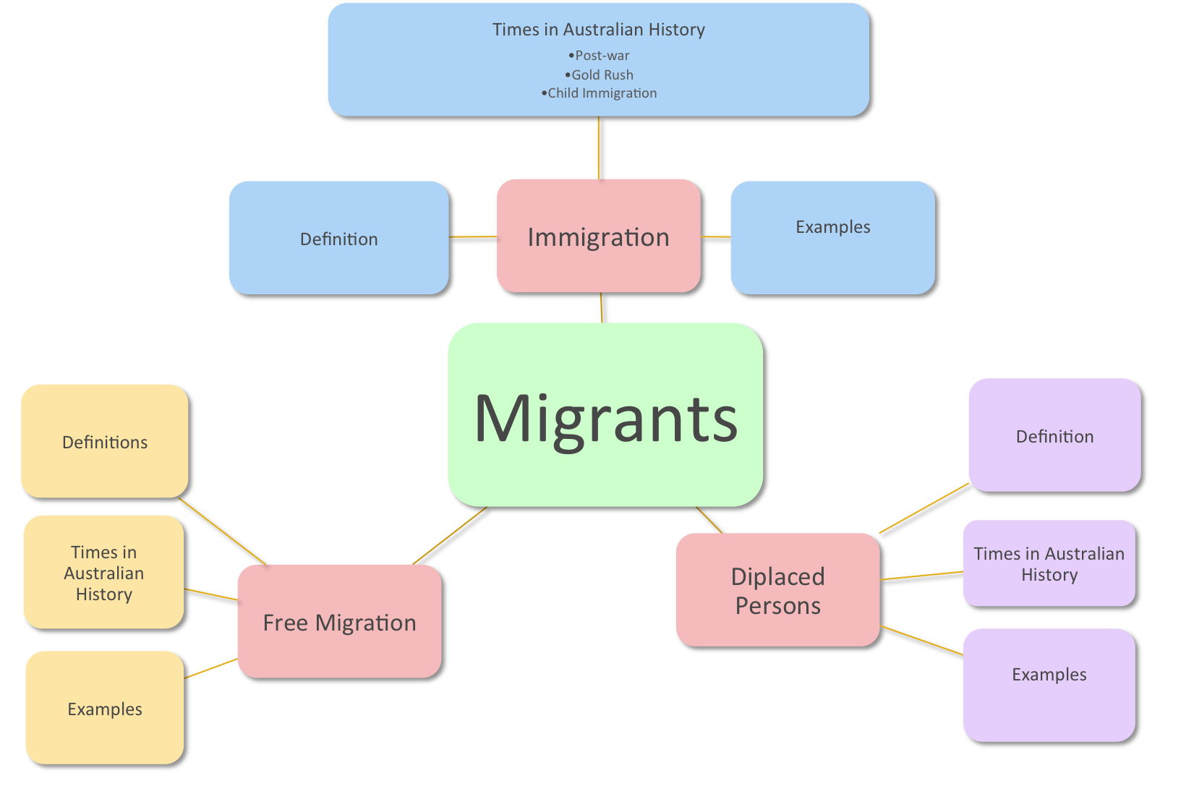
Lesson 1

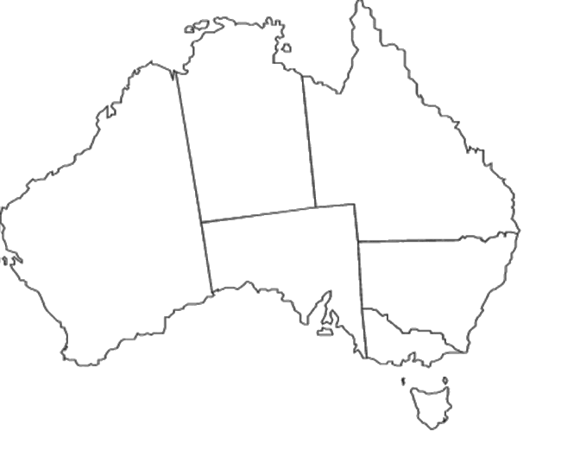
Lesson 2
Image retrieved from http://www.abcteach.com/Maps/australia.htm

Lesson 2

Portfolio MARKING RUBRIC
(Should be handed to students at start of lesson 2)

Lesson 2 - GOLD RUSH Information Overview
- The Gold Rush Years (dates)
- Where migrants came from and where they went.
- On a map mark and annotate the states that people flocked to (students may like to use Gold Splash)
- In your own words, write a paragraph to answer “Why did the Australian Government encourage immigration during the Gold Rush?”
Poor | Good | Exceptional | Teacher Comments
Not all aspects of this portfolio task were submitted. Work appeared rushed and/or incomplete. | All aspects were submitted and correct. Your work showed good understanding. Information was neat and carefully presented. | All aspects of this task were submitted. Your work was comprehensive. It was evident that worked hard and read all the readings on the class website. Your work was beautifully presented.
Lesson 3 – Post-war Migration
Write up a short profile entry for the individual’s life you examined. Include the following information
- Country of birth
- Year of migration
- Reason for emigration
- Transport into Australia
- Provide a paragraph or two outlining the person’s story.
You may choose to present this information as a voice recording
Poor | Good | Exceptional | Teacher Comments
Not all aspects of this portfolio task were submitted. Work appeared rushed and/or incomplete. | All aspects were submitted and correct. Your work showed good understanding. Information was neat and carefully presented. | All aspects of this task were submitted. Your work was comprehensive. It was evident that worked hard and read all the readings on the class website. Your work was beautifully presented.
Lesson 4 – CHILD MIGRATION
Students will read the child migration articles provided on the class website. Students will compare these articles with the pictures viewed at the start of the lesson. You will analyse the articles against the pictures. You will consider the following:
    - The emotions, physical strains, feelings, fears/concerns child migrants endured.
    - Do the pictures of the children align with the emotions and feelings described in the articles?
Complete a table that compares conflicts, consequences and benefits of child migration.
Poor | Good | Exceptional | Teacher Comments
Not all aspects of this portfolio task were submitted. Work appeared rushed and/or incomplete. | All aspects were submitted and correct. Your work showed good understanding of the conflicts and consequences associated with child migration. You provided clear interpretation of the sources and readings used in this lesson. | All aspects of this task were submitted. Your work was comprehensive. It was evident that worked hard. Your work showed outstanding interpretation of the conflicts and consequences associated with child migration.
Lesson 5 & 6 – BIOGRAPHY
Students research and write a biography about the life of someone who has migrated into Australia. (You may choose to work with a partner to share the workload). The presentation will include:
    - Background of an individual’s migration journey
    - An annotated map showing journey taken and significant happenings on the way
    - A timeline of the journey
    - A factual reflection of thoughts, feelings, and physical happenings along the journey.
    - Any other significant occurrences

Poor | Good | Exceptional | Teacher Comments
Not all aspects of this portfolio task were submitted. Work appeared rushed and/or incomplete. | All aspects were submitted and correct. Your work showed good understanding. Information was neat and carefully presented. | All aspects of this task were submitted. Your work was comprehensive. It was evident that worked hard and read all the readings on the class website. Your work was beautifully presented.

Lesson 3

Migrant Comparison Table

Migrant Name  Provide some background | Conflicts  Why did they migrate | Consequences  What happened on arrival | Comments  Any interesting information can be recorded here.

Lesson 5

QUICK QUIZ

- Describe a displaced person
- Post Vietnam War migration was active during which years?
- Were child migrants given a choice when leaving their home country?
- List the most common migrant nationalities during the Gold-rush
- Provide three positive points/aspects of free immigration.

