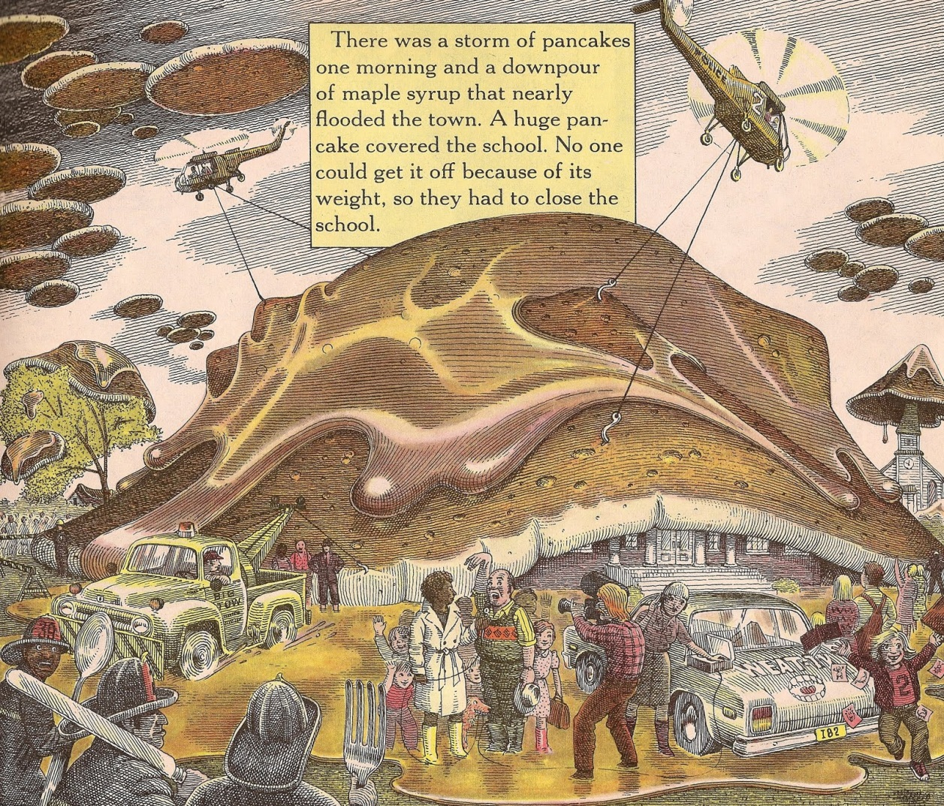
Activity Two
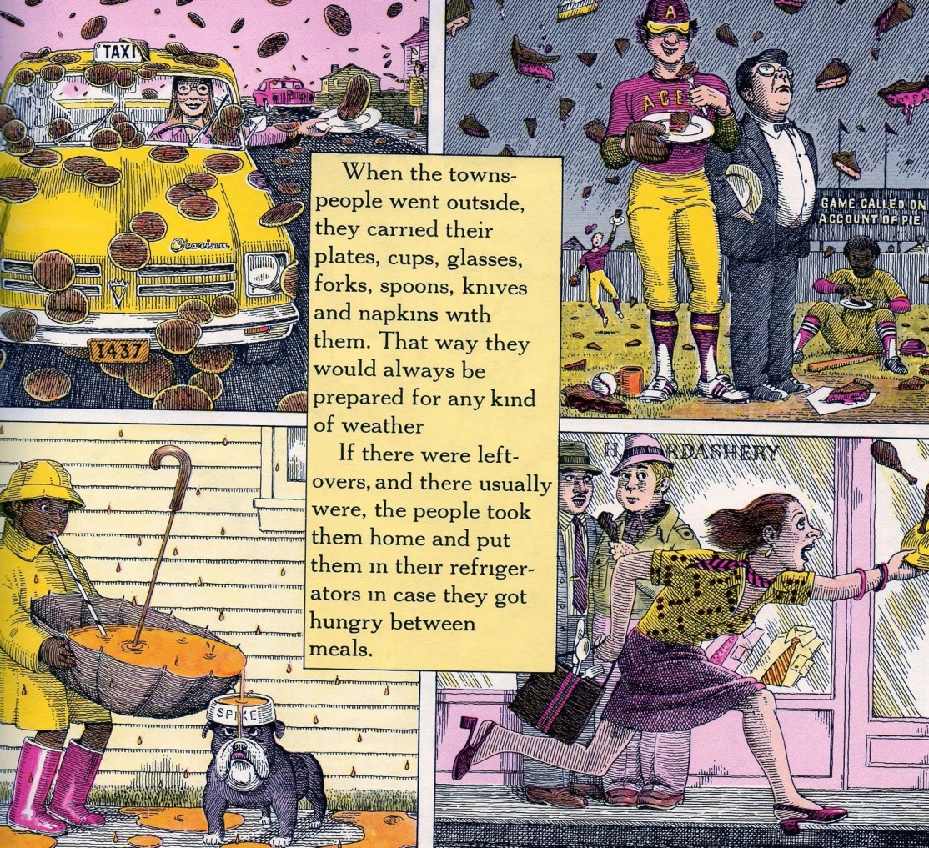

Compound Words
Place a tick or a cross in the box if it is a compound word.
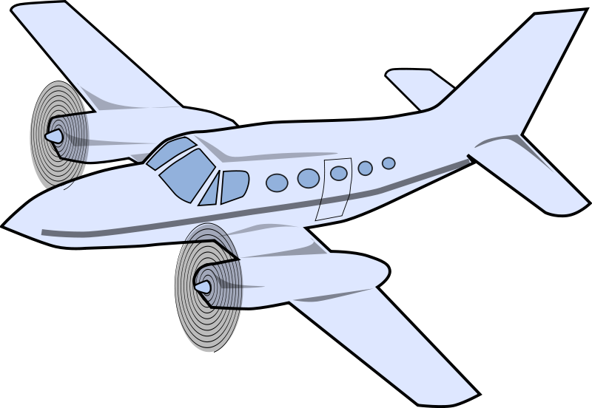
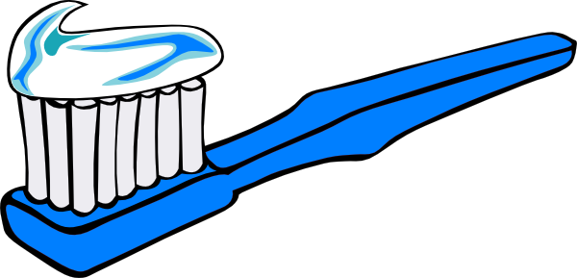
_________________________________
_________________________________

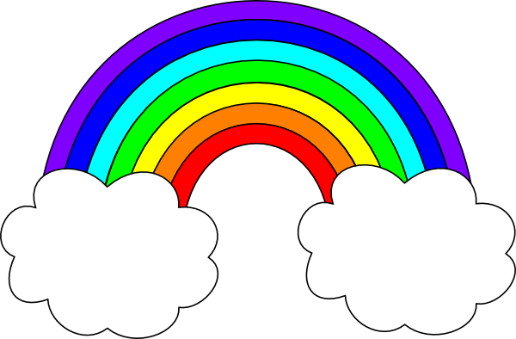
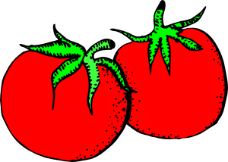
_________________________________
_________________________________

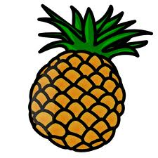


_________________________________
_________________________________

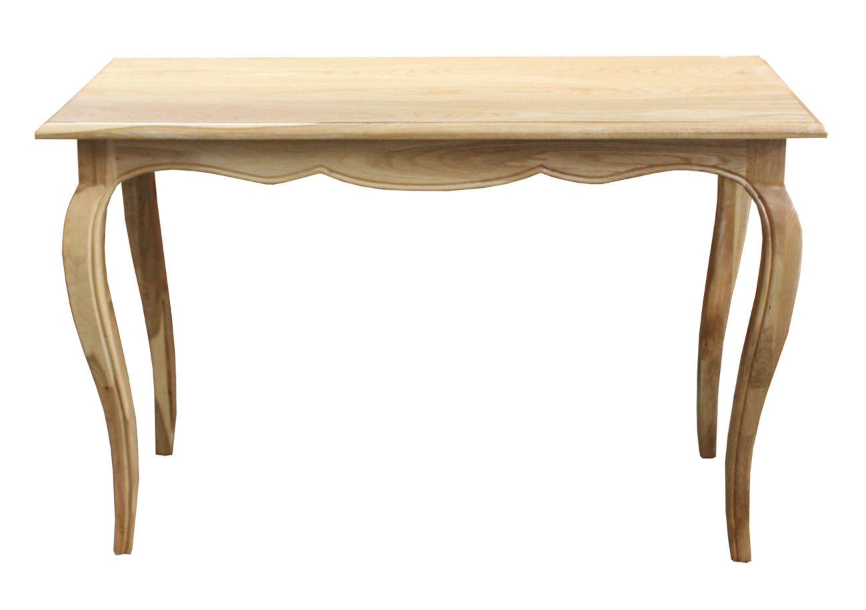
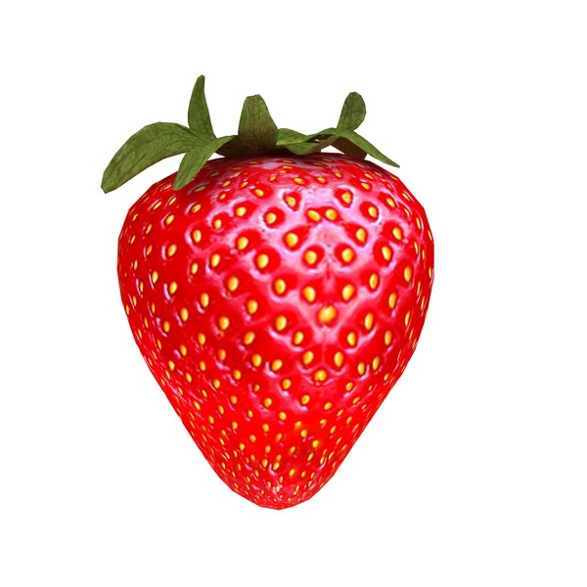
_________________________________
_________________________________

Compound Words
Have a look at the pictures and identify as many compound words as possible. Draw them in the boxes below and spell the compound word below the image.

_________________________________
_________________________________

_________________________________
_________________________________

_________________________________
_________________________________

_________________________________
_________________________________

