Weather Forecast
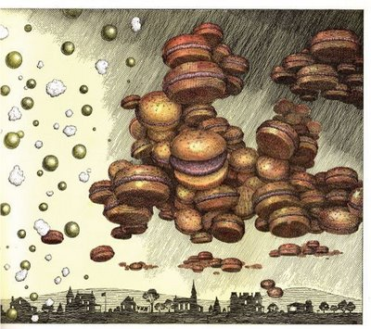

Sunday 13th June 2056
Good morning citizens of Chewandswallow. Today we will be expecting a breeze of hamburgers to cross over our famous waterfall. We expect that the goldfish will get a good feed from this.
Later on in the day a storm of strawberries will make an appearance. It will however, drift off elsewhere.
It may be best to stay underground in the evening as a tornado of cupcakes will be passing through. Expect a huge storm of frosting to upturn trees and cause damage to houses and property.
______________________Now Create your own!________________________
Weather Forecast

________________________________________________________________________________________________________________________________________________________________________________________________________________________________________________________________________________________________________________________________________________________________________________________________________________________________________________________________

