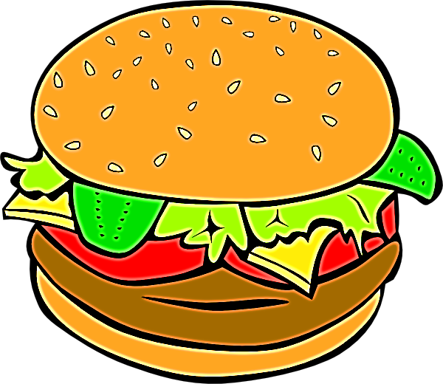
Activity One
- Use the word cards to match the compound words. Try to create other compound words.

- Remember to write down all of your combinations.
- Create your own compound words on the blank cards.
- Swap these with a partner and practice matching their words.
- Write the new compound words you discovered on the word wall.

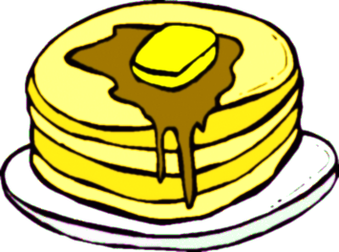
Activity Two
- Use the compound words worksheet to practice spelling the compound words.

- Start by looking at the picture, sound out what the picture is, tick it if it is a compound word and then try to spell it correctly.

- Look at the picture snapshots taken from the book. Identify pictures that are compound words. Draw these pictures and then practice spelling them.

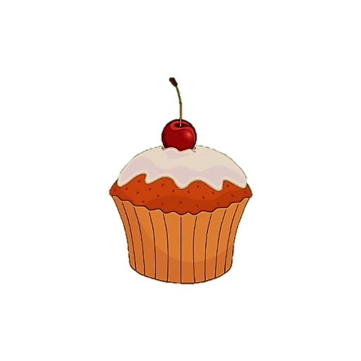
Activity Three
- Fill in the missing blanks on the menus using compound words. Try to be as creative as possible.
- Invent your own food compound word. Draw and write a definition describing this item. For example: Pastachip – A Pastachip is a chip with mini pieces of pasta in it.
- Use your new food and incorporate it into a menu.

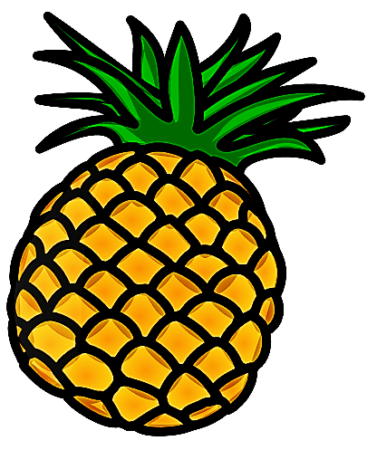
Activity Four

- Look at the weather forecast and circle all of the compound words.
- Complete the look, say, cover, write, check to practice spelling the compound words.

- Create your own weather forecast using compound words, be creative!

