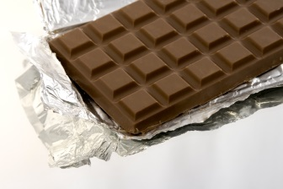
Chocolate
Have the word CHOCOLATE written on the board in big letters.
What do you know about chocolate? Discuss the properties of chocolate.
Have students look around the room. They will compile a short list of everything they can see that is a solid. Show this to a partner to check if you’re right. What makes something a solid?
EXPERIMENT
In our experiment today who can guess what ingredient we will be using? CHOCOLATE!
Students will be given a snap lock bag that has chocolate chips inside it.

The first part of this experiment involves us only using our eyes, we cannot touch the bags. Look inside your bag and describe what you can see. What is the current state of matter?
Can chocolate take on different states of matter? Can it be a solid, liquid and a gas?
How can we make the chocolate become a liquid? We can apply heat. What are some ways that we can apply heat with our bodies?
Prediction: Before we melt the chocolate, we are going to time how long it takes to melt. In your groups predict how long it will take for your chocolate to melt. Record some responses on the board. The group who melts their entire chocolate first will be given points. The group that got the closest time to their prediction will also receive points.
READY STEADY MELT!
What happened to the chocolate? What changes occurred? Why do you think the changes occurred? Have students again observe their bag and think of interesting words to describe the current contents.
Students will now write their names on their bag. Place each student’s bag in the freezer/fridge for 5 minutes. What do you think will happen to the chocolate? After 5 minutes students observe the changes that have taken place. How does temperature affect states of matter?

