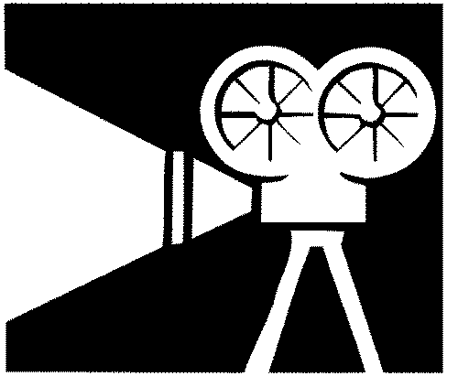

Media checklist

Planning to make a media product | Response
Who do you represent?
What is your purpose?

What technology options do you have?

From what point of view are you coming from??
How are you using conventions to convey your message?

Who is the intended audience?
How are you appealing to the target audience?
What assumptions have been made about the audience?

