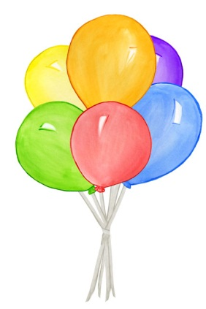
Balloon Time
Candle
Balloon

Prediction One: ______________________________________________________________________________________________________________________________________________________

Prediction Two: ______________________________________________________________________________________________________________________________________________________

