
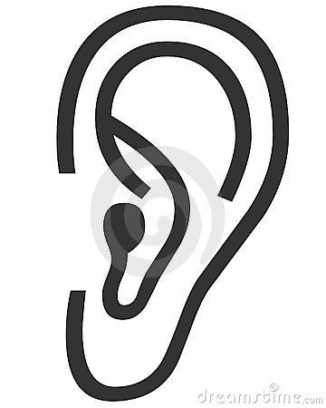
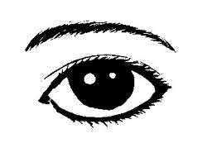
Y- chart Example:
Respect

Happy

Productive

Trust

Inclusive

Learning
People using their manners!

One person talking at a time

Each person gets equal opportunity to talk

“Great idea!” (People complimenting one another)

Sharing of ideas

Asking for help

Asking questions

Working noise (not too quiet but not loud)

Talking about problems or challenges

Sharing equipment

Listening to one another

Helping one another

Happy faces

Everyone is included

Everyone following classroom rules

People are working and staying on task

Supporting and encouraging one another

Being flexible and open to new/different ideas

No putdowns

Eyes on speaker

Being responsible

