Hyperlink File
Tunnel
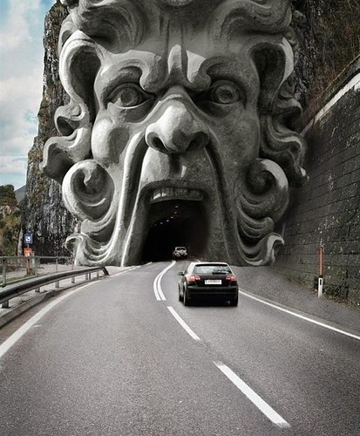

Passage
Once up on a time, there was a groop of friends who where walking threw the bush. Thay had walked and walked for hours and were starting to get verry sleepy?
All off a sudden one of the boys saw a light comming from behind the trees. They started to walk in that direction when, they noticed somethink strange.
“What is that, tom asked.
None of the boyz new what thay were loking at. It was the strangst thing they had eva seen,
It looked a, little bit like a spaceship but it was bright orannge and covered in grasse.
Slowly tha boys started to back away and ran as they, saw a strange crature emerge from the top.
There hearts raced as thay ran bak threw the bush. They sprinted untill they got home. Whateva that thingg was, they had lernt there lesson to never go wondering back into the bush!
The End
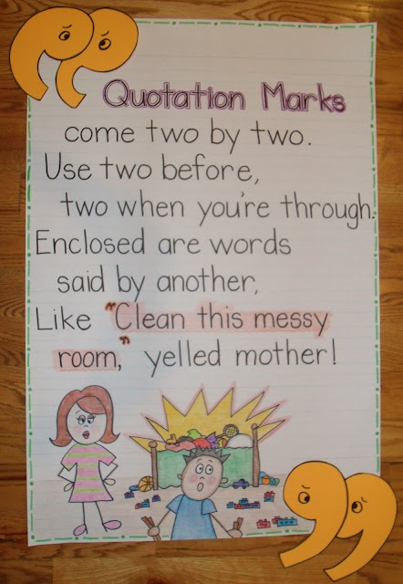
Quotation Marks

Image - what questions come to mind?
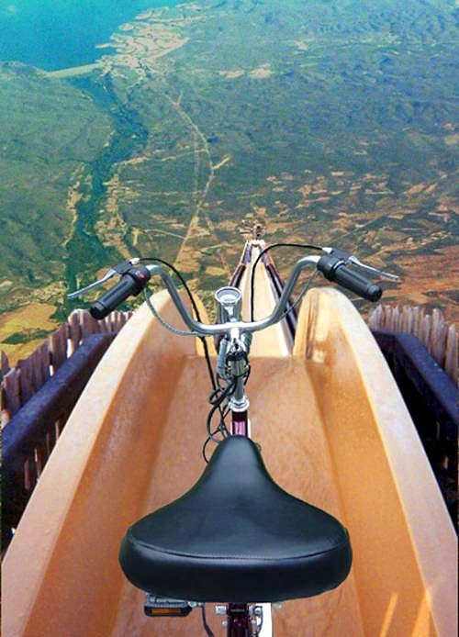

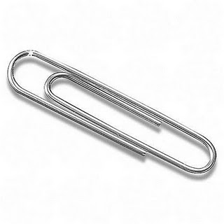
Paperclip

- Toothpick for a giant.
- Walking stick for a tiny man.
- Bookmark
- Earrings

Homophones

Words that sound the same but have different meanings.

Ate Eight
Meat Meet
Sale Sail

Sentences:
Nancy ate two cupcakes at the party.
My brother didn’t go to bed until eight o’clock.

Dad cooked a lot of meat on the barbeque.
Yesterday I got to meet our new neighbours.

We watched the boats sail smoothly over the water.
The garage sale had some great bargains.

Watermelon
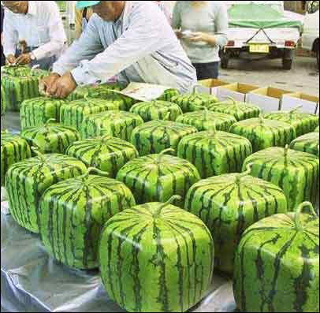

Which one is sadder?

Leaf Ice-block
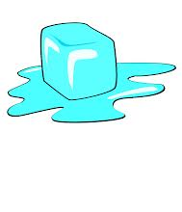
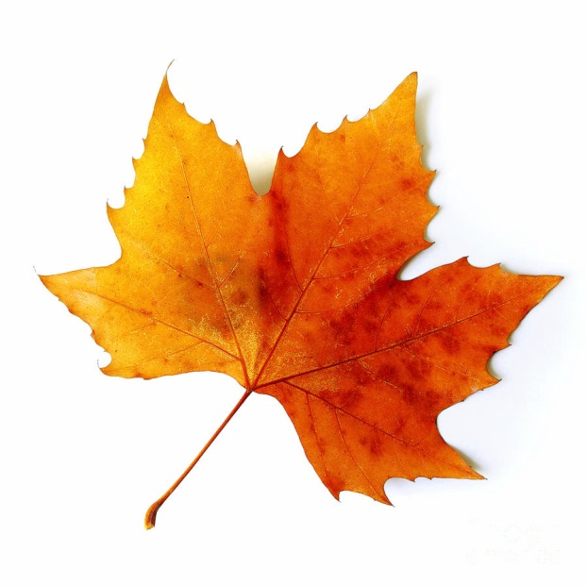

I think the leaf is sadder because it has fallen from the tree and it will never be green again.

I think the leaf is sadder because someone might step on it.

The ice-block is sadder because it will never be a solid again.

Compare picture 1 and 2.
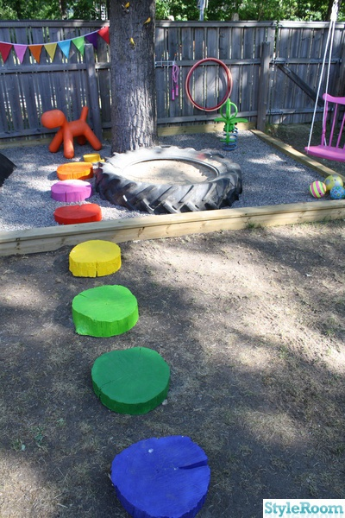



Jellyfish
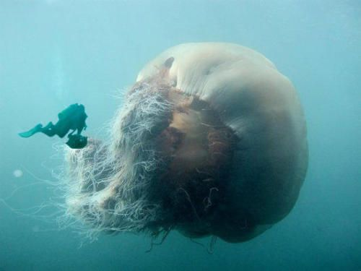

Item – sell this item


