Attachment 1

Memory bag
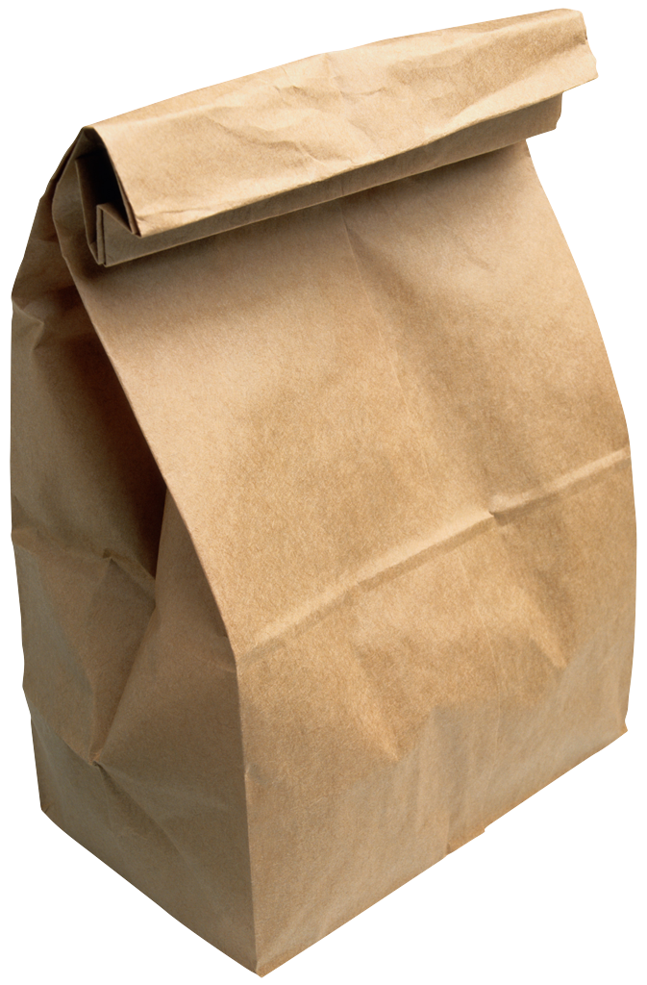

Dear Parent/Carer

Tomorrow your child needs to bring to school an item that is associated with a special memory to them. For example, a Mickey Mouse hat they got from their holiday to Disney Land of a shell from their birthday at the beach.

Thank you for your assistance.

