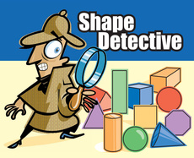
Who am I?

You are a shape detective and your mission is to:
- Identify the shape, and
- Draw a picture of the shape in the box provided

I have 2 short sides and 2 long sides. Who am I?

___________________

I have 3 sides, all sides are the same in length. Who am I?

___________________

I have 8 sides, all the same in length. Who am I?
__________________

I have 4 equal sides. Who am I?

I have 5 sides, all equal in length. Who am I?
___________________

