Storm Boy
Workbook

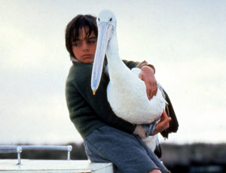

Name: ______________________

Storm Boy Setting

Write down the information you researched about the Coorong.
________________________________________________________________________________________________________________________________________________________________________________________________________________________________________________________________________________________
Describe the setting in the book Storm Boy.
________________________________________________________________________________________________________________________________________________________________________________________________________________________________________________________________________________________________________________________________________________________________________________________________________
Characters
Describe what you like about the following characters. Which one is your favourite?
Storm Boy
_____________________________________________________________________________________________________________________________________________________________________________________________________________________________________________________
Hideaway Tom
_____________________________________________________________________________________________________________________________________________________________________________________________________________________________________________________
Fingerbone Bill
_____________________________________________________________________________________________________________________________________________________________________________________________________________________________________________________

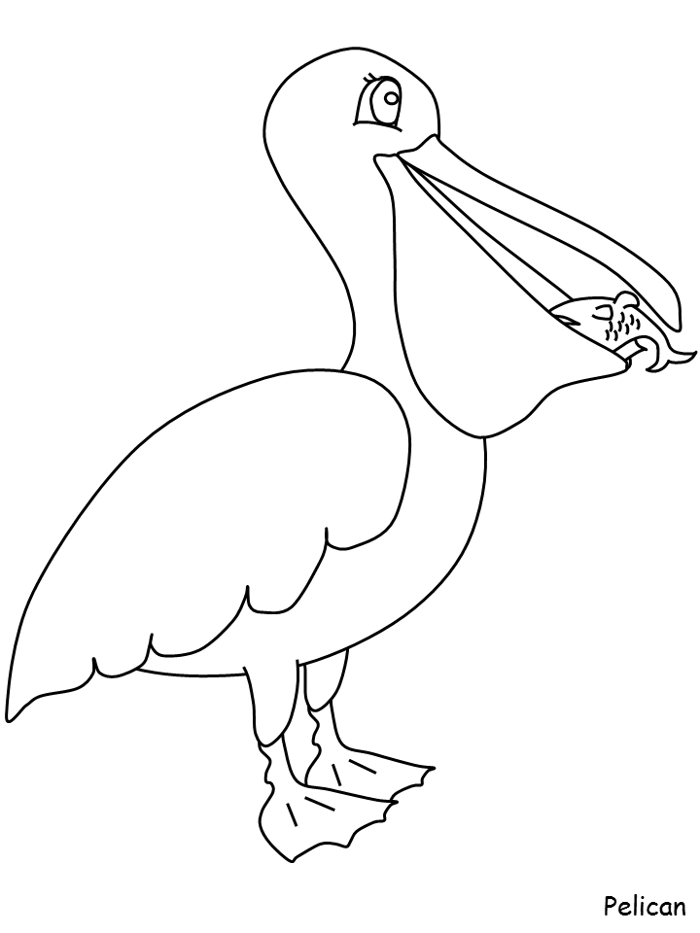

Storm Boy

Write a conversation between Storm Boy and Mr Percival.
S.B: ________________________________________________________________________________________________________________________________________________________________________
Mr P:
________________________________________________________________________________________________________________________________________________________________________
S.B:
________________________________________________________________________________________________________________________________________________________________________
Mr P:
________________________________________________________________________________________________________________________________________________________________________
Illustrate the characters engaging in your conversation.


Rescue Mission

Mr Percival has passed away. Storm boy wants you to create something to help him remember Mr Percival. If you were to make a little gift for Storm Boy out of clay, what would you make and why?
________________________________________________________________________________________________________________________________________________________________________________________________________________________________________________________________________________________

Readers Review

________________________________________________________________________________________________________________________________________________________________________________________________________________________________________________________________________________________________________________________________
Author: ________________________

