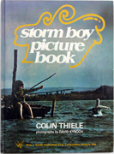
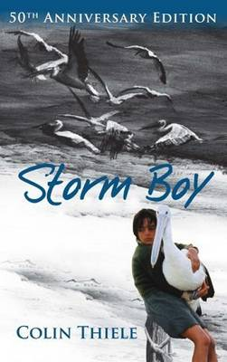
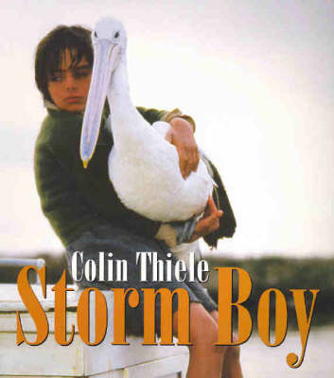

Image references:
http://www.babyboomerbooks.com.au/catalogue%20colin%20thiele.htm
http://www.boomerangbooks.com.au/Storm-Boy/Colin-Thiele/book_9781864368048.htm
http://www.boomerangbooks.com.au/Storm-Boy/Colin-Thiele/book_9781741101874.htm

