Smallest to Largest

Assessment

Name: _______________________

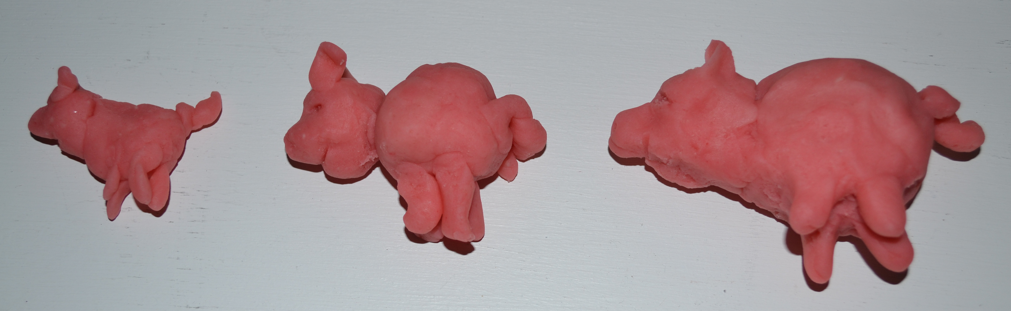

*Example assessment annotations directly linked to lesson objectives and ACARA outcomes.

______ was able to verbally identify the smallest pig and the biggest pig.
_______was able to put three pigs in ascending order from the smallest to the biggest.

