My Favourite Shape

Students create their favourite shape using play dough and describe its features.

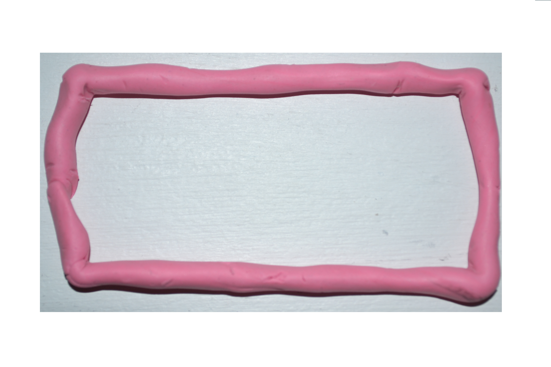

My favourite shape is a________________________________________

It has _______________ sides and ______________ corners.

