Food

The Aboriginal people had a very healthy diet. They knew how to find foods that were full of vitamins and minerals.
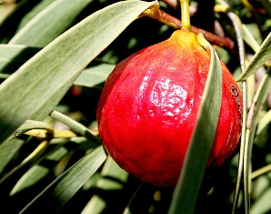
The women were the main food gatherers and they would go out and search for seeds, vegetables, fruit and witchetty grubs. The men were in charge of hunting animals. They would hunt for kangaroo, lizards, snakes and goannas. To catch the animals they would use boomerangs, throwing sticks and spears.
The Aboriginal people ate different foods depending on where they lived in Australia. Some parts of Australia had a wide range of plants and animals that the Aboriginals could eat. In other parts of Australia there was barely enough food to survive.

The Aboriginals that lived along the coast would eat mainly fish and turtles. They would catch these animals by using spears.
Once the food was caught the Aboriginals would usually cook their meat on a fire. Before cooking their meat they would wrap it in bark or leaves.
There were various ways of preparing food. Meat was generally cooked on fire or steamed in pits. Sometimes it was wrapped in bark or leaves. Plant foods were washed, grinded, strained, grated, boiled or cooked in large seashells or in bark troughs. Roots were dried in the sun or roasted on hot ashes and sometimes baked into cakes.

Clothing

In the northern parts of Australia the Aboriginal people rarely wore clothes and usually covered their bodies with paintings.
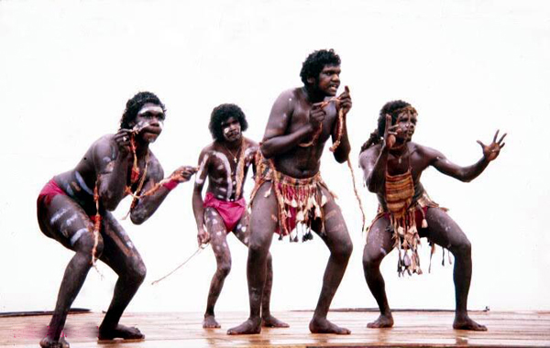
The Aboriginal people would often use bark, grass and leaves to cover their bodies. The men would wear a riji and this was an item of clothing that went around their waist. It was tied together by grass and leaves.

In the cooler parts of Australia the Aboriginal people would wear possum cloaks. These were made by combining several possum skins together.

Most of their clothing consisted of animal skins. The skins were usually rubbed with fat and this provided extra warmth during the colder nights. Animal skins were also used as blankets and bedding.
The Aborigines did wear various kinds of personal ornaments such as arm and head bands, necklaces, and bracelets. These were usually made from shells, bones, animal teeth and claws, or bits of feather and fur.

Shelter

Most of Australia has a very hot climate and people often slept out in the open. To keep themselves warm at night they would sleep close to fires.

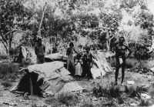
Aboriginal housing mostly consisted of simple shelters made from branches and then covered with leaves and sheets of bark. The Aboriginals were dependant on the materials that they could get from the land. In some places soft paperbark was easily pulled off trees to make a shelter. In other places there were only branches and leaves that could be used.

In the wet and cold conditions, closed dome-shaped shelters were made. Sticks were bent over and bark, grass and leaves were used to cover the shelter.
In the northern areas of Australia, the shelters were often larger in size. The shelters often had multiple entrances and were big enough for a small fire to be made inside. The fires provided warmth and were also used to repel mosquitos.
In other areas of Australia the Aboriginals would find rock caves to live in. They would use paperbark and leaves to make their beds.

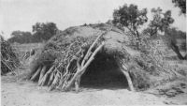

Music

Music plays a major role in traditional Aboriginal societies and is linked with a person's ancestry and country (the animals, plants and physical features of the landscape). It is traditionally connected with important events such as the bringing of rain, healing, wounding enemies and the winning of battles.

Music is used throughout an Aboriginal’s life to teach what must be known about their culture, about their place in it and about the world of nature. Children are encouraged to dance and sing about everyday tasks.
A didgeridoo is a type of musical instrument. It is one of the oldest instruments to date. It consists of a long tube and is traditionally made of eucalyptus. Today, didgeridoos are most commonly made from PVC piping. The didgeridoo is played only by men, and usually is played during ceremonies, singing and dancing.
The Australian Aboriginals have had no written language and rely on oral methods and music to pass on their knowledge. Without a written language, they could pass on knowledge through songs.
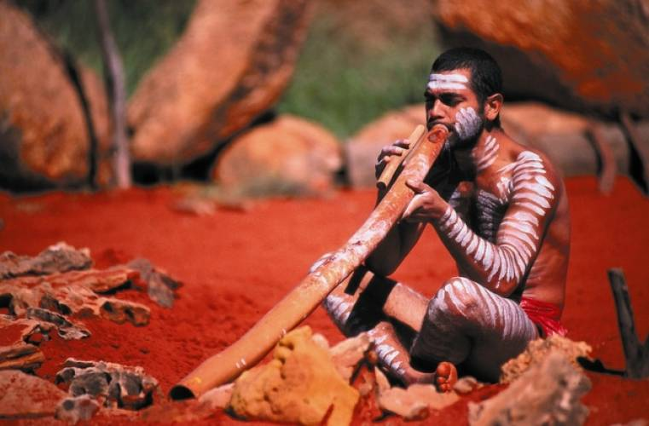

Transport

The main form of transport amongst traditional Indigenous people was walking. Because the Indigenous lifestyle was nomadic, people had to do a lot of walking to get from place to place.

Those Indigenous groups that lived near the coast or large bodies of water would often travel in canoes that they had made from hollowed out tree trunks. These canoes were very helpful in fishing activities, as well as for travelling around.

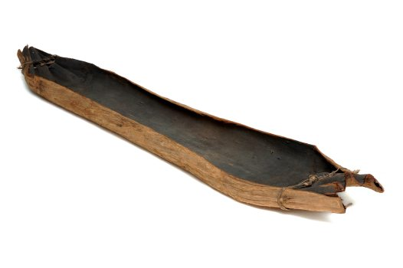

Art

Aboriginal art is one of the oldest surviving art forms still practiced today. The oldest paintings were painted thousands of years ago in caves. These would have been painted with Ochre.
Traditional Aboriginal paintings always have a story because the Aboriginal people do not have a written language. The only way they could tell their stories was through paintings and songs.

Aboriginal art comes in many forms including dot painting, bark painting, body painting and wood carving.
In central Australia, body painting was used in ceremonies and sand paintings were also used to tell important stories. Aboriginal symbols were incorporated into the artworks.
Paints were made from ochre. These stone pigments were mixed with emu fats and kangaroo oils to make a liquid paint.
