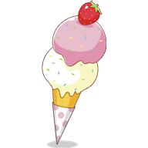
…Ice-Cream Flavours…

Which ice-cream flavour would you like to be invented?
Tick 1 box below.

Girl Boy

Popcorn ice-cream

Cinnamon ice-cream

Carrot cake ice-cream

Apple ice-cream

Shortbread ice-cream

Pineapple ice-cream

Sour worm’s ice-cream

Pancake ice-cream

