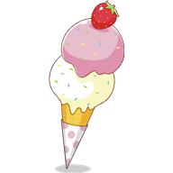
Ice-cream flavours

Flavour | Total | Girls | Boys
Popcorn

Cinnamon

Carrot cake

Apple

Shortbread

Pineapple

Sour worm’s

Pancake

