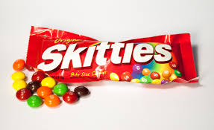
Skittle Maths
Before you can eat your skittles, you must do the following questions:

- How many of each flavour skittle do you have in your bag? Draw a table to show this like so:
Lemon | Orange | Grape | Apple | Raspberry

- You have 12 skittles in your bag, what fraction, decimal and percentage do you have of each flavour? Make a table like so:
Flavour | Fraction | Decimal | Percentage
Lemon
Orange
Grape
Apple
Raspberry

- Graph your results in 2 forms. (Bar, pie etc.)

- Design and construct a net which you can fold into a box to put the skittles in. eg below

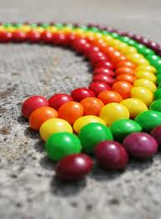
- What was the mode of your skittles bag? (Remember mode is most occurring).

Please turn this into an A3 poster. Then you can eat your skittles!

