Karl Gauss Investigation
Karl Friedrich Gauss was born in Brunswick, Germany in 1777. When he was in grade 6, his teacher gave him a problem where he had to find the sum (answer) of all numbers from 1 to 100. Karl completed it within 3 minutes. What is the answer to the problem? (1 + 2 + 3+ 4 etc.)
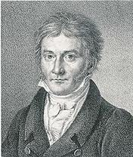
Show all your workings out below as well as the answer.

- What strategy did you use to solve the problem? _________________________________________________________________________________________________________________________________________________________________________________________________________________________________

- Was it the best way? Why/Why not?__________________________________________________________________________________________________________________________________________________________________________________________________________________________________________________

- Did you notice anything special?_______________________________________________________________________________________________________________________________________________________________________________________________________________________________________________

Inquiry:
- Who is Karl Gauss? Tell me little about his life. (Born, Contribution to mathematics etc.)
_________________________________________________________________________________________________________________________________________________________________________________________________________________________________

- What is the story that is associated with this maths problem?____________________________________________________________________________________________________________________________________________________________________________________________________________________________________________________________________________________________________

- What did Karl Gauss do in order to solve this problem as quickly as he possibly could?_______________________________________________________________________________________________________________________________________________________________________________________________________________________________________________________________________________________________________

